**Supplementary Materials for “Network regression analysis for binary and ordinal categorical phenotypes in transcriptome-wide association studies”**

Liye Zhang1,2†, Tao Ju1,2†, Xiuyuan Jin1,2, Jiadong Ji3, Jiayi Han1,2, Xiang Zhou4, Zhongshang Yuan1,2*

1 Department of Biostatistics, School of Public Health, Cheeloo College of Medicine, Shandong University, Jinan, Shandong, 250012, China

2 Institute for Medical Dataology, Shandong University, Jinan, Shandong, 250003, China

3 Institute for Financial Studies, Shandong University, Jinan, Shandong, 250100, China

4 Department of Biostatistics, The University of Michigan,1420 Washington Heights, Ann Arbor, MI, 48109, USA

†Liye Zhang and Tao Ju contributed equally to this work.

* Corresponding author.

Email addresses: [yuanzhongshang@sdu.edu.cn](%20yuanzhongshang@sdu.edu.cn) (Zhongshang Yuan)

**Supplementary Figures S1-S48:**

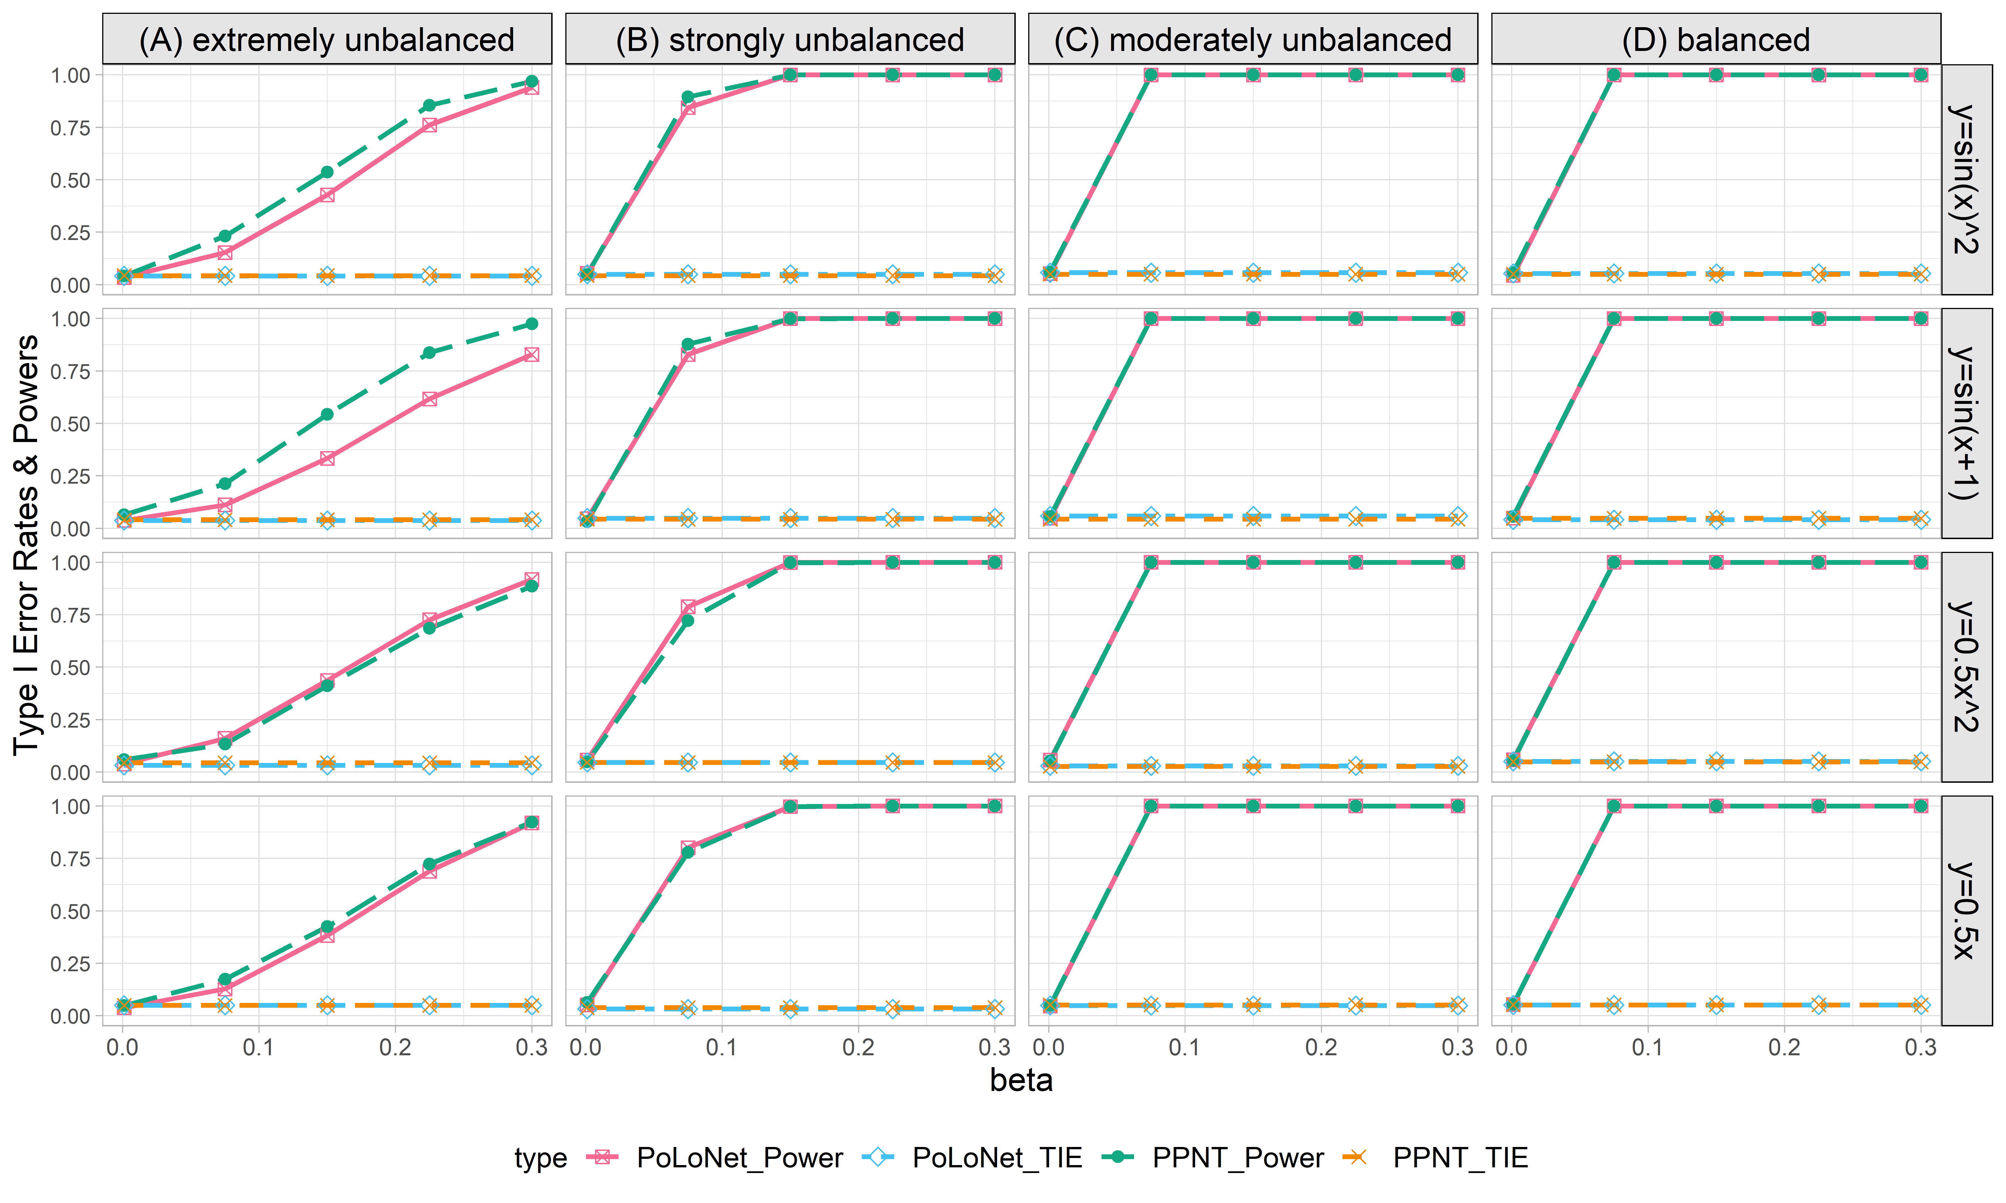

**Figure S1. Empirical type I error rates and powers for detecting the effect of the node for the binary trait under the setting that both node and edge have effects, with the node hanging on the edge (n=10000), with DPR as gene expression prediction model in TWAS.** The significance level is α=0.05. Simulations are conducted with 4 different between-node correlation patterns (the recombination of quadratic and sine, sine, quadratic, linear) and 5 different effect sizes (0.001, 0.075, 0.15, 0.225, 0.3). (A) extremely unbalanced (1:999) ; (B) strongly unbalanced (99:1); (C)moderately unbalanced (1:9); (D) balanced (1:1))

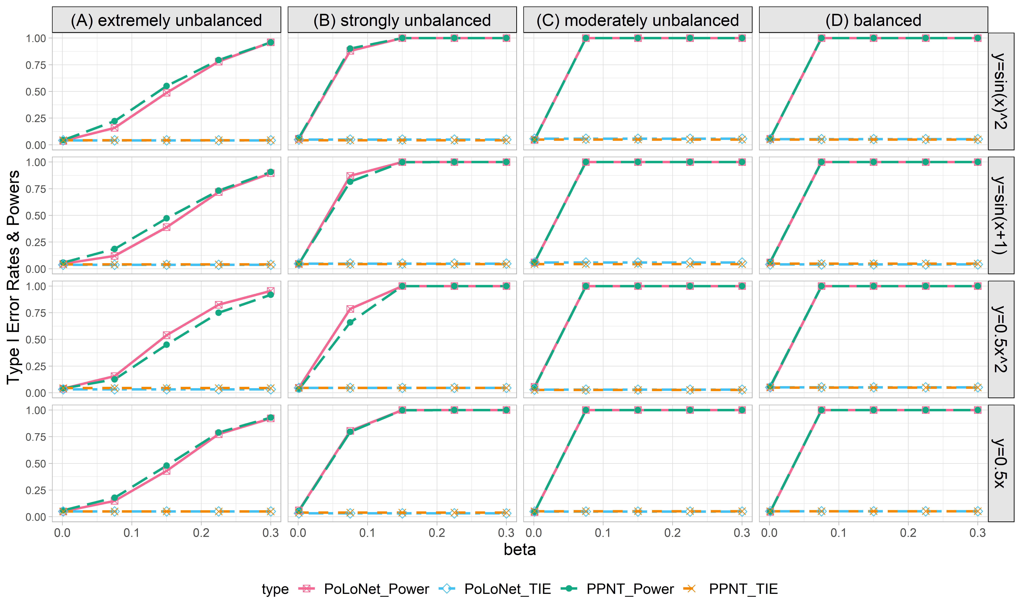

**Figure S2. Empirical type I error rates and powers for detecting the effect of the node for the binary trait under the setting that both node and edge have effects, with the node not hanging on the edge (n=10000), with DPR as gene expression prediction model in TWAS.** The significance level is α=0.05. Simulations are conducted with 4 different between-node correlation patterns (the recombination of quadratic and sine, sine, quadratic, linear) and 5 different effect sizes (0.001, 0.075, 0.15, 0.225, 0.3). (A) extremely unbalanced (1:999) ; (B) strongly unbalanced (99:1); (C)moderately unbalanced (1:9); (D) balanced (1:1)).

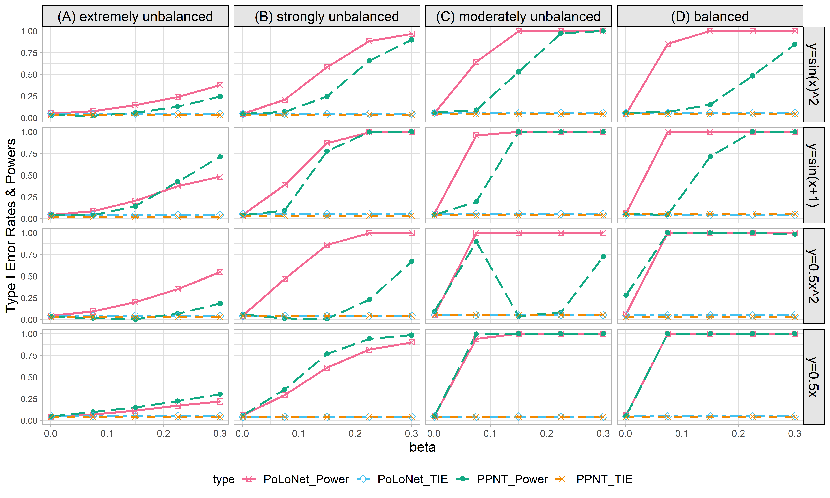

**Figure S3. Empirical type I error rates and powers for detecting the effect of the edge for the binary trait under the setting that both node and edge have effects, with the node hanging on the edge (n=10000), with DPR as gene expression prediction model in TWAS.** The significance level is α=0.05. Simulations are conducted with 4 different between-node correlation patterns (the recombination of quadratic and sine, sine, quadratic, linear) and 5 different effect sizes (0.001, 0.075, 0.15, 0.225, 0.3). (A) extremely unbalanced (1:999) ; (B) strongly unbalanced (99:1); (C)moderately unbalanced (1:9); (D) balanced (1:1)).

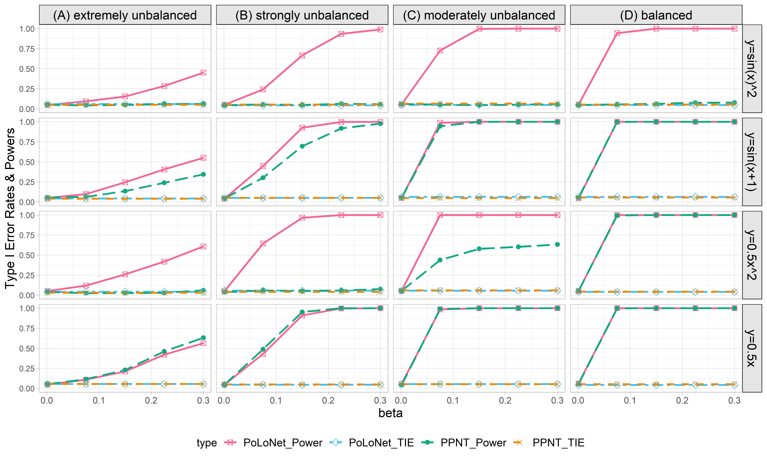

**Figure S4. Empirical type I error rates and powers for detecting the effect of the edge for the binary trait under the setting that both node and edge have effects, with the node not hanging on the edge (n=10000), with DPR as gene expression prediction model in TWAS.** The significance level is α=0.05. Simulations are conducted with 4 different between-node correlation patterns (the recombination of quadratic and sine, sine, quadratic, linear) and 5 different effect sizestt (0.001, 0.075, 0.15, 0.225, 0.3). (A) extremely unbalanced (1:999) ; (B) strongly unbalanced (99:1); (C)moderately unbalanced (1:9); (D) balanced (1:1)).

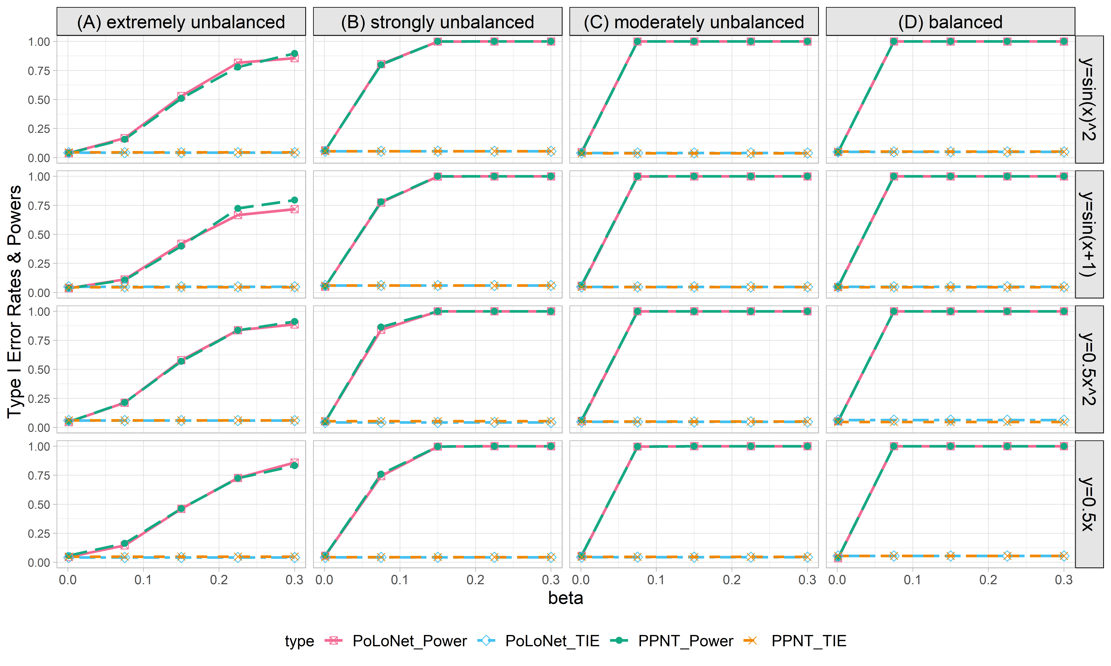

**Figure S5. Empirical type I error rates and powers for detecting the effect of the node for the binary trait under the setting that only node has effects (n=5000), with DPR as gene expression prediction model in TWAS.** The significance level is α=0.05. Simulations are conducted with 4 different between-node correlation patterns (the recombination of quadratic and sine, sine, quadratic, linear) and 5 different effect sizes (0.001, 0.075, 0.15, 0.225, 0.3). (A) extremely unbalanced (1:999) ; (B) strongly unbalanced (99:1); (C)moderately unbalanced (1:9); (D) balanced (1:1)).

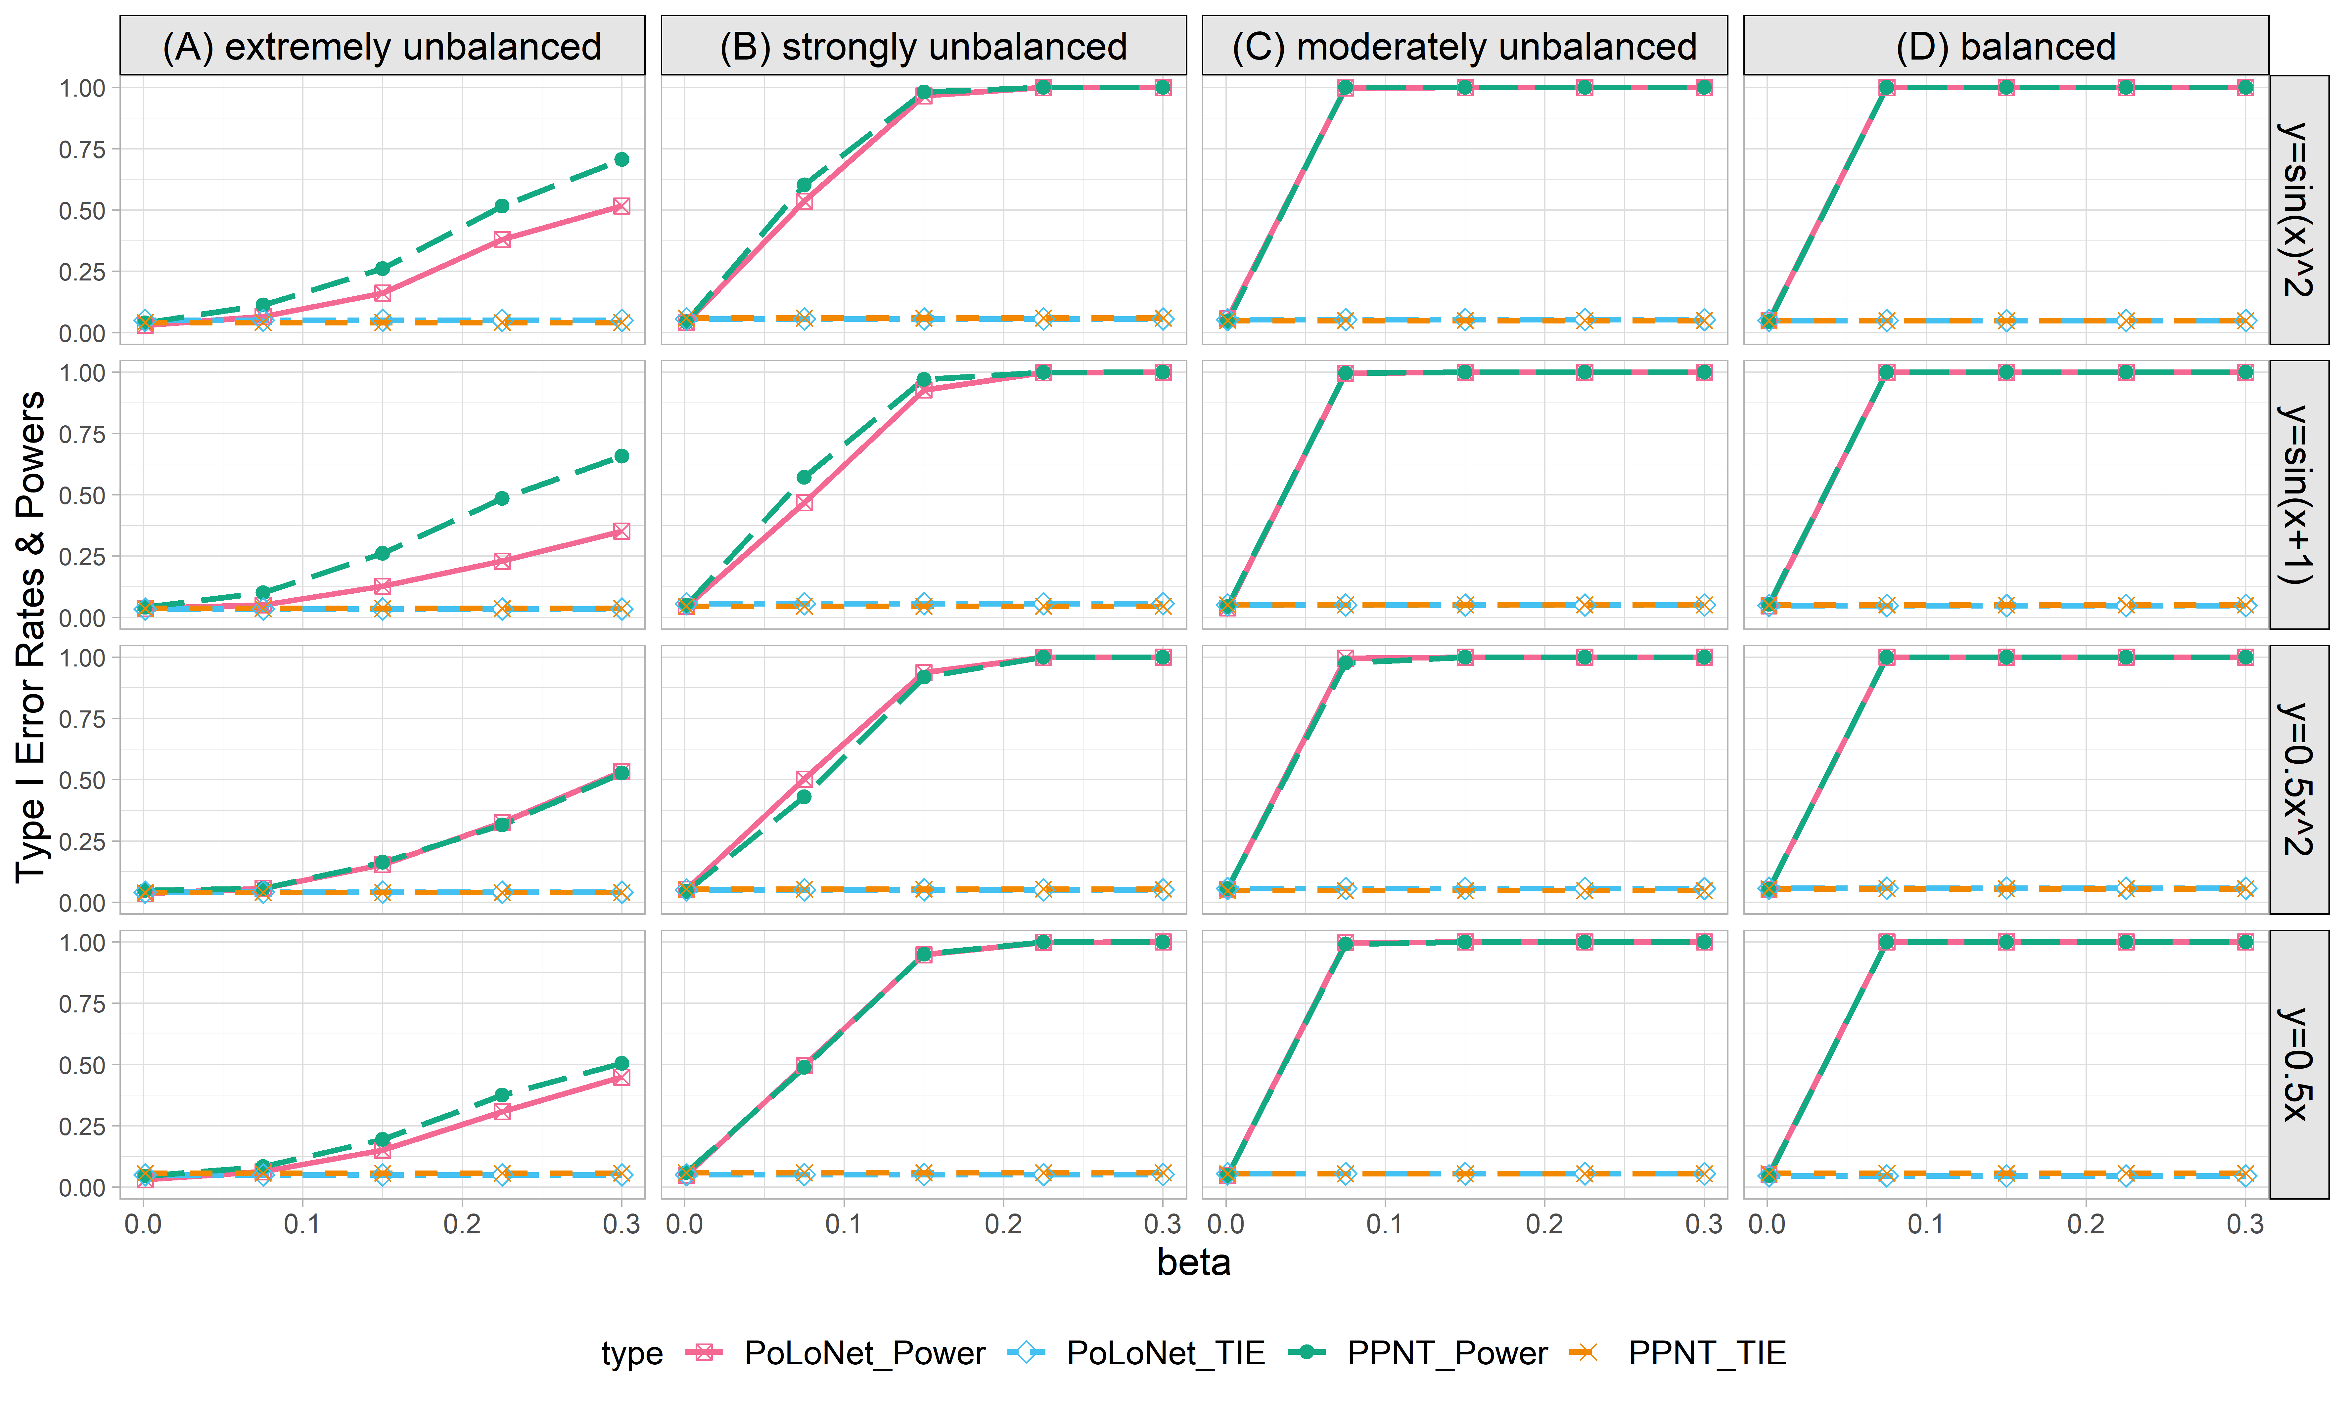

**Figure S6. Empirical type I error rates and powers for detecting the effect of the node for the binary trait under the setting that both node and edge has effects, with the node hanging on the edge (n=5000), with DPR as gene expression prediction model in TWAS.** The significance level is α=0.05. Simulations are conducted with 4 different between-node correlation patterns (the recombination of quadratic and sine, sine, quadratic, linear) and 5 different effect sizes (0.001, 0.075, 0.15, 0.225, 0.3). (A) extremely unbalanced (1:999) ; (B) strongly unbalanced (99:1); (C)moderately unbalanced (1:9); (D) balanced (1:1)).

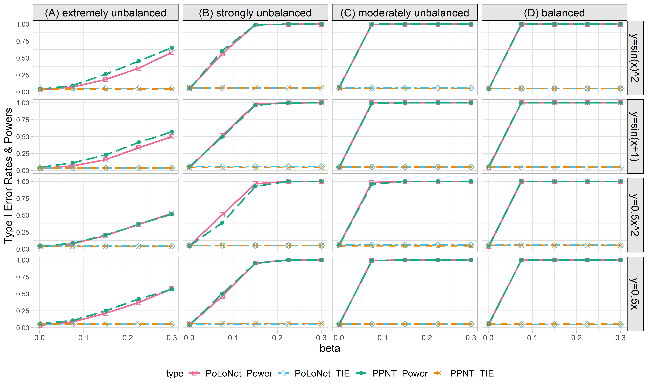

**Figure S7. Empirical type I error rates and powers for detecting the effect of the node for the binary trait under the setting that both node and edge have effects, with the node not hanging on the edge (n=5000), with DPR as gene expression prediction model in TWAS.** The significance level is α=0.05. Simulations are conducted with 4 different between-node correlation patterns (the recombination of quadratic and sine, sine, quadratic, linear) and 5 different effect sizes (0.001, 0.075, 0.15, 0.225, 0.3). (A) extremely unbalanced (1:999) ; (B) strongly unbalanced (99:1); (C)moderately unbalanced (1:9); (D) balanced (1:1)).

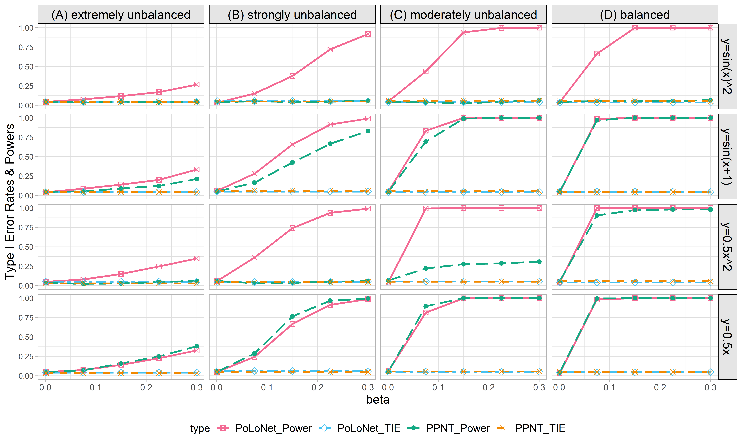

**Figure S8. Empirical type I error rates and powers for detecting the effect of the edge for the binary trait under the setting that only the edge has an effect (n=5000), with DPR as gene expression prediction model in TWAS.** The significance level is α=0.05. Simulations are conducted with 4 different between-node correlation patterns (the recombination of quadratic and sine, sine, quadratic, linear) and 5 different effect sizes (0.001, 0.075, 0.15, 0.225, 0.3). (A) extremely unbalanced (1:999) ; (B) strongly unbalanced (99:1); (C)moderately unbalanced (1:9); (D) balanced (1:1)).

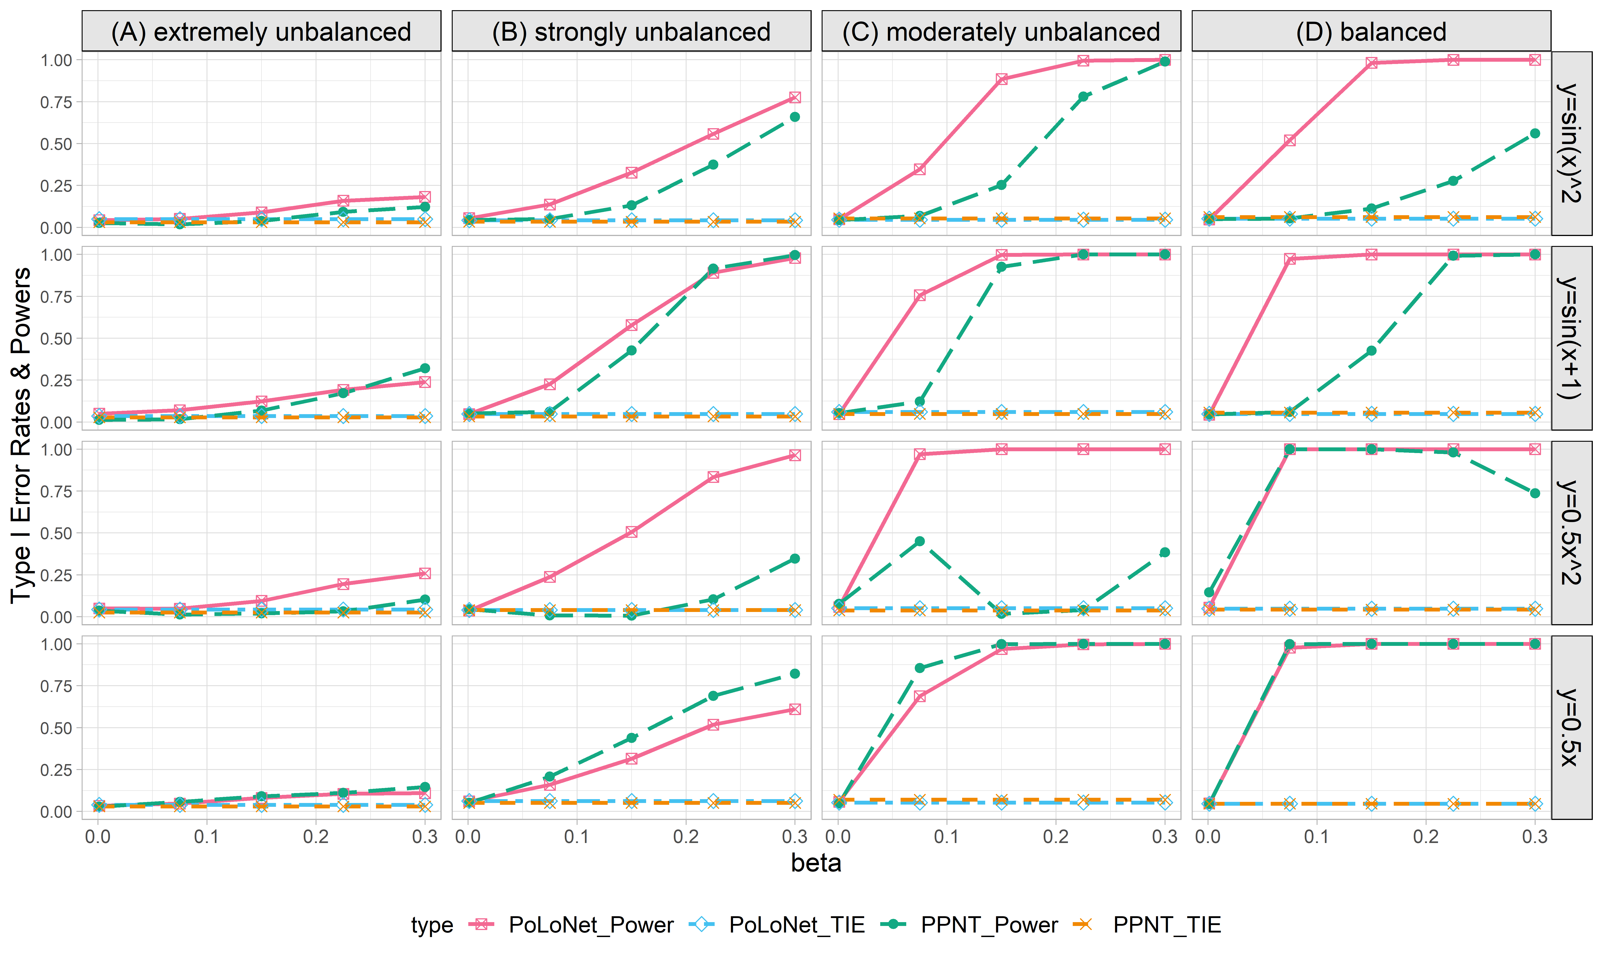

**Figure S9. Empirical type I error rates and powers for detecting the effect of the edge for the binary trait under the setting that both node and edge have effects, with the node hanging on the edge (n=5000), with DPR as gene expression prediction model in TWAS.** The significance level is α=0.05. Simulations are conducted with 4 different between-node correlation patterns (the recombination of quadratic and sine, sine, quadratic, linear) and 5 different effect sizes (0.001, 0.075, 0.15, 0.225, 0.3). (A) extremely unbalanced (1:999) ; (B) strongly unbalanced (99:1); (C)moderately unbalanced (1:9); (D) balanced (1:1)).

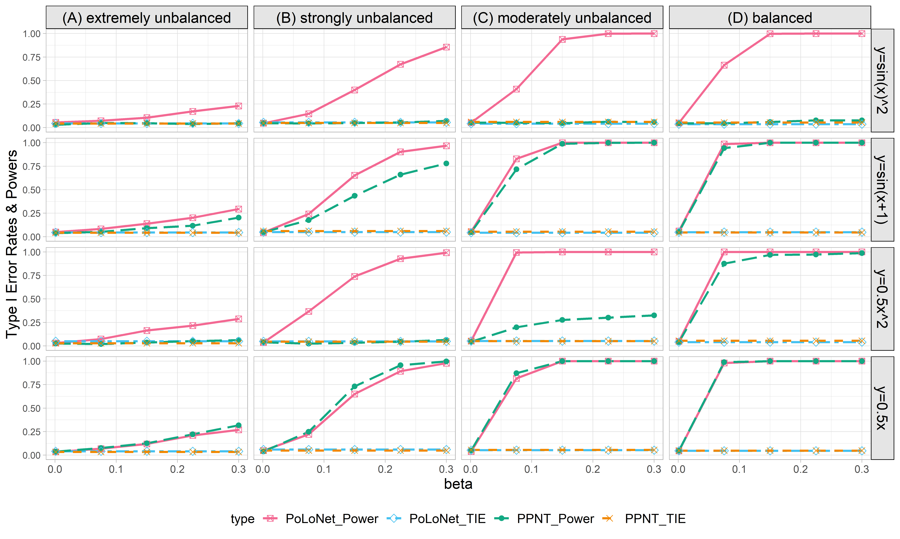

**Figure S10. Empirical type I error rates and powers for detecting the effect of the edge for the binary trait under the setting that both node and edge have effects, with the node not hanging on the edge (n=5000), with DPR as gene expression prediction model in TWAS.** The significance level is α=0.05. Simulations are conducted with 4 different between-node correlation patterns (the recombination of quadratic and sine, sine, quadratic, linear) and 5 different effect sizes (0.001, 0.075, 0.15, 0.225, 0.3). (A) extremely unbalanced (1:999) ; (B) strongly unbalanced (99:1); (C)moderately unbalanced (1:9); (D) balanced (1:1)).

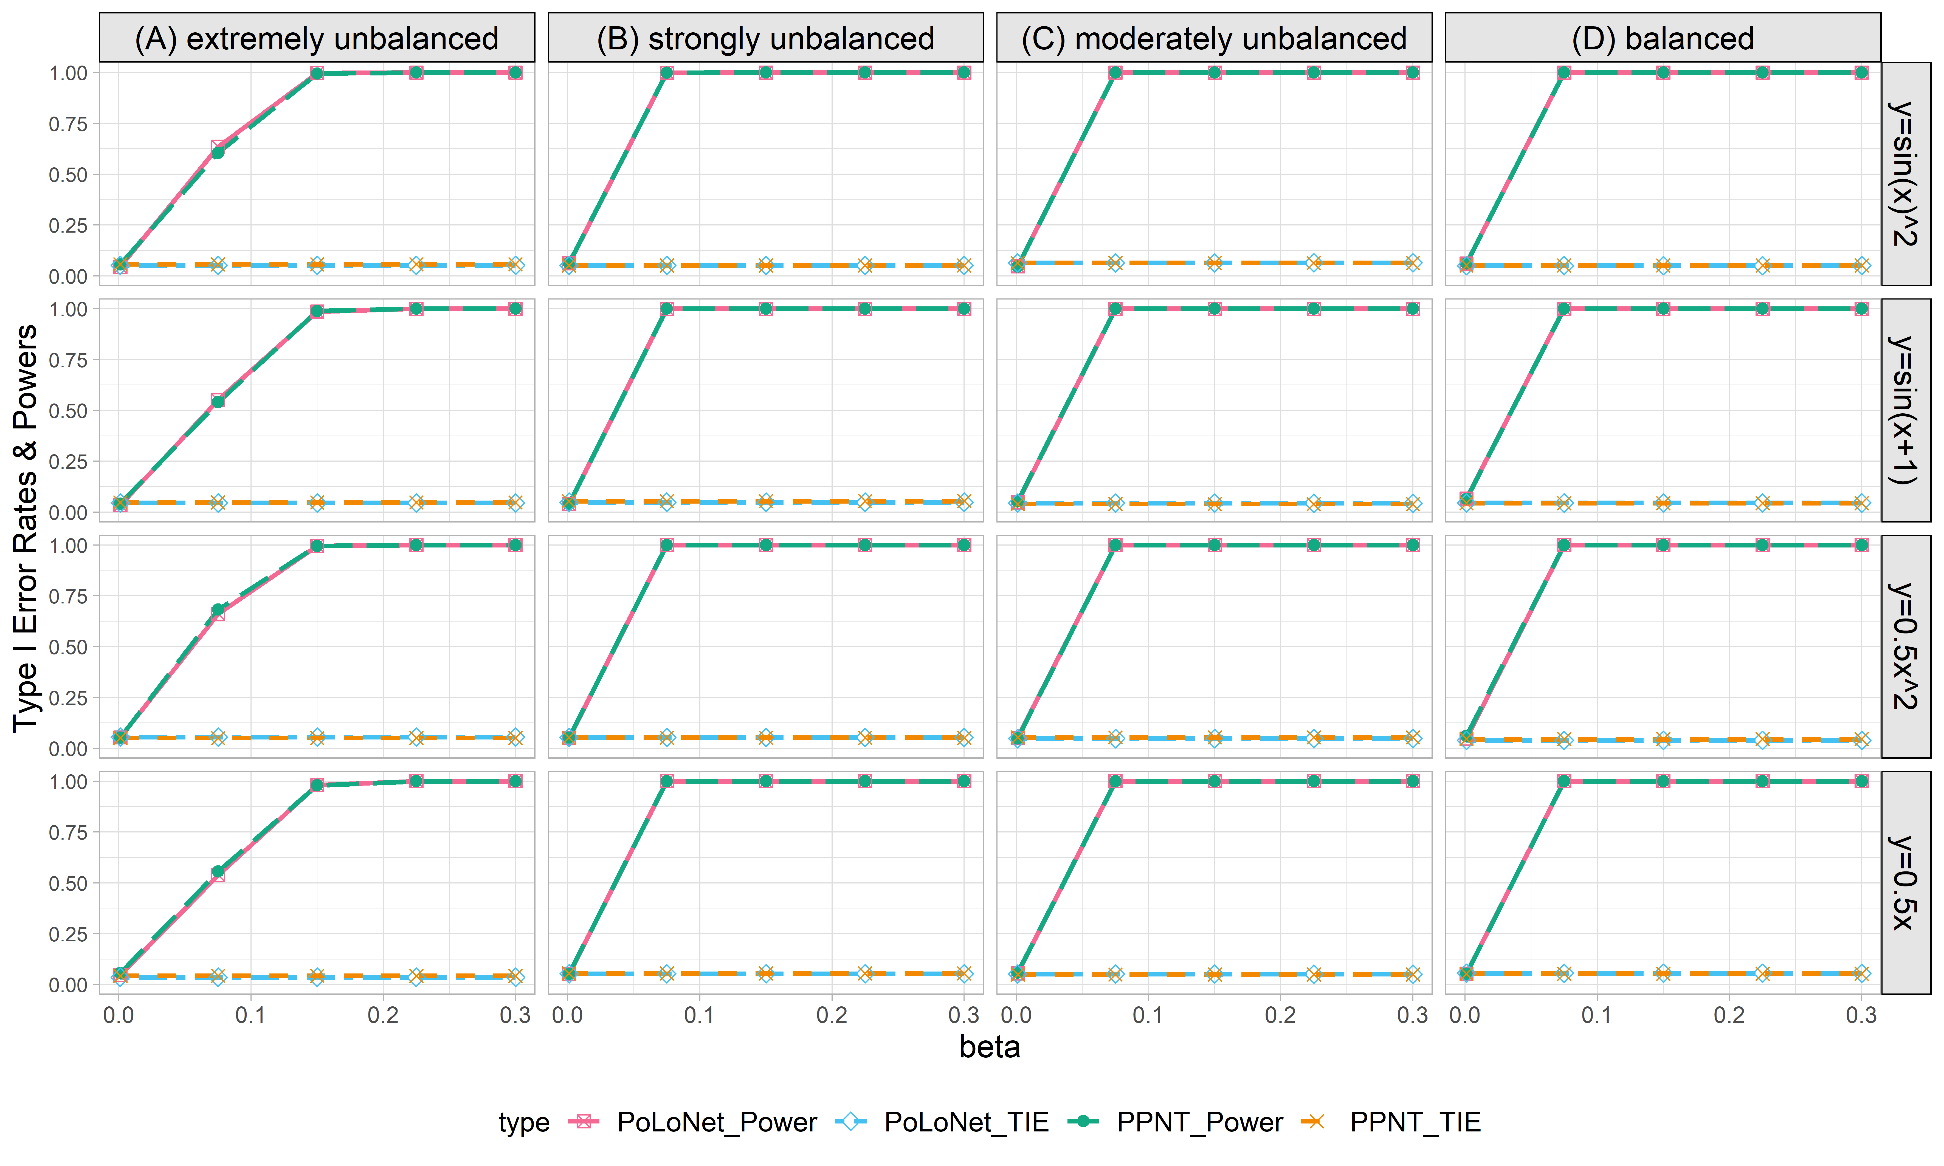

**Figure S11. Empirical type I error rates and powers for detecting the effect of the node for the binary trait under the setting that only node has an effect (n=20000), with DPR as gene expression prediction model in TWAS.** The significance level is α=0.05. Simulations are conducted with 4 different between-node correlation patterns (the recombination of quadratic and sine, sine, quadratic, linear) and 5 different effect sizes (0.001, 0.075, 0.15, 0.225, 0.3). (A) extremely unbalanced (1:999) ; (B) strongly unbalanced (99:1); (C)moderately unbalanced (1:9); (D) balanced (1:1)).

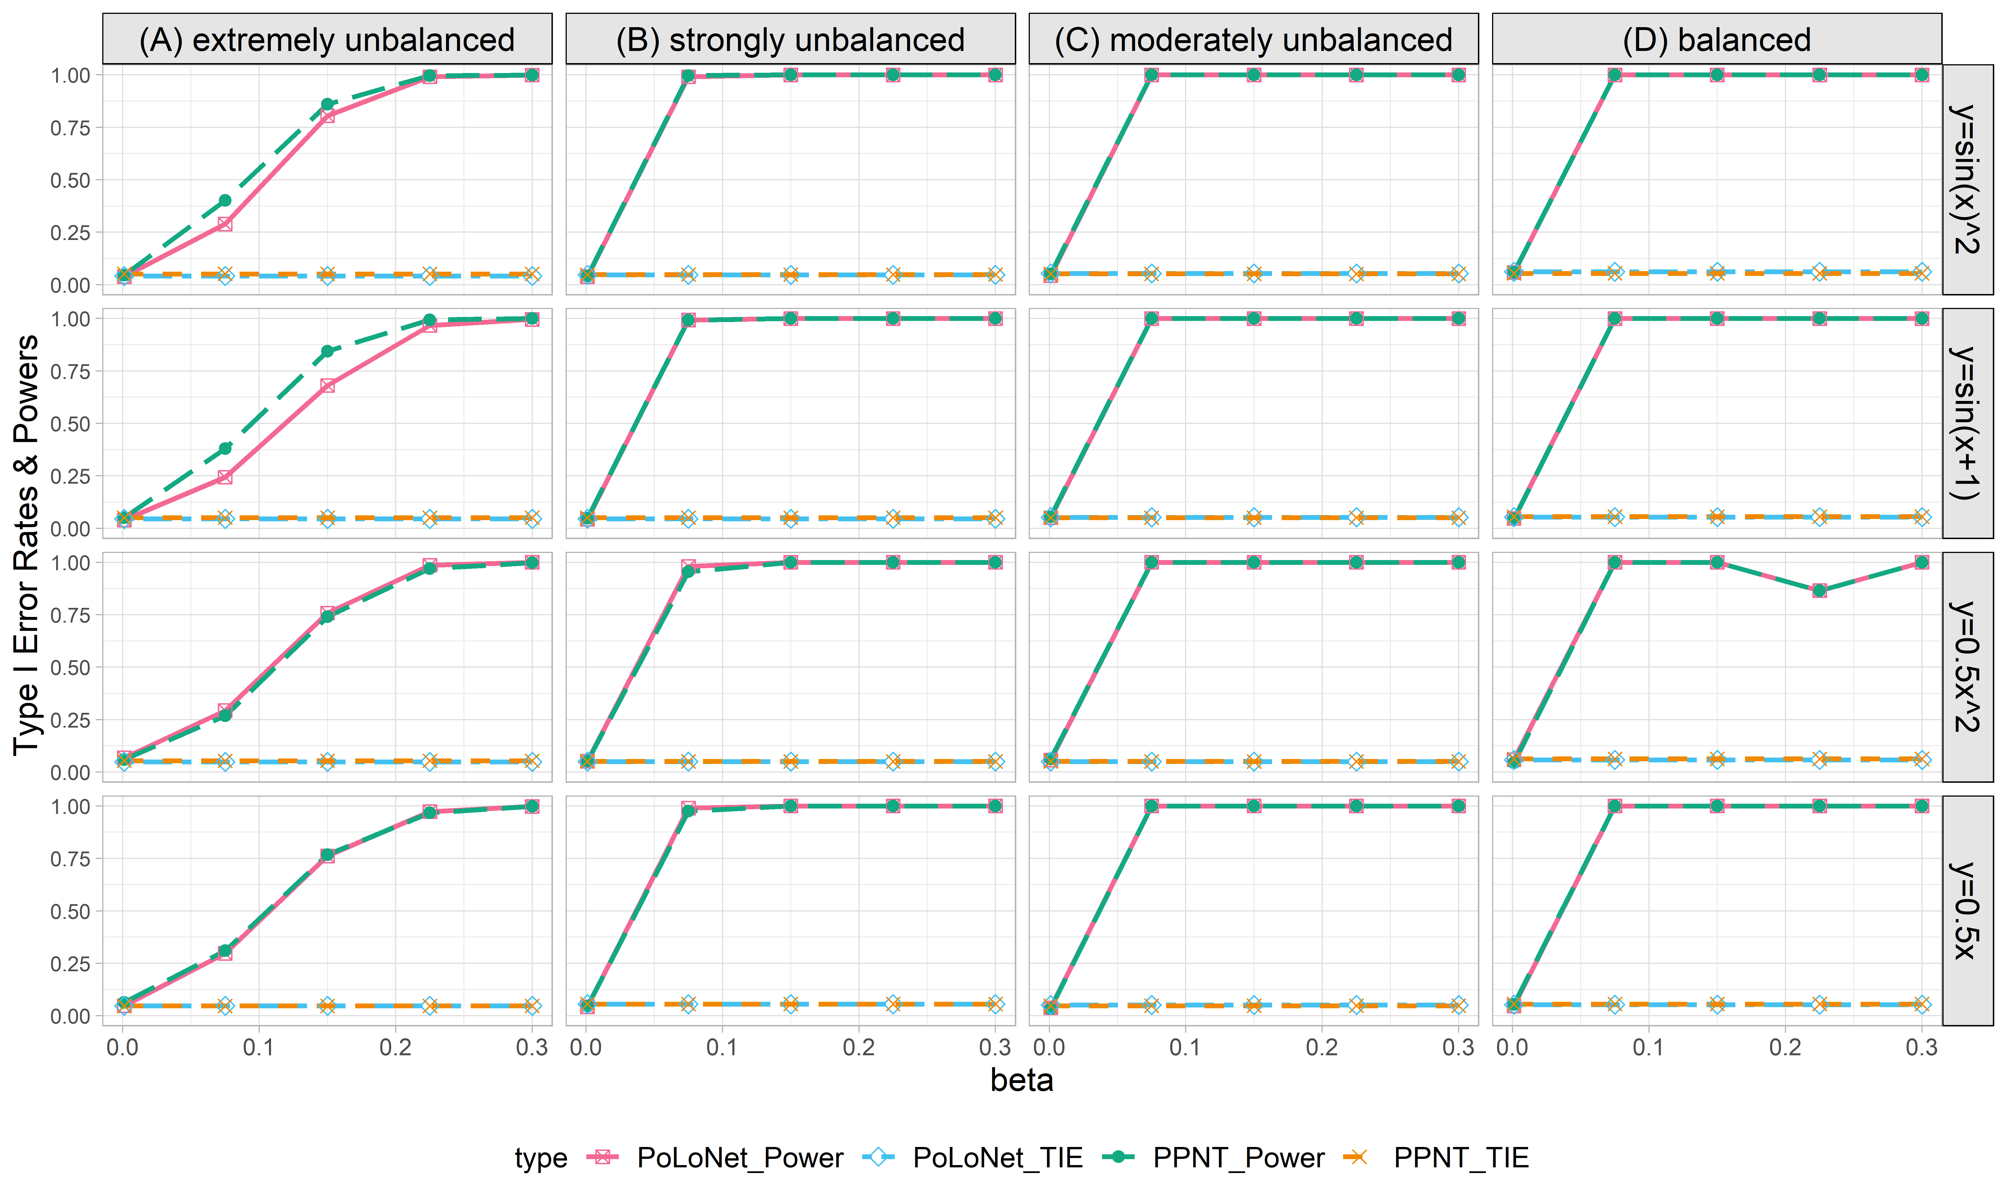

**Figure S12. Empirical type I error rates and powers for detecting the effect of the node for the binary trait under the setting that both node and edge have effects, with the node hanging on the edge (n=20000), with DPR as gene expression prediction model in TWAS.** The significance level is α=0.05. Simulations are conducted with 4 different between-node correlation patterns (the recombination of quadratic and sine, sine, quadratic, linear) and 5 different effect sizes (0.001, 0.075, 0.15, 0.225, 0.3). (A) extremely unbalanced (1:999) ; (B) strongly unbalanced (99:1); (C)moderately unbalanced (1:9); (D) balanced (1:1)).

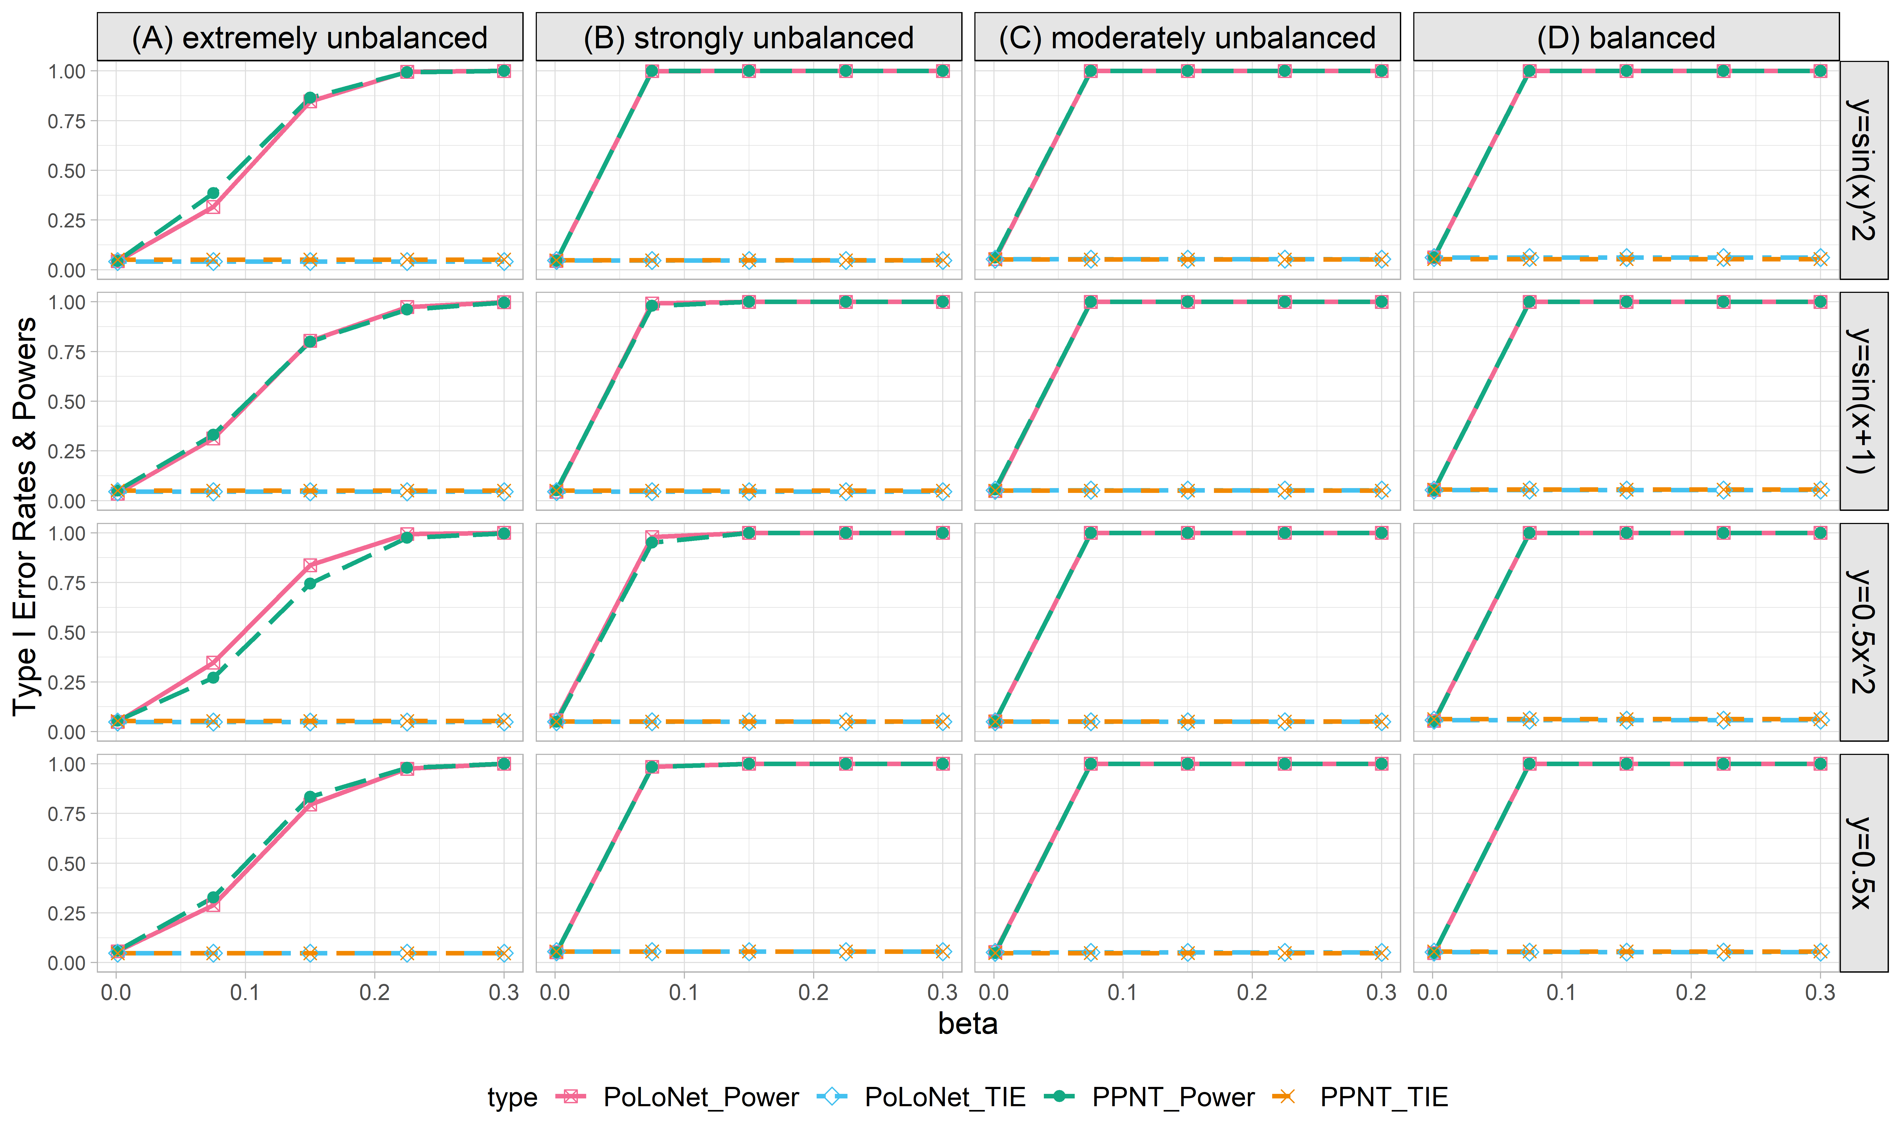

**Figure S13. Empirical type I error rates and powers for detecting the effect of the node for the binary trait under the setting that both node and edge have effects, with the node not hanging on the edge (n=20000), with DPR as gene expression prediction model in TWAS.** The significance level is α=0.05. Simulations are conducted with 4 different between-node correlation patterns (the recombination of quadratic and sine, sine, quadratic, linear) and 5 different effect sizes (0.001, 0.075, 0.15, 0.225, 0.3). (A) extremely unbalanced (1:999) ; (B) strongly unbalanced (99:1); (C)moderately unbalanced (1:9); (D) balanced (1:1)).

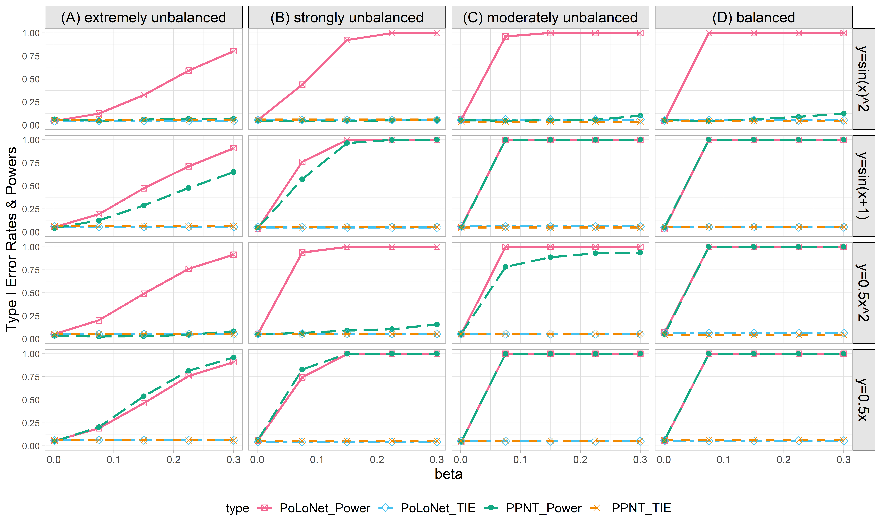

**Figure S14. Empirical type I error rates and powers for detecting the effect of the edge for the binary trait under the setting that only the edge has an effect (n=20000), with DPR as the gene expression prediction model in TWAS.** The significance level is α=0.05. Simulations are conducted with 4 different between-node correlation patterns (the recombination of quadratic and sine, sine, quadratic, linear) and 5 different effect sizes (0.001, 0.075, 0.15, 0.225, 0.3). (A) extremely unbalanced (1:999) ; (B) strongly unbalanced (99:1); (C)moderately unbalanced (1:9); (D) balanced (1:1)).

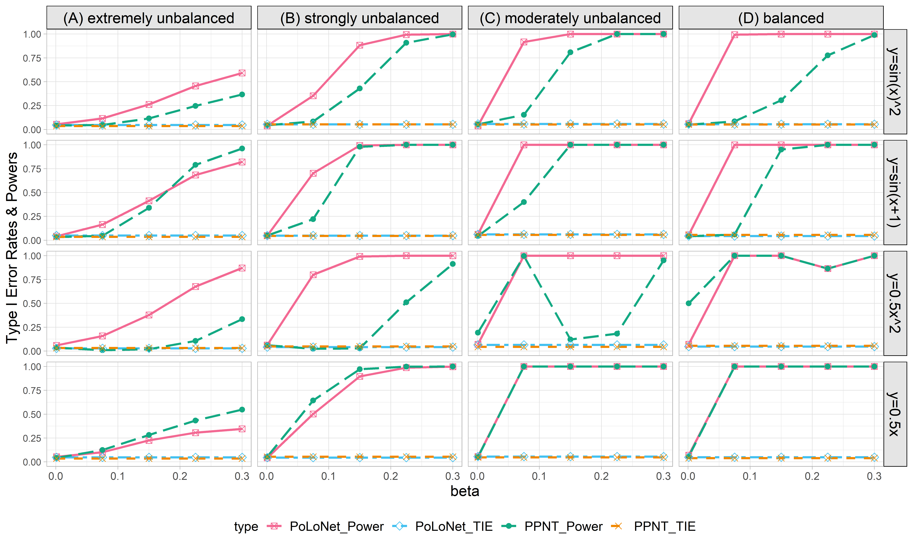

**Figure S15. Empirical type I error rates and powers for detecting the effect of the edge for the binary trait under the setting that both node and edge have effects, with the node hanging on the edge (n=20000), with DPR as gene expression prediction model in TWAS.** The significance level is α=0.05. Simulations are conducted with 4 different between-node correlation patterns (the recombination of quadratic and sine, sine, quadratic, linear) and 5 different effect sizes (0.001, 0.075, 0.15, 0.225, 0.3). (A) extremely unbalanced (1:999) ; (B) strongly unbalanced (99:1); (C)moderately unbalanced (1:9); (D) balanced (1:1)).

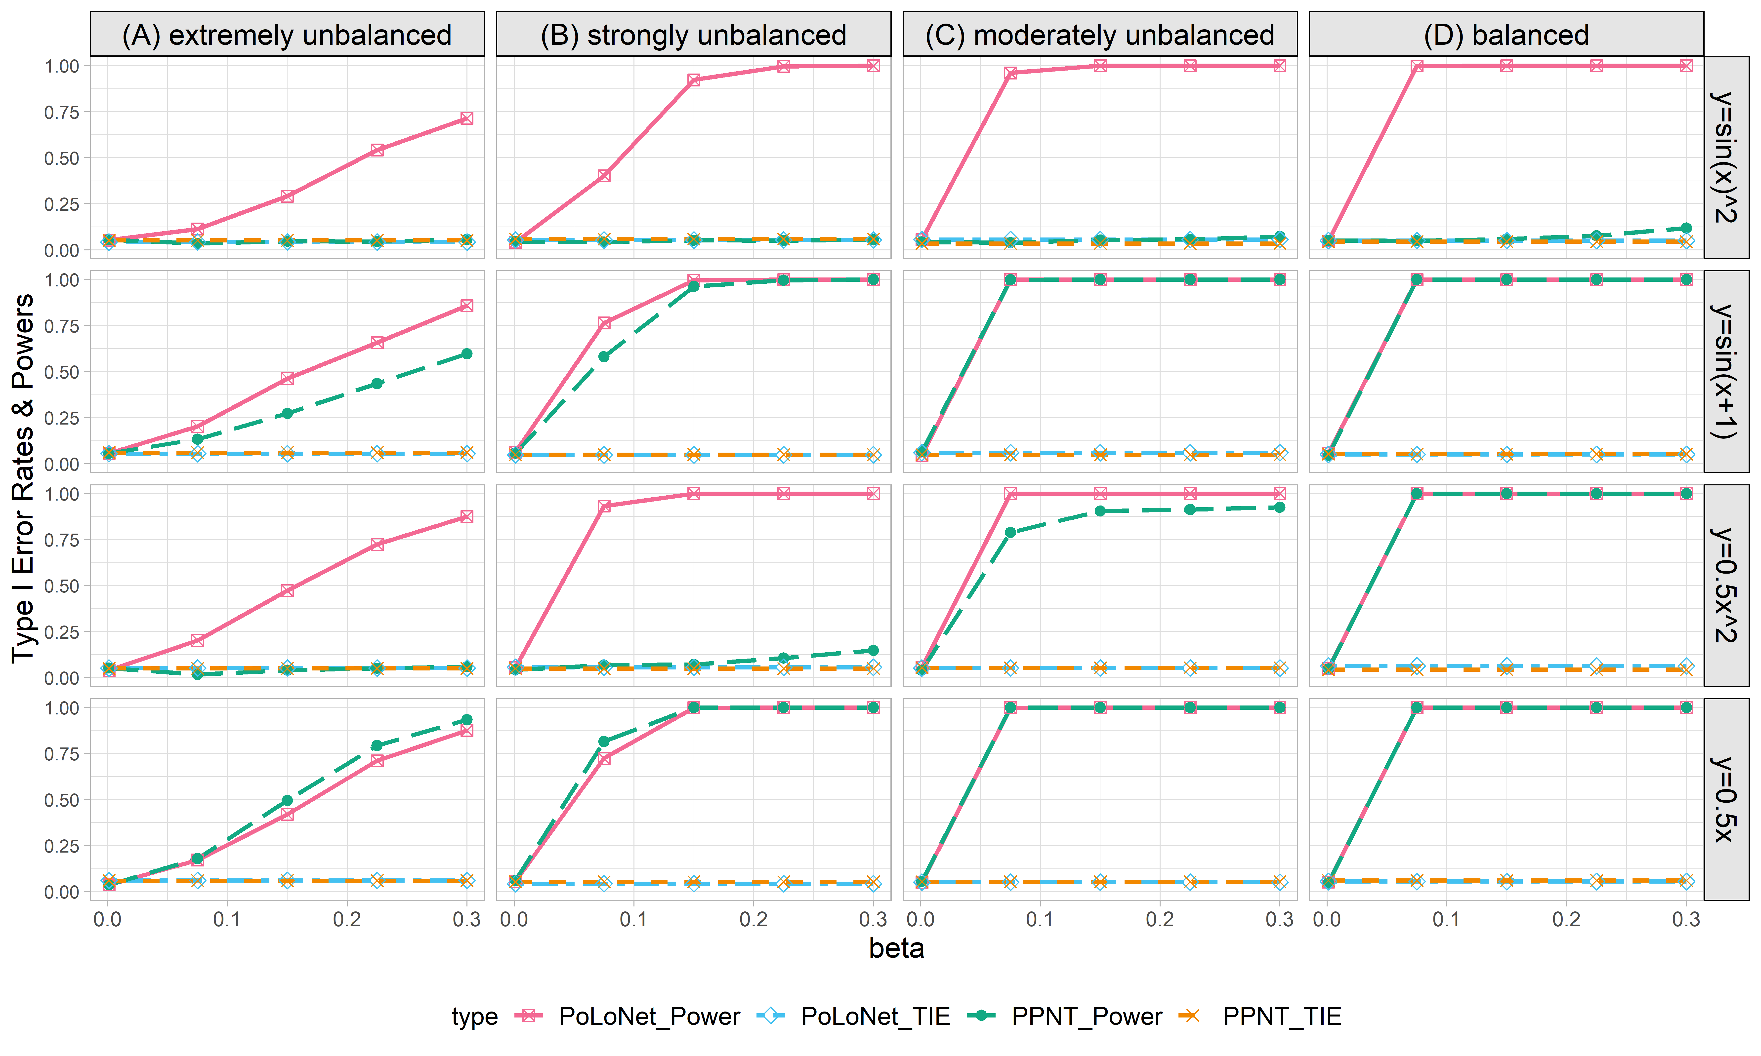

**Figure S16. Empirical type I error rates and powers for detecting the effect of the edge for the binary trait under the setting that both node and edge have effects, with the node not hanging on the edge (n=20000), with DPR as gene expression prediction model in TWAS.** The significance level is α=0.05. Simulations are conducted with 4 different between-node correlation patterns (the recombination of quadratic and sine, sine, quadratic, linear) and 5 different effect sizes (0.001, 0.075, 0.15, 0.225, 0.3). (A) extremely unbalanced (1:999) ; (B) strongly unbalanced (99:1); (C)moderately unbalanced (1:9); (D) balanced (1:1)).

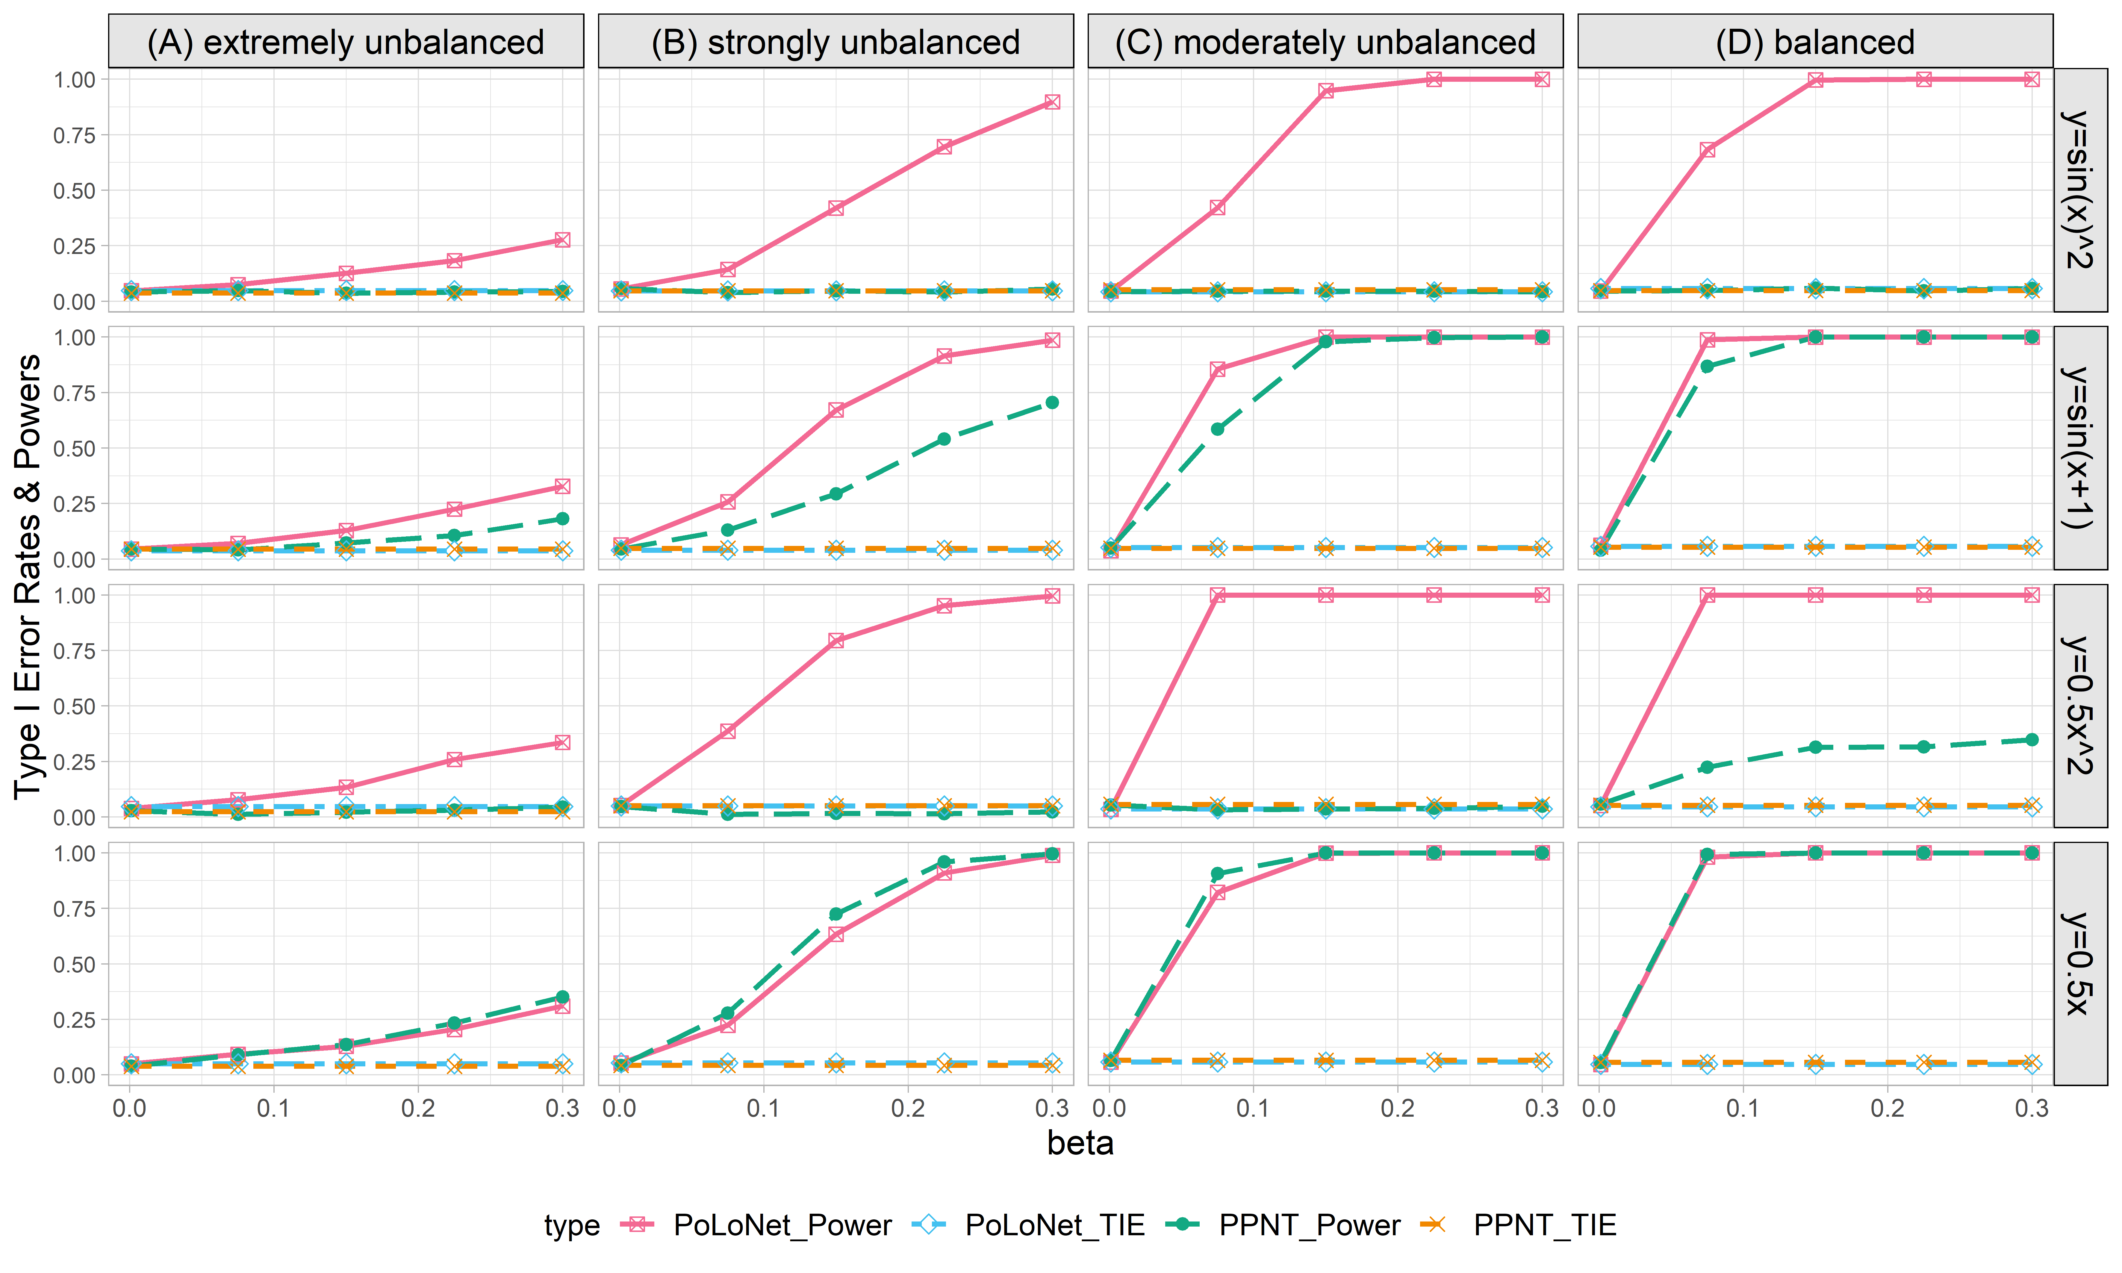

**Figure S17. Empirical type I error rates and powers for detecting the effect of the edge for the binary trait under the setting that only edge has an effects (n=5000), with BSLMM as gene expression prediction model in TWAS.** The significance level is α=0.05. Simulations are conducted with 4 different between-node correlation patterns (the recombination of quadratic and sine, sine, quadratic, linear) and 5 different effect sizes (0.001, 0.075, 0.15, 0.225, 0.3). (A) extremely unbalanced (1:999) ; (B) strongly unbalanced (99:1); (C)moderately unbalanced (1:9); (D) balanced (1:1)).

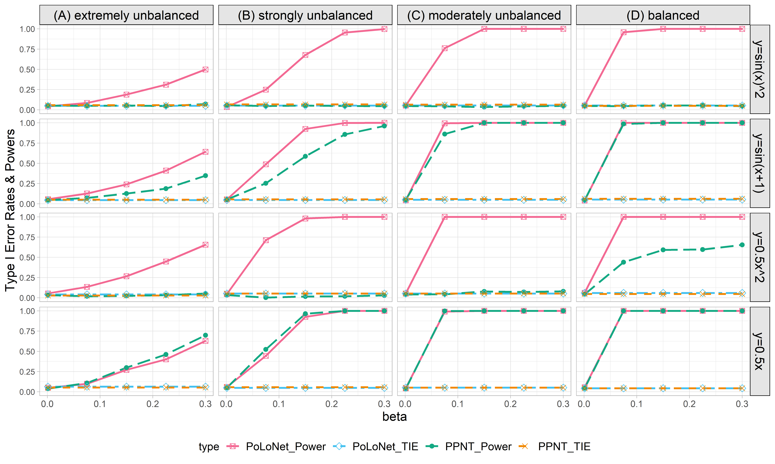

**Figure S18. Empirical type I error rates and powers for detecting the effect of the edge for the binary trait under the setting that only the edge has an effect (n=10000), with BSLMM as gene expression prediction model in TWAS.** The significance level is α=0.05. Simulations are conducted with 4 different between-node correlation patterns (the recombination of quadratic and sine, sine, quadratic, linear) and 5 different effect sizes (0.001, 0.075, 0.15, 0.225, 0.3). (A) extremely unbalanced (1:999) ; (B) strongly unbalanced (99:1); (C)moderately unbalanced (1:9); (D) balanced (1:1)).

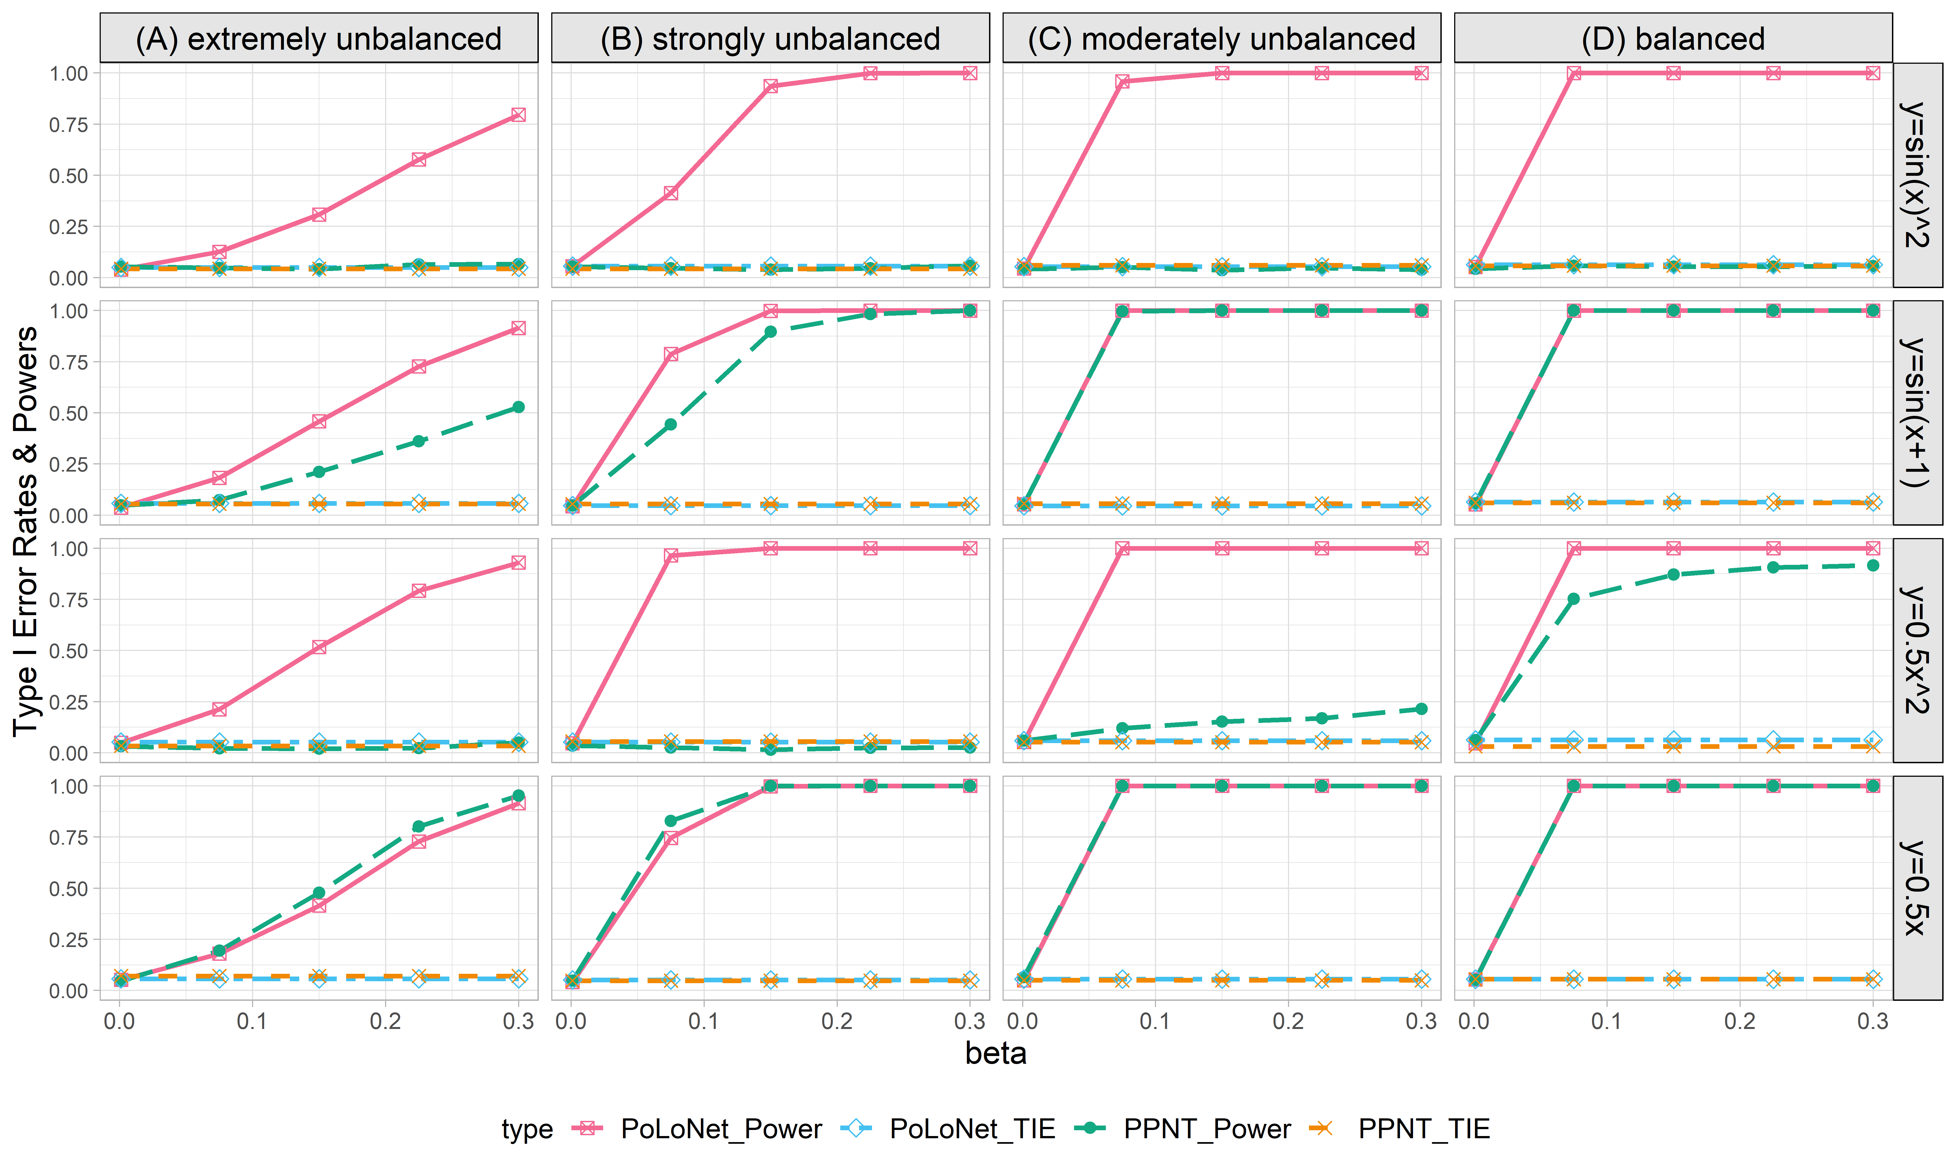

**Figure S19. Empirical type I error rates and powers for detecting the effect of the edge for the binary trait under the setting that only the edge has an effect (n=20000), with BSLMM as gene expression prediction model in TWAS.** The significance level is α=0.05. Simulations are conducted with 4 different between-node correlation patterns (the recombination of quadratic and sine, sine, quadratic, linear) and 5 different effect sizes (0.001, 0.075, 0.15, 0.225, 0.3). (A) extremely unbalanced (1:999) ; (B) strongly unbalanced (99:1); (C)moderately unbalanced (1:9); (D) balanced (1:1)).

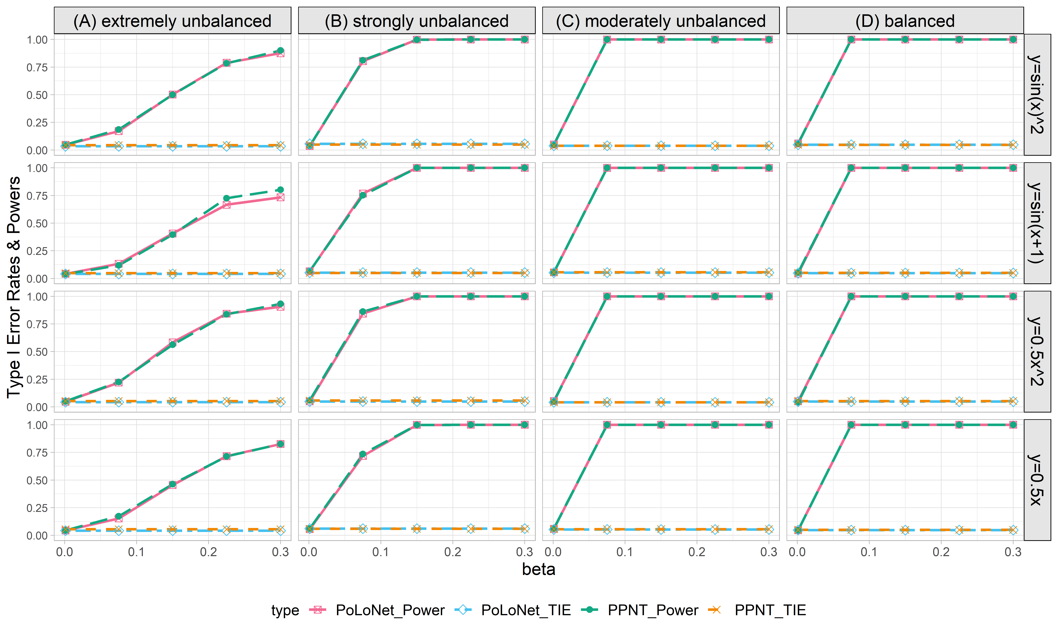

**Figure S20. Empirical type I error rates and powers for detecting the effect of the node for the binary trait under the setting that only the node has an effect (n=5000), with BSLMM as gene expression prediction model in TWAS.** The significance level is α=0.05. Simulations are conducted with 4 different between-node correlation patterns (the recombination of quadratic and sine, sine, quadratic, linear) and 5 different effect sizes (0.001, 0.075, 0.15, 0.225, 0.3). (A) extremely unbalanced (1:999) ; (B) strongly unbalanced (99:1); (C)moderately unbalanced (1:9); (D) balanced (1:1)).

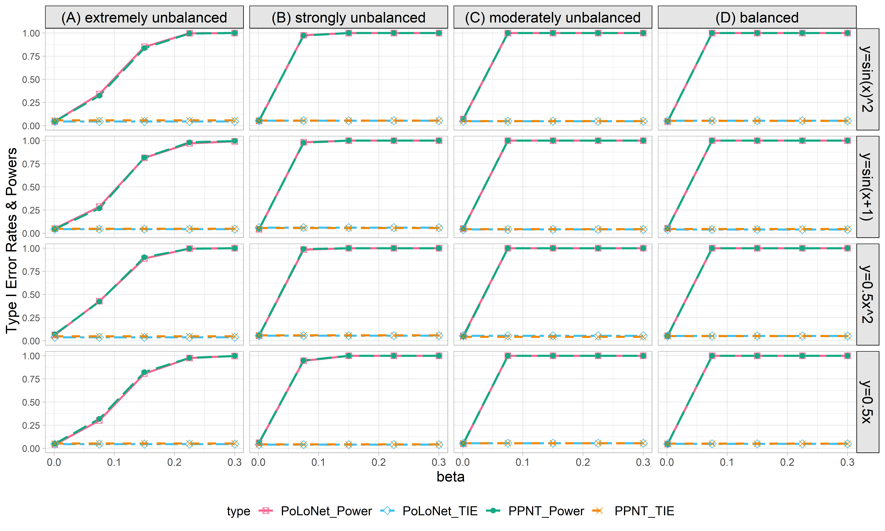

**Figure S21. Empirical type I error rates and powers for detecting the effect of the node for the binary trait under the setting that only the node has an effect (n=10000), with BSLMM as gene expression prediction model in TWAS.** The significance level is α=0.05. Simulations are conducted with 4 different between-node correlation patterns (the recombination of quadratic and sine, sine, quadratic, linear) and 5 different effect sizes (0.001, 0.075, 0.15, 0.225, 0.3). (A) extremely unbalanced (1:999) ; (B) strongly unbalanced (99:1); (C)moderately unbalanced (1:9); (D) balanced (1:1)).

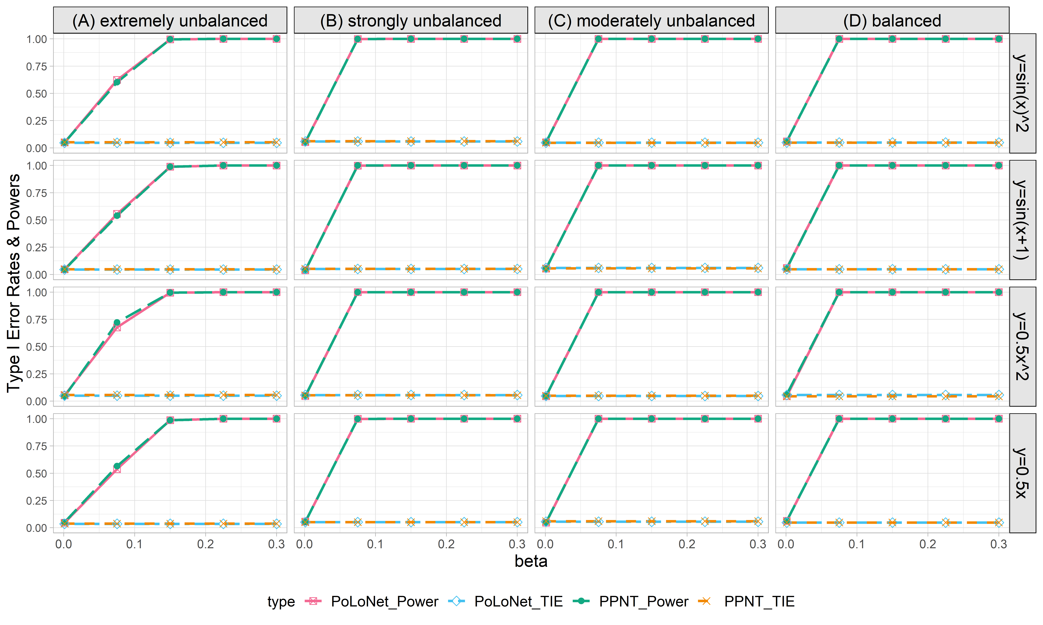

**Figure S22. Empirical type I error rates and powers for detecting the effect of the node for the binary trait under the setting that only the node has an effects (n=20000), with BSLMM as gene expression prediction model in TWAS.** The significance level is α=0.05. Simulations are conducted with 4 different between-node correlation patterns (the recombination of quadratic and sine, sine, quadratic, linear) and 5 different effect sizes (0.001, 0.075, 0.15, 0.225, 0.3). (A) extremely unbalanced (1:999) ; (B) strongly unbalanced (99:1); (C)moderately unbalanced (1:9); (D) balanced (1:1)).

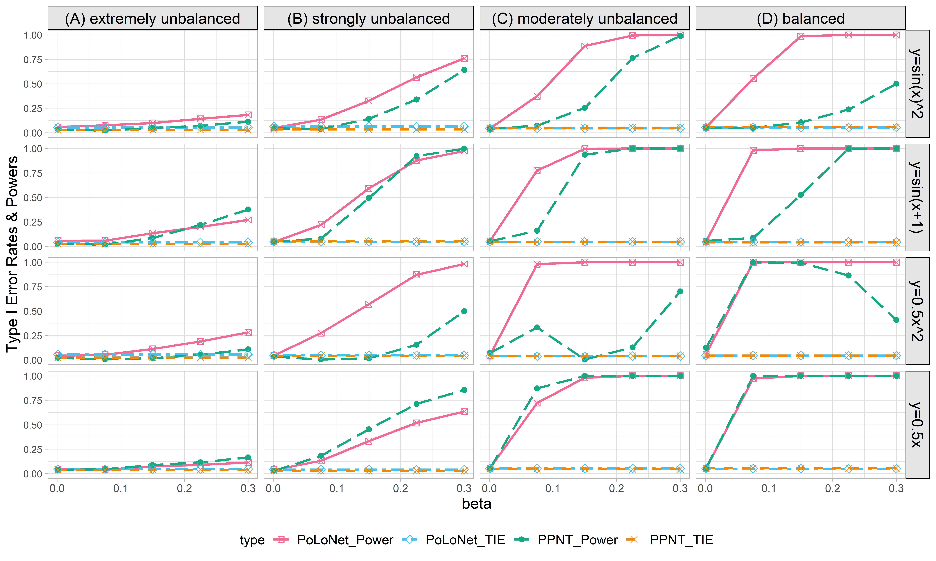

**Figure S23. Empirical type I error rates and powers for detecting the effect of the edge for the binary trait under the setting that both node and edge have effects, with the node hanging on the edge (n=5000), with BSLMM as gene expression prediction model in TWAS.** The significance level is α=0.05. Simulations are conducted with 4 different between-node correlation patterns (the recombination of quadratic and sine, sine, quadratic, linear) and 5 different effect sizes (0.001, 0.075, 0.15, 0.225, 0.3). (A) extremely unbalanced (1:999) ; (B) strongly unbalanced (99:1); (C)moderately unbalanced (1:9); (D) balanced (1:1)).

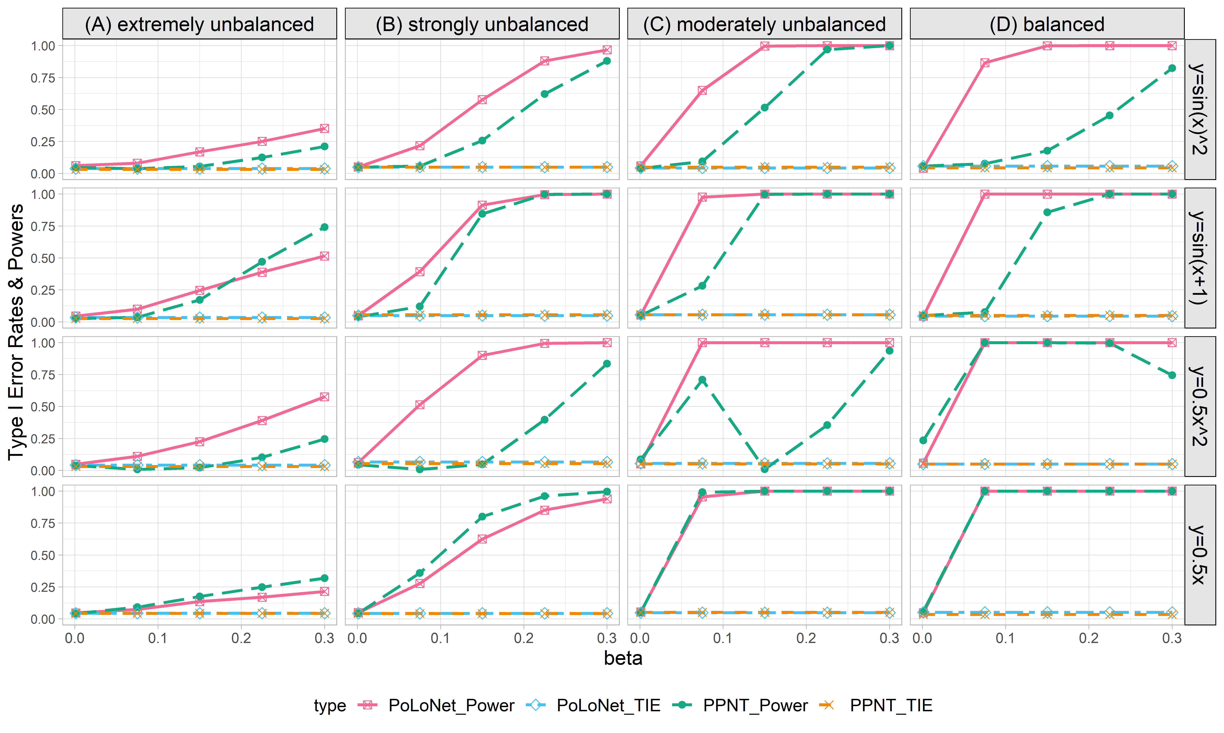

**Figure S24. Empirical type I error rates and powers for detecting the effect of the edge for the binary trait under the setting that both node and edge have effects, with the node hanging on the edge (n=10000), with BSLMM as gene expression prediction model in TWAS.** The significance level is α=0.05. Simulations are conducted with 4 different between-node correlation patterns (the recombination of quadratic and sine, sine, quadratic, linear) and 5 different effect sizes (0.001, 0.075, 0.15, 0.225, 0.3). (A) extremely unbalanced (1:999) ; (B) strongly unbalanced (99:1); (C)moderately unbalanced (1:9); (D) balanced (1:1)).

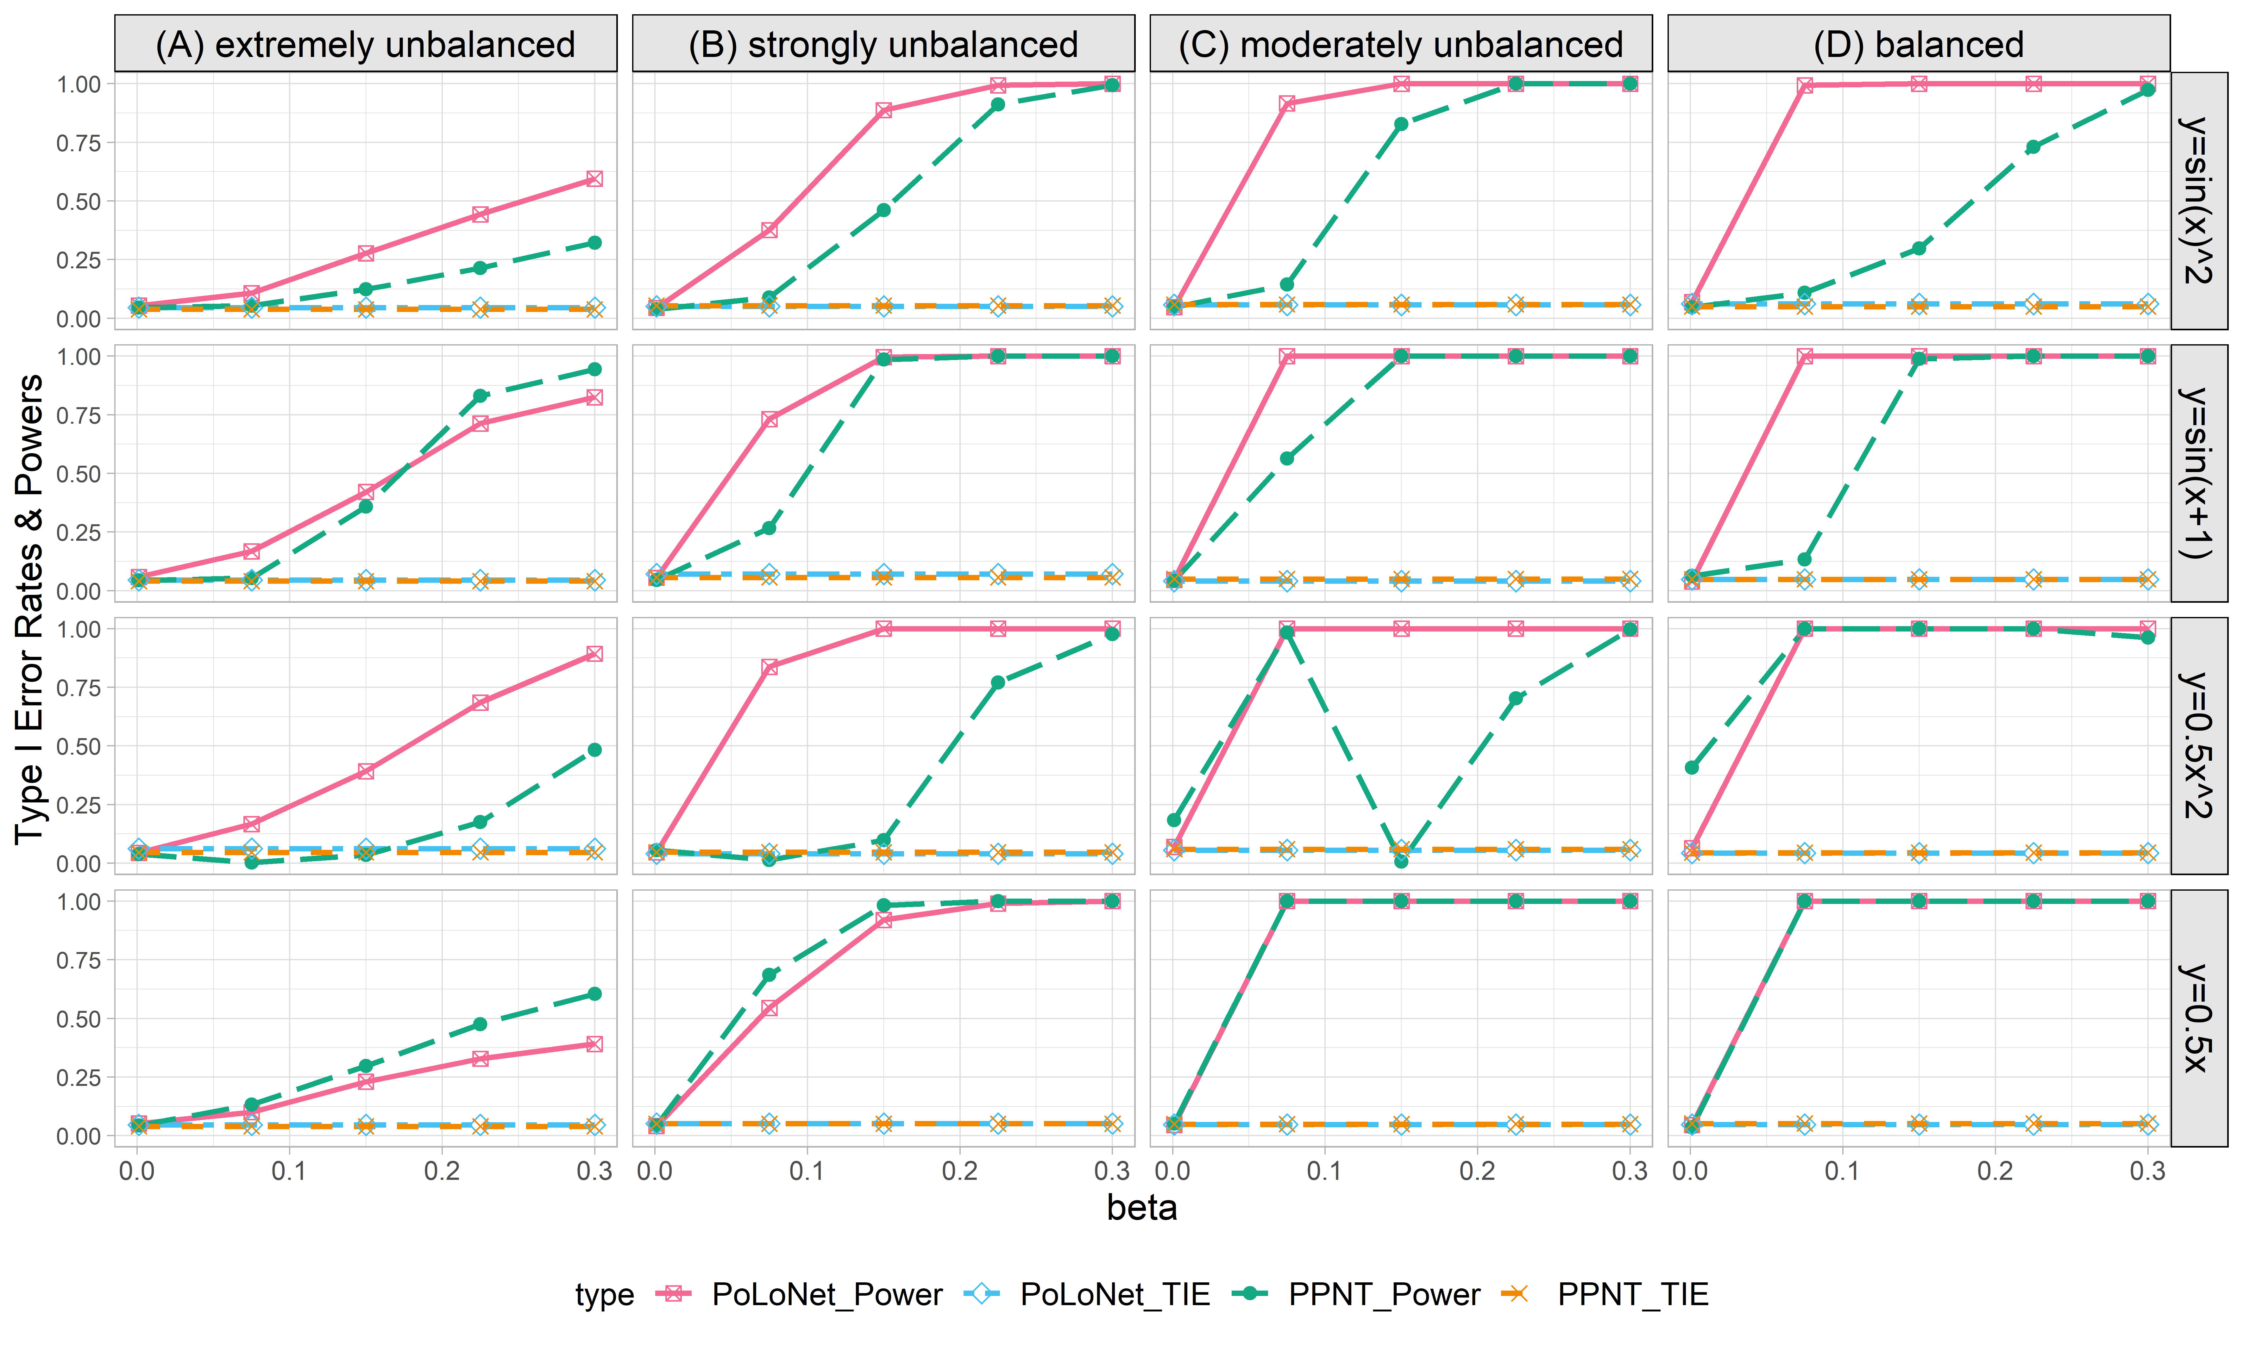

**Figure S25. Empirical type I error rates and powers for detecting the effect of the edge for the binary trait under the setting that both node and edge have effects, with the node hanging on the edge (n=20000), with BSLMM as gene expression prediction model in TWAS.** The significance level is α=0.05. Simulations are conducted with 4 different between-node correlation patterns (the recombination of quadratic and sine, sine, quadratic, linear) and 5 different effect sizes (0.001, 0.075, 0.15, 0.225, 0.3). (A) extremely unbalanced (1:999) ; (B) strongly unbalanced (99:1); (C)moderately unbalanced (1:9); (D) balanced (1:1)).

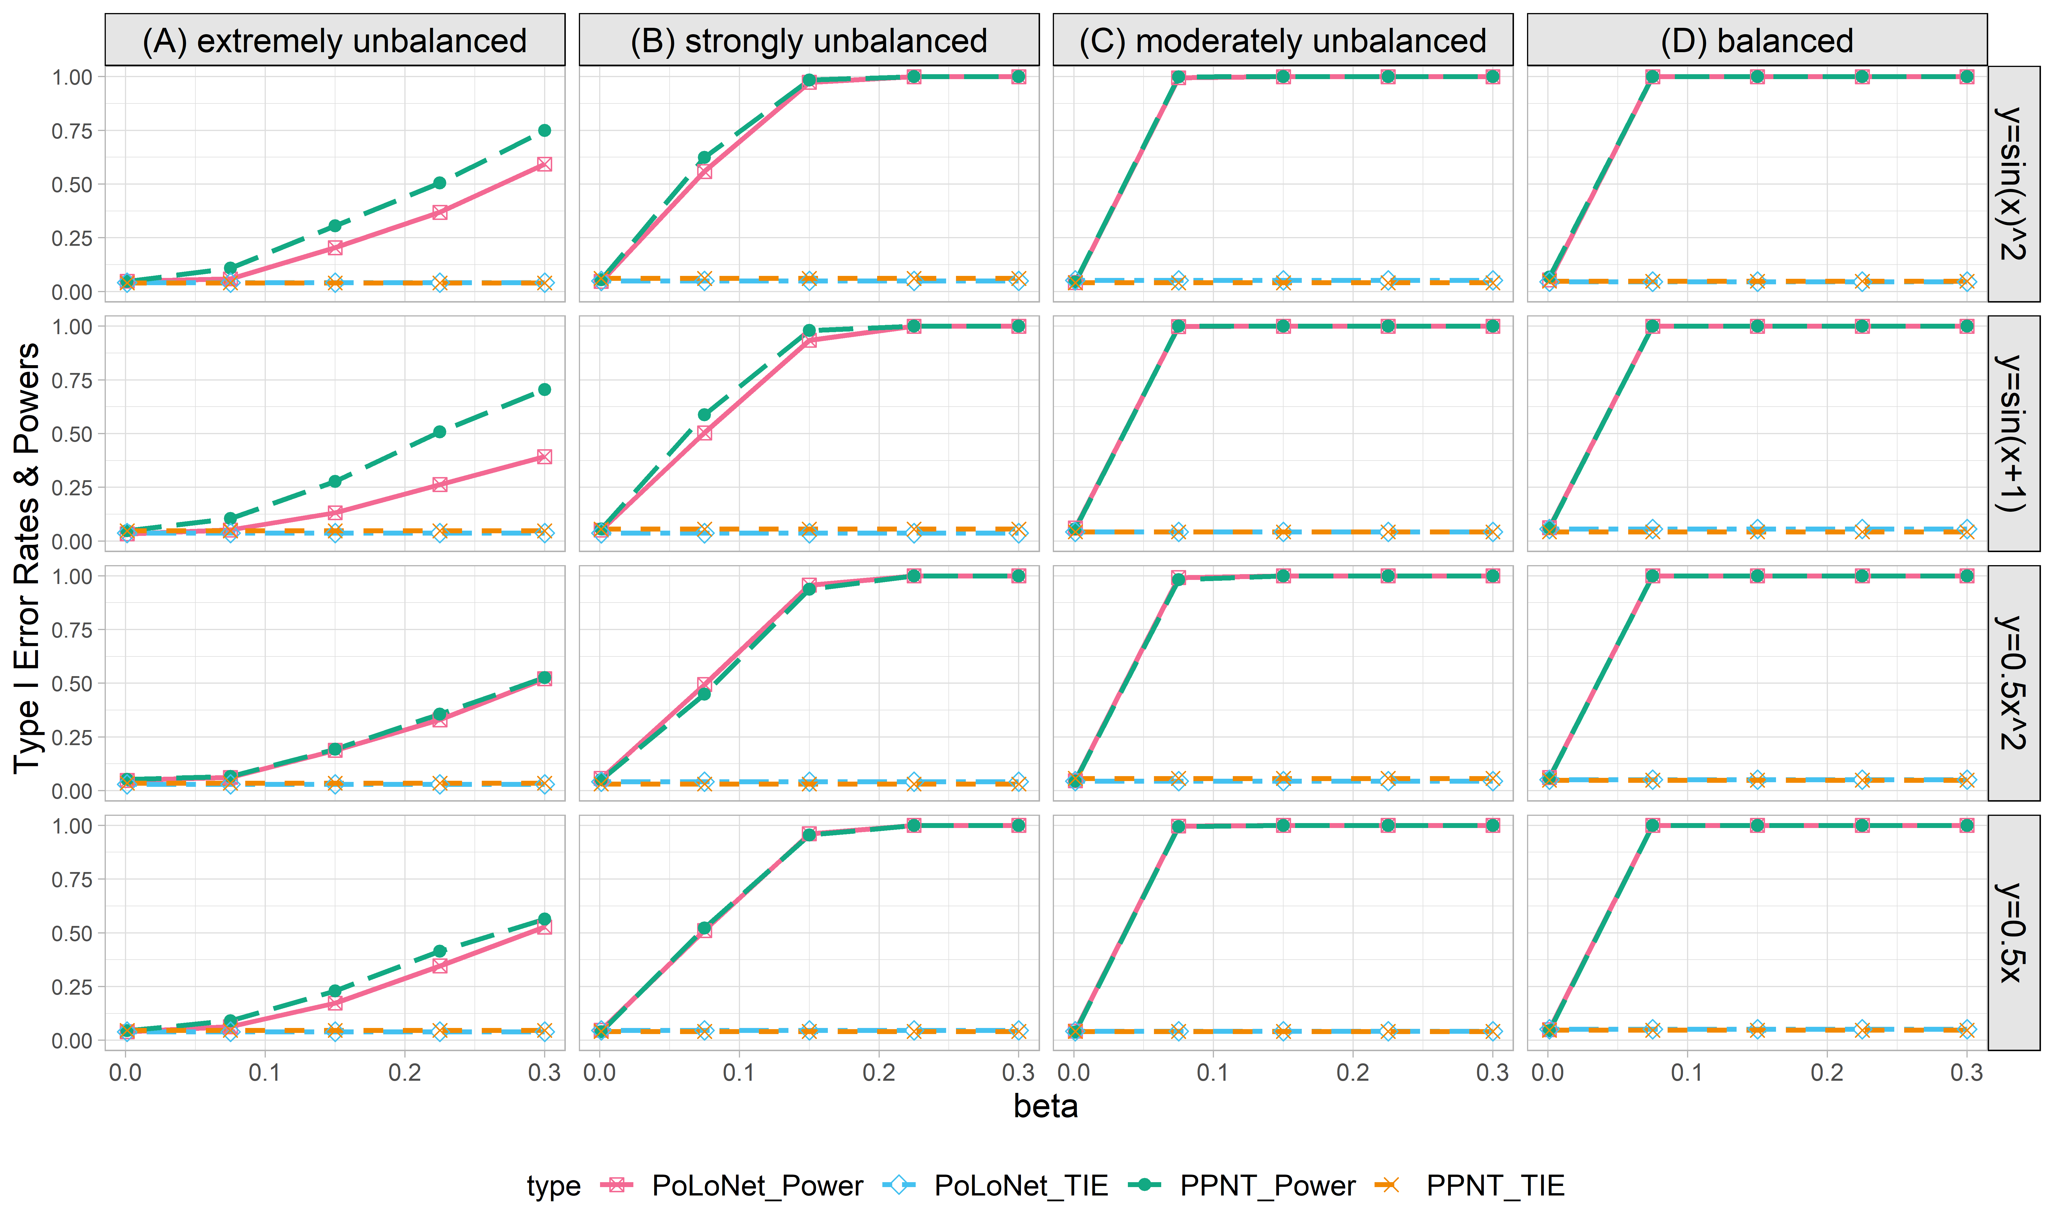

**Figure S26. Empirical type I error rates and powers for detecting the effect of the node for the binary trait under the setting that both node and edge have effects, with the node hanging on the edge (n=5000), with BSLMM as gene expression prediction model in TWAS.** The significance level is α=0.05. Simulations are conducted with 4 different between-node correlation patterns (the recombination of quadratic and sine, sine, quadratic, linear) and 5 different effect sizes (0.001, 0.075, 0.15, 0.225, 0.3). (A) extremely unbalanced (1:999) ; (B) strongly unbalanced (99:1); (C)moderately unbalanced (1:9); (D) balanced (1:1)).

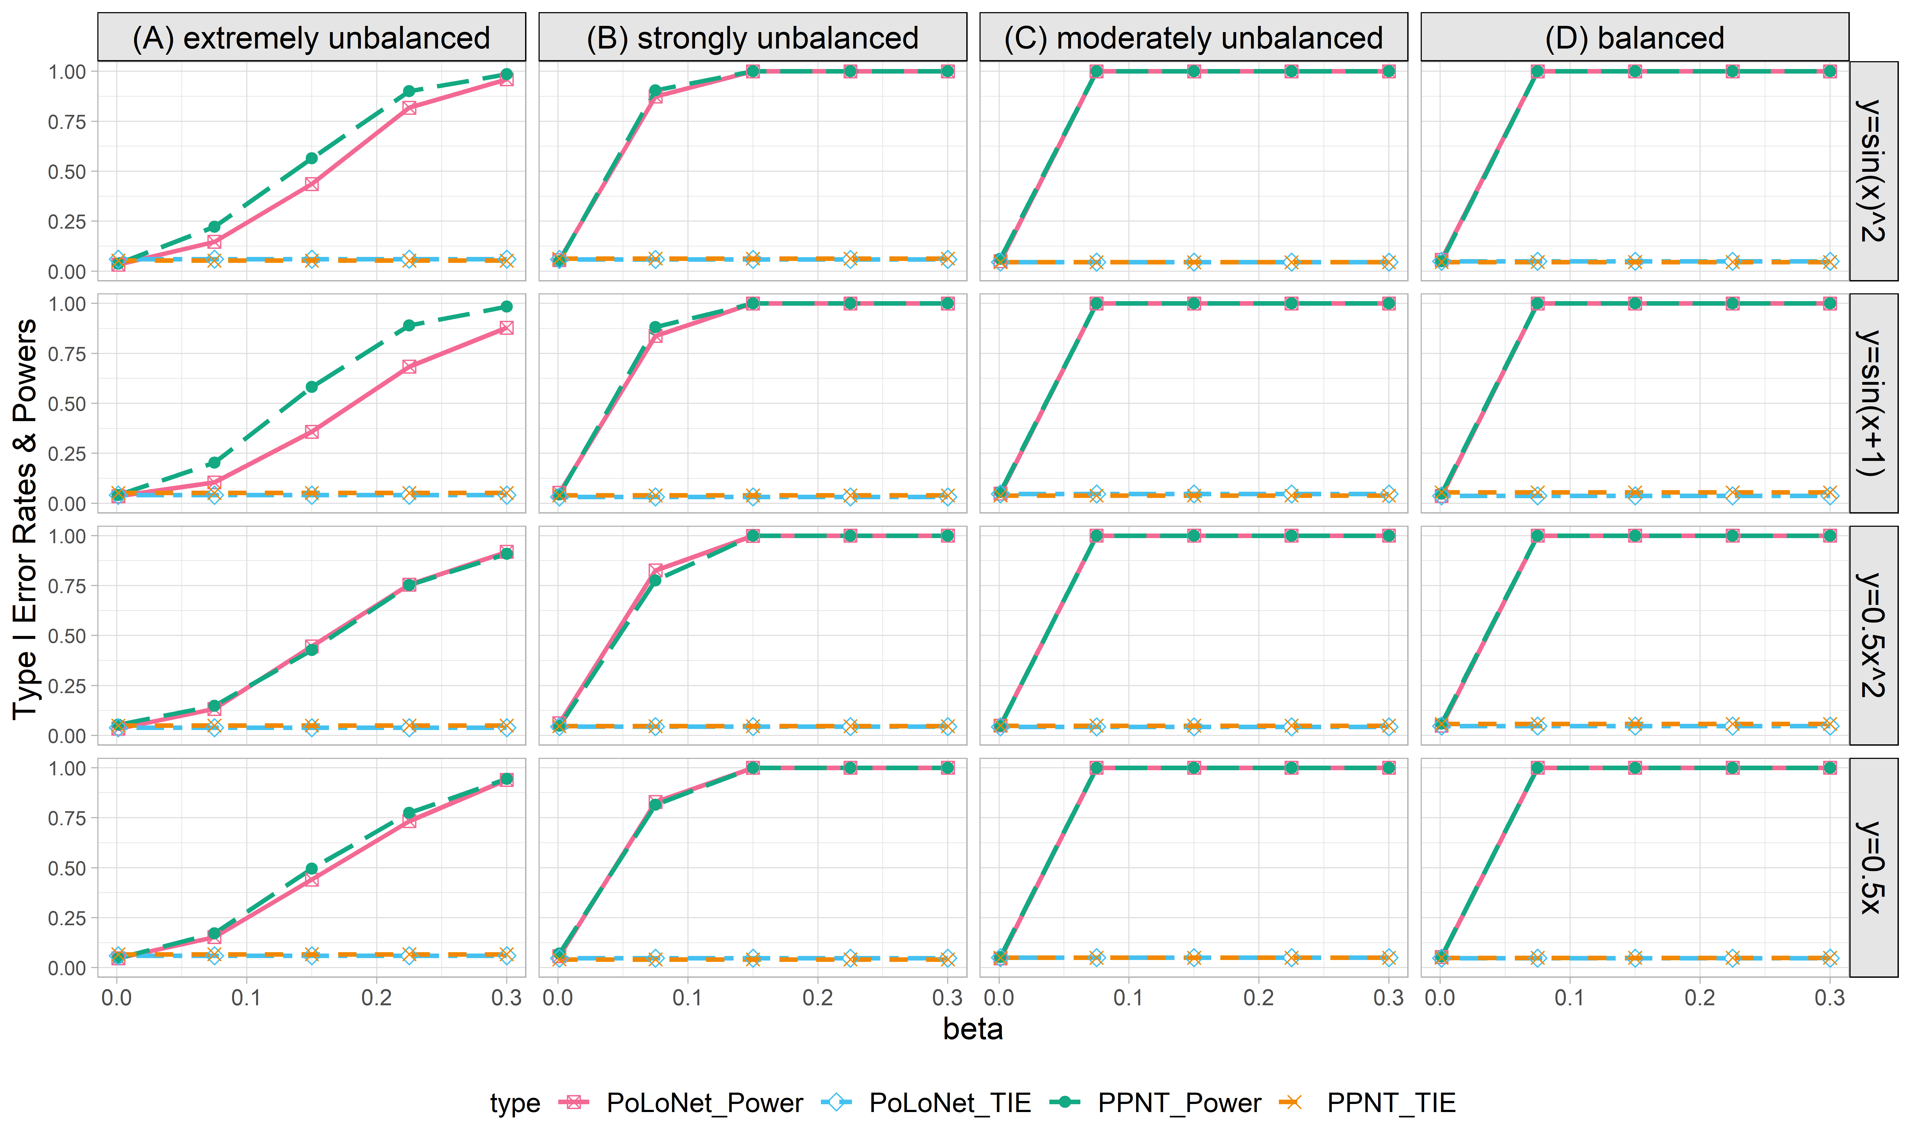

**Figure S27. Empirical type I error rates and powers for detecting the effect of the node for the binary trait under the setting that both node and edge have effects, with the node hanging on the edge (n=10000), with BSLMM as gene expression prediction model in TWAS.** The significance level is α=0.05. Simulations are conducted with 4 different between-node correlation patterns (the recombination of quadratic and sine, sine, quadratic, linear) and 5 different effect sizes (0.001, 0.075, 0.15, 0.225, 0.3). (A) extremely unbalanced (1:999) ; (B) strongly unbalanced (99:1); (C)moderately unbalanced (1:9); (D) balanced (1:1)).

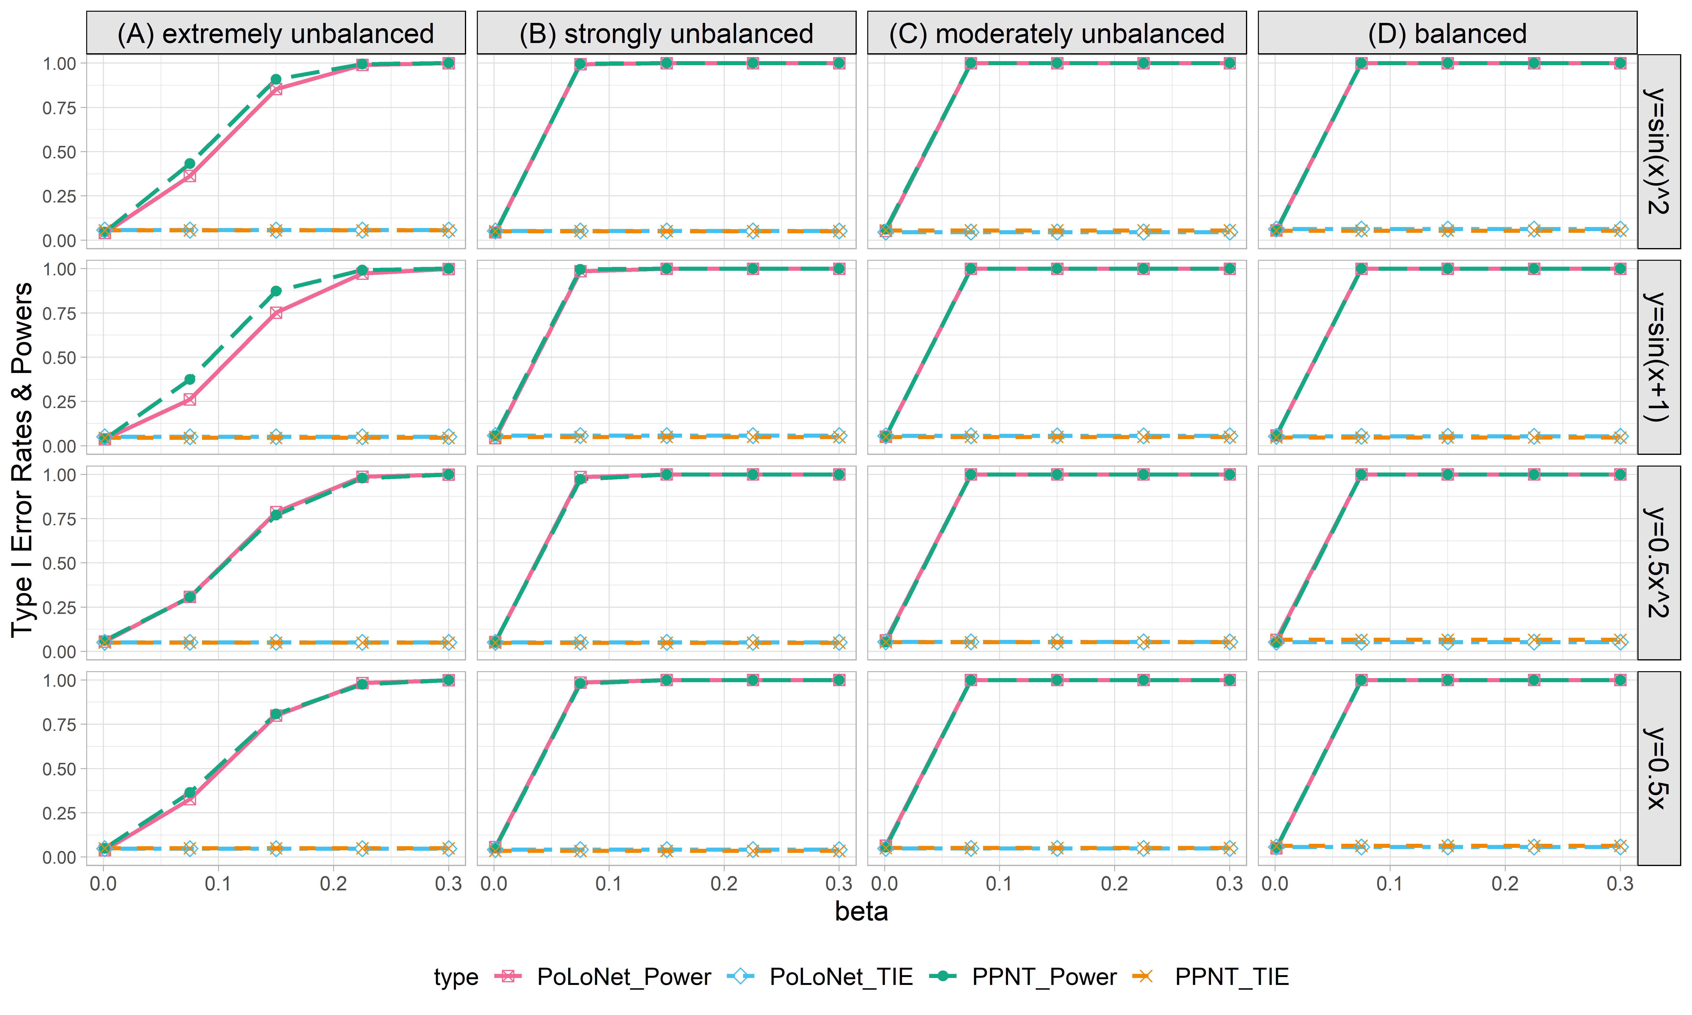

**Figure S28. Empirical type I error rates and powers for detecting the effect of the node for the binary trait under the setting that both node and edge have effects, with the node hanging on the edge (n=20000), with BSLMM as gene expression prediction model in TWAS.** The significance level is α=0.05. Simulations are conducted with 4 different between-node correlation patterns (the recombination of quadratic and sine, sine, quadratic, linear) and 5 different effect sizes (0.001, 0.075, 0.15, 0.225, 0.3). (A) extremely unbalanced (1:999) ; (B) strongly unbalanced (99:1); (C)moderately unbalanced (1:9); (D) balanced (1:1)).

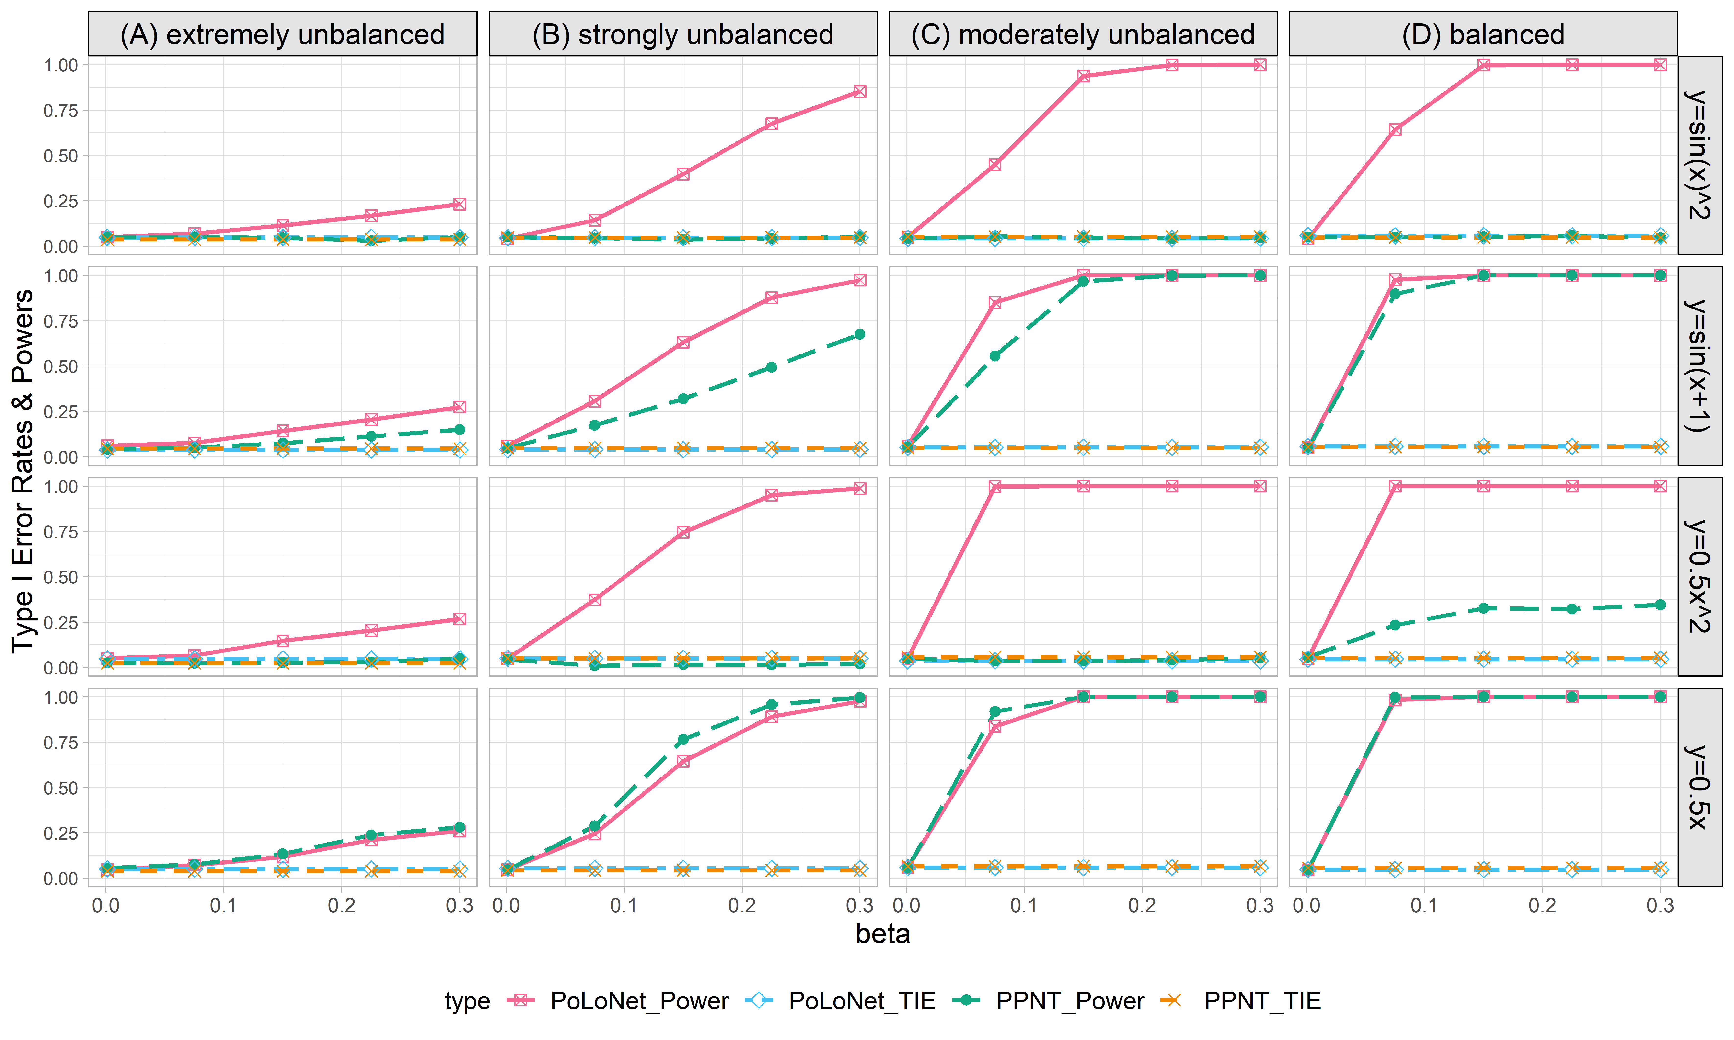

**Figure S29. Empirical type I error rates and powers for detecting the effect of the edge for the binary trait under the setting that both node and edge have effects, with the node not hanging on the edge (n=5000), with BSLMM as gene expression prediction model in TWAS.** The significance level is α=0.05. Simulations are conducted with 4 different between-node correlation patterns (the recombination of quadratic and sine, sine, quadratic, linear) and 5 different effect sizes (0.001, 0.075, 0.15, 0.225, 0.3). (A) extremely unbalanced (1:999) ; (B) strongly unbalanced (99:1); (C)moderately unbalanced (1:9); (D) balanced (1:1)).

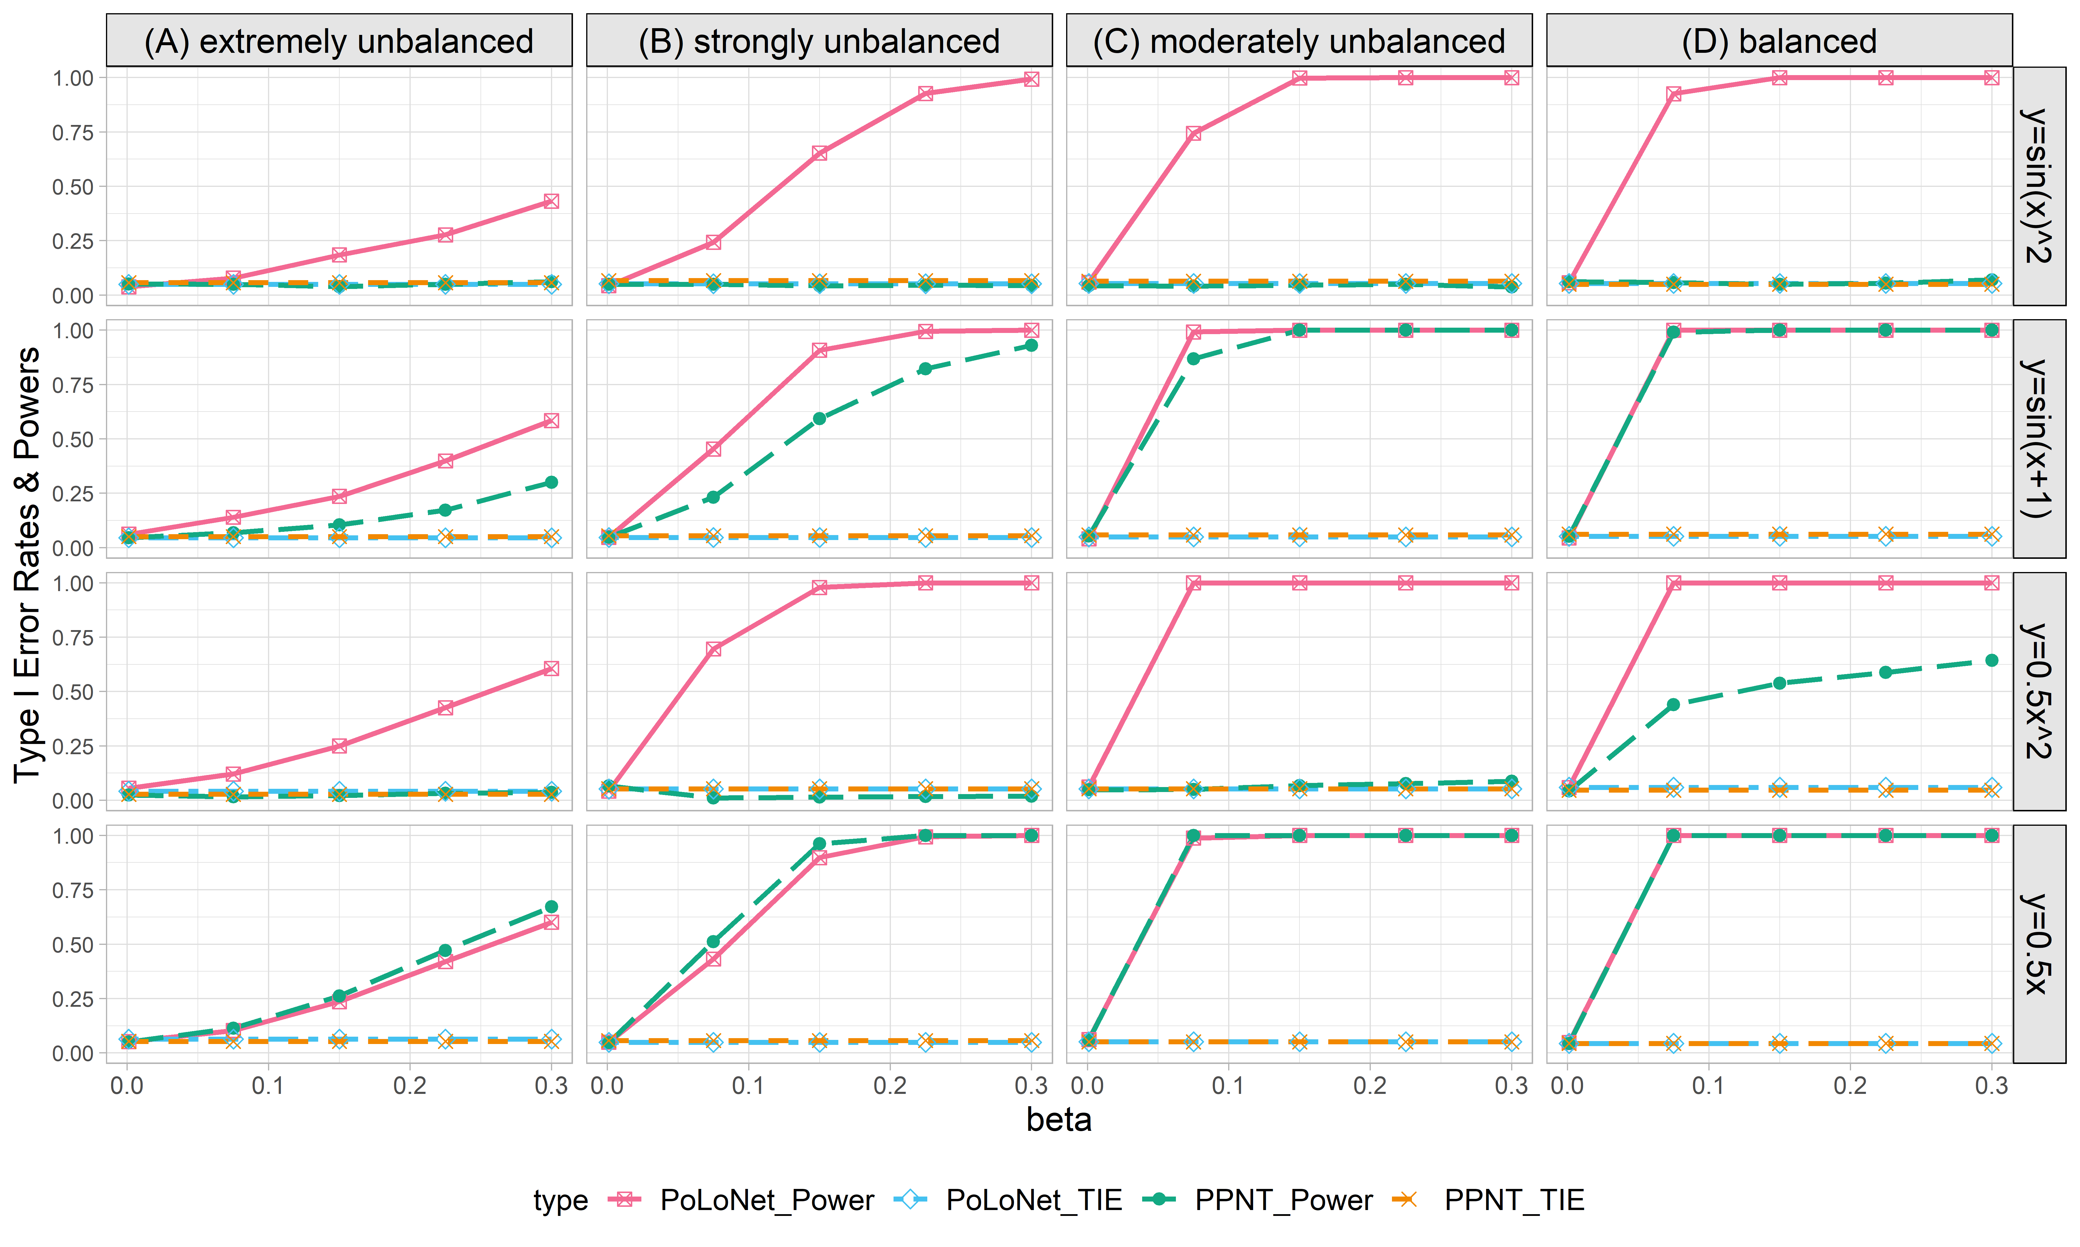

**Figure S30. Empirical type I error rates and powers for detecting the effect of the edge for the binary trait under the setting that both node and edge have effects, with the node not hanging on the edge (n=10000), with BSLMM as gene expression prediction model in TWAS.** The significance level is α=0.05. Simulations are conducted with 4 different between-node correlation patterns (the recombination of quadratic and sine, sine, quadratic, linear) and 5 different effect sizes (0.001, 0.075, 0.15, 0.225, 0.3). (A) extremely unbalanced (1:999) ; (B) strongly unbalanced (99:1); (C)moderately unbalanced (1:9); (D) balanced (1:1)).

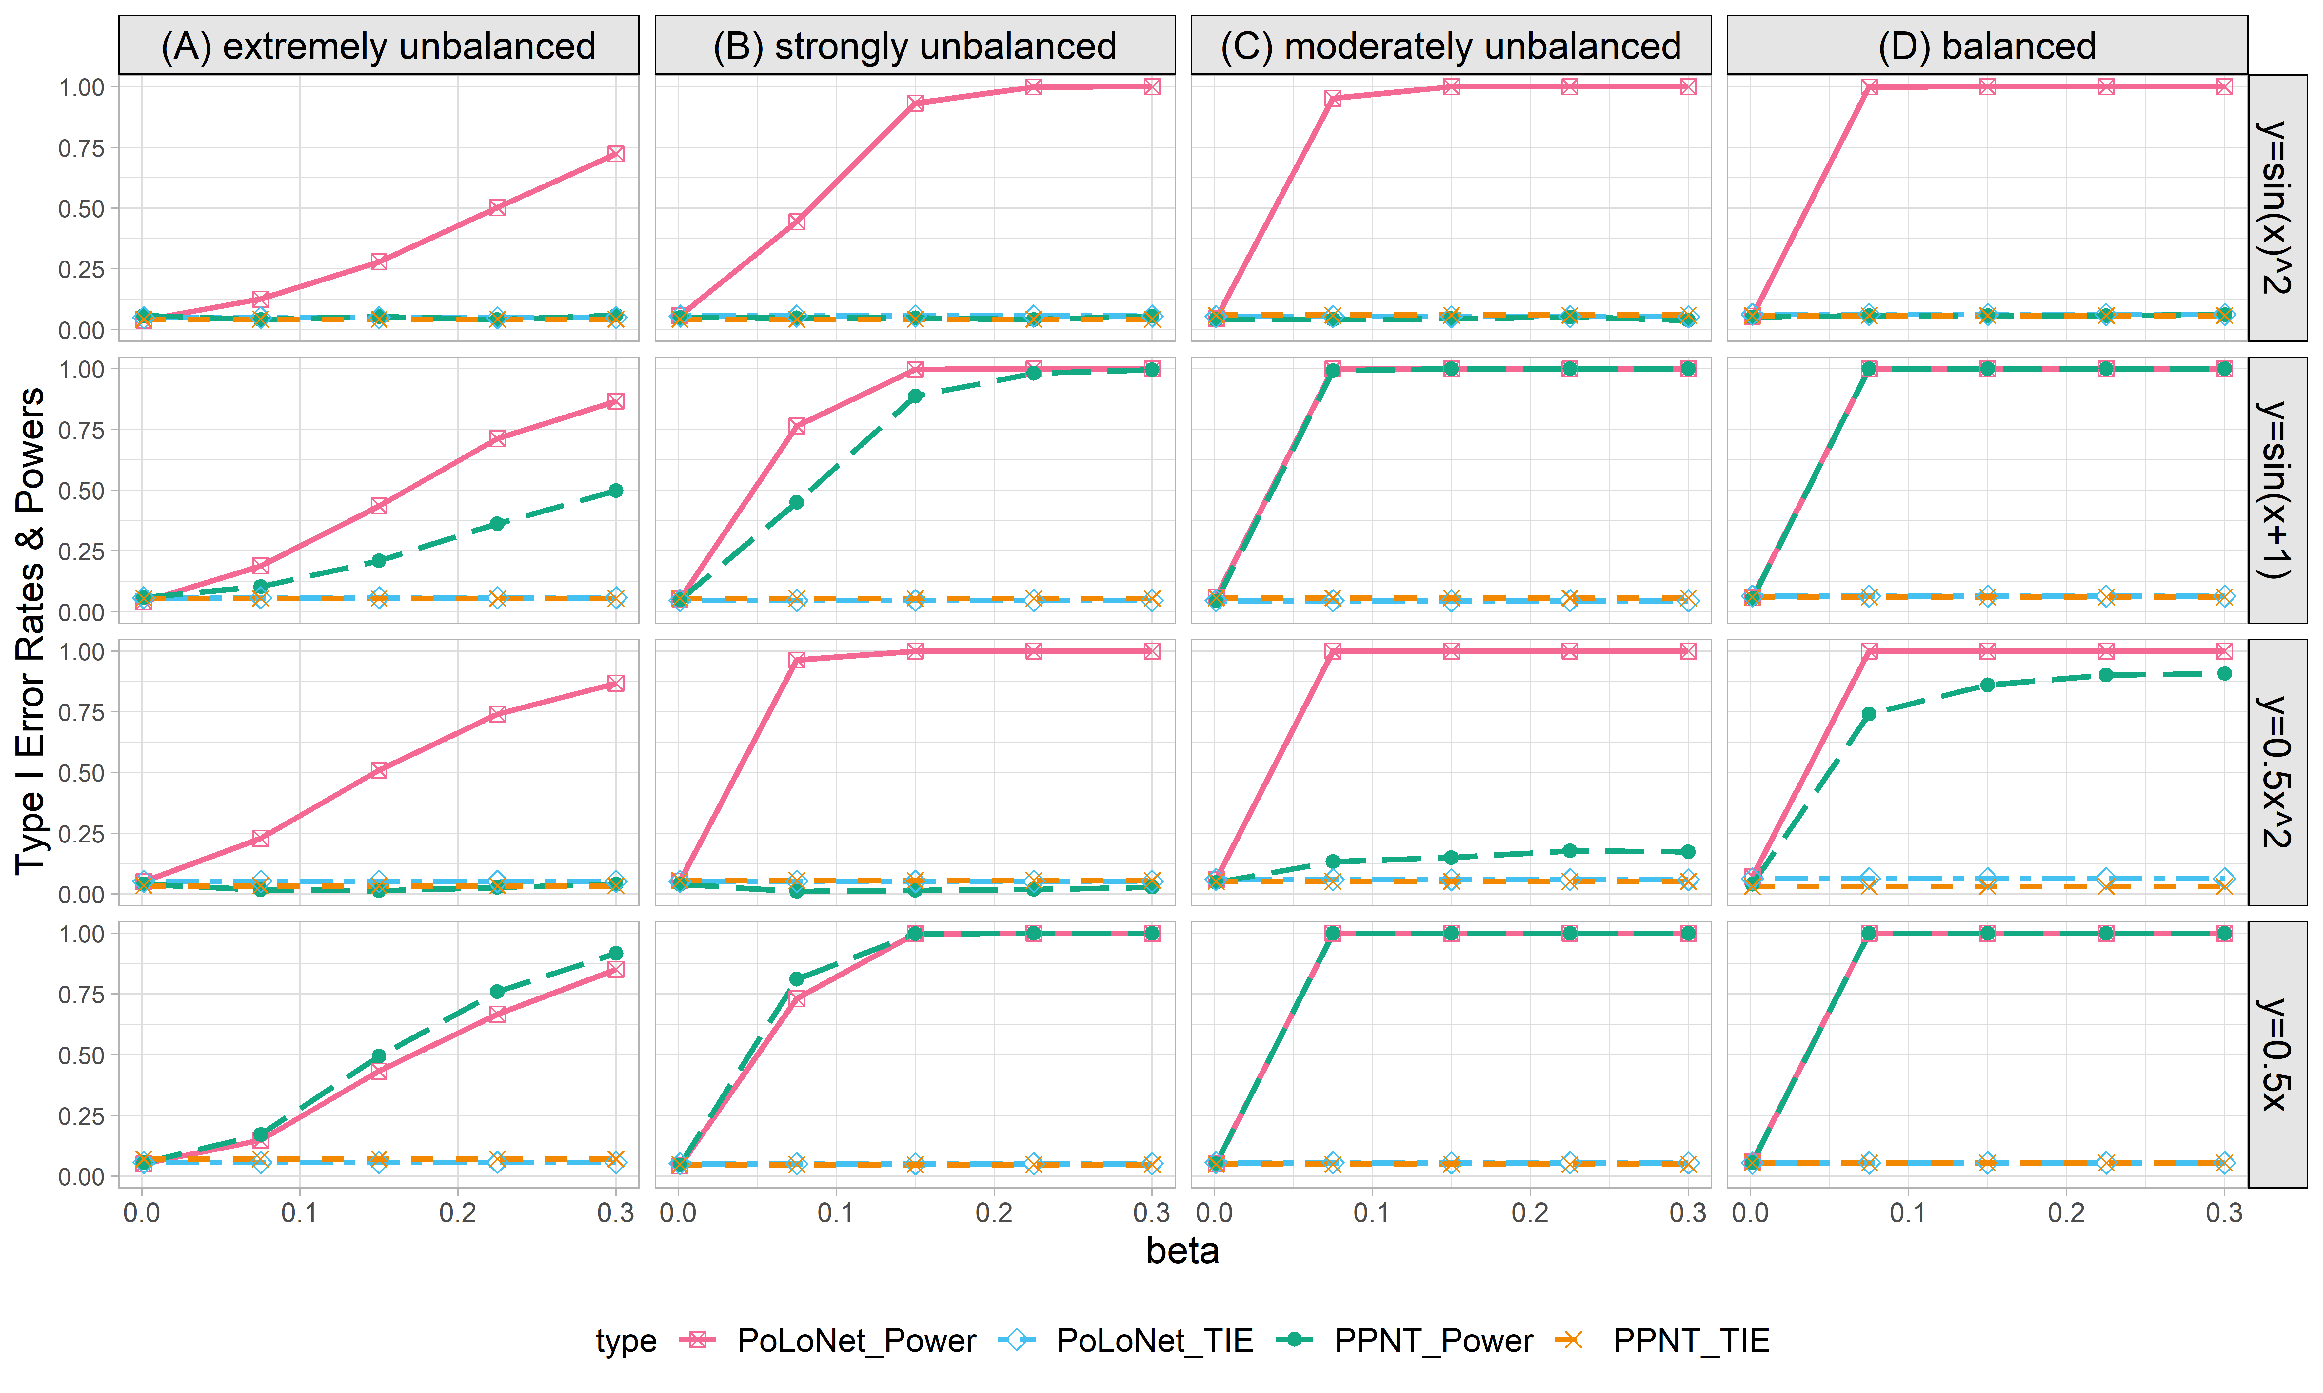

**Figure S31. Empirical type I error rates and powers for detecting the effect of the edge for the binary trait under the setting that both node and edge have effects, with the node not hanging on the edge (n=20000), with BSLMM as gene expression prediction model in TWAS.** The significance level is α=0.05. Simulations are conducted with 4 different between-node correlation patterns (the recombination of quadratic and sine, sine, quadratic, linear) and 5 different effect sizes (0.001, 0.075, 0.15, 0.225, 0.3). (A) extremely unbalanced (1:999) ; (B) strongly unbalanced (99:1); (C)moderately unbalanced (1:9); (D) balanced (1:1)).

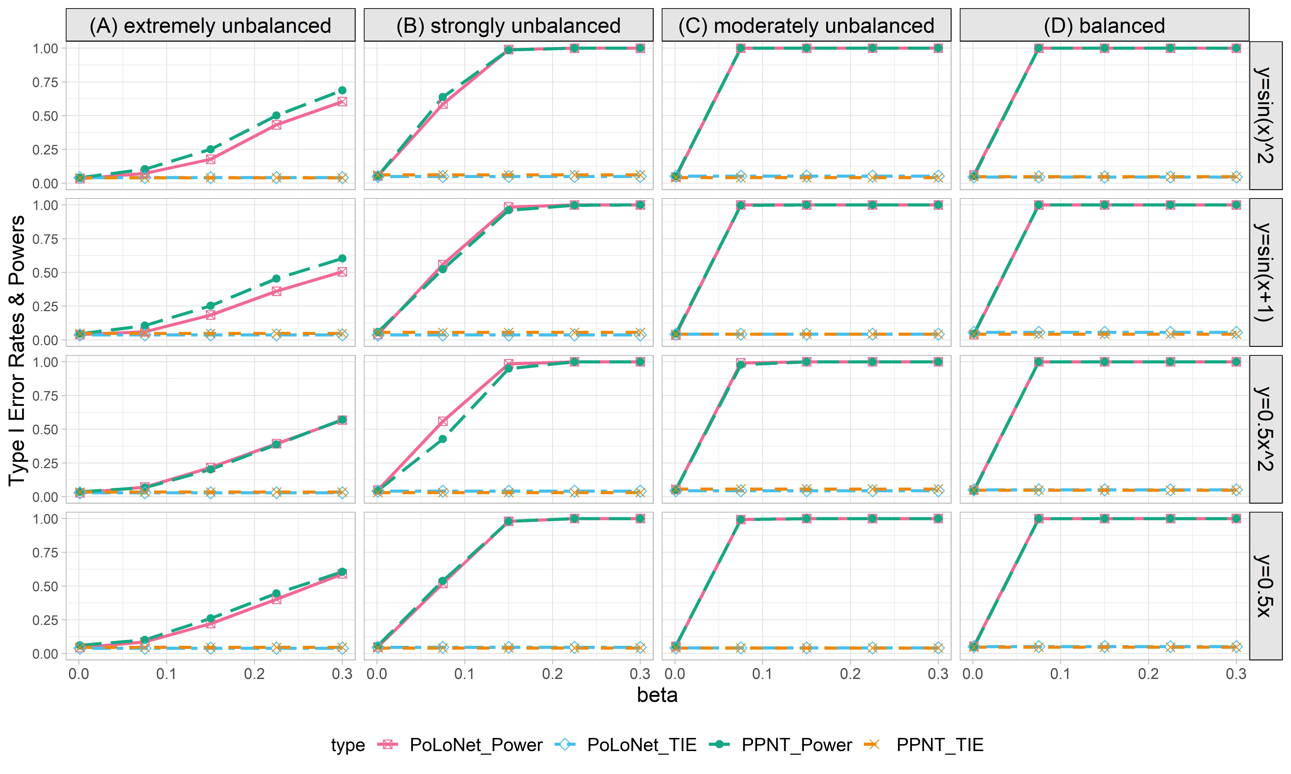

**Figure S32. Empirical type I error rates and powers for detecting the effect of the node for the binary trait under the setting that both node and edge have effects, with the node not hanging on the edge (n=5000), with BSLMM as gene expression prediction model in TWAS.** The significance level is α=0.05. Simulations are conducted with 4 different between-node correlation patterns (the recombination of quadratic and sine, sine, quadratic, linear) and 5 different effect sizes (0.001, 0.075, 0.15, 0.225, 0.3). (A) extremely unbalanced (1:999) ; (B) strongly unbalanced (99:1); (C)moderately unbalanced (1:9); (D) balanced (1:1)).

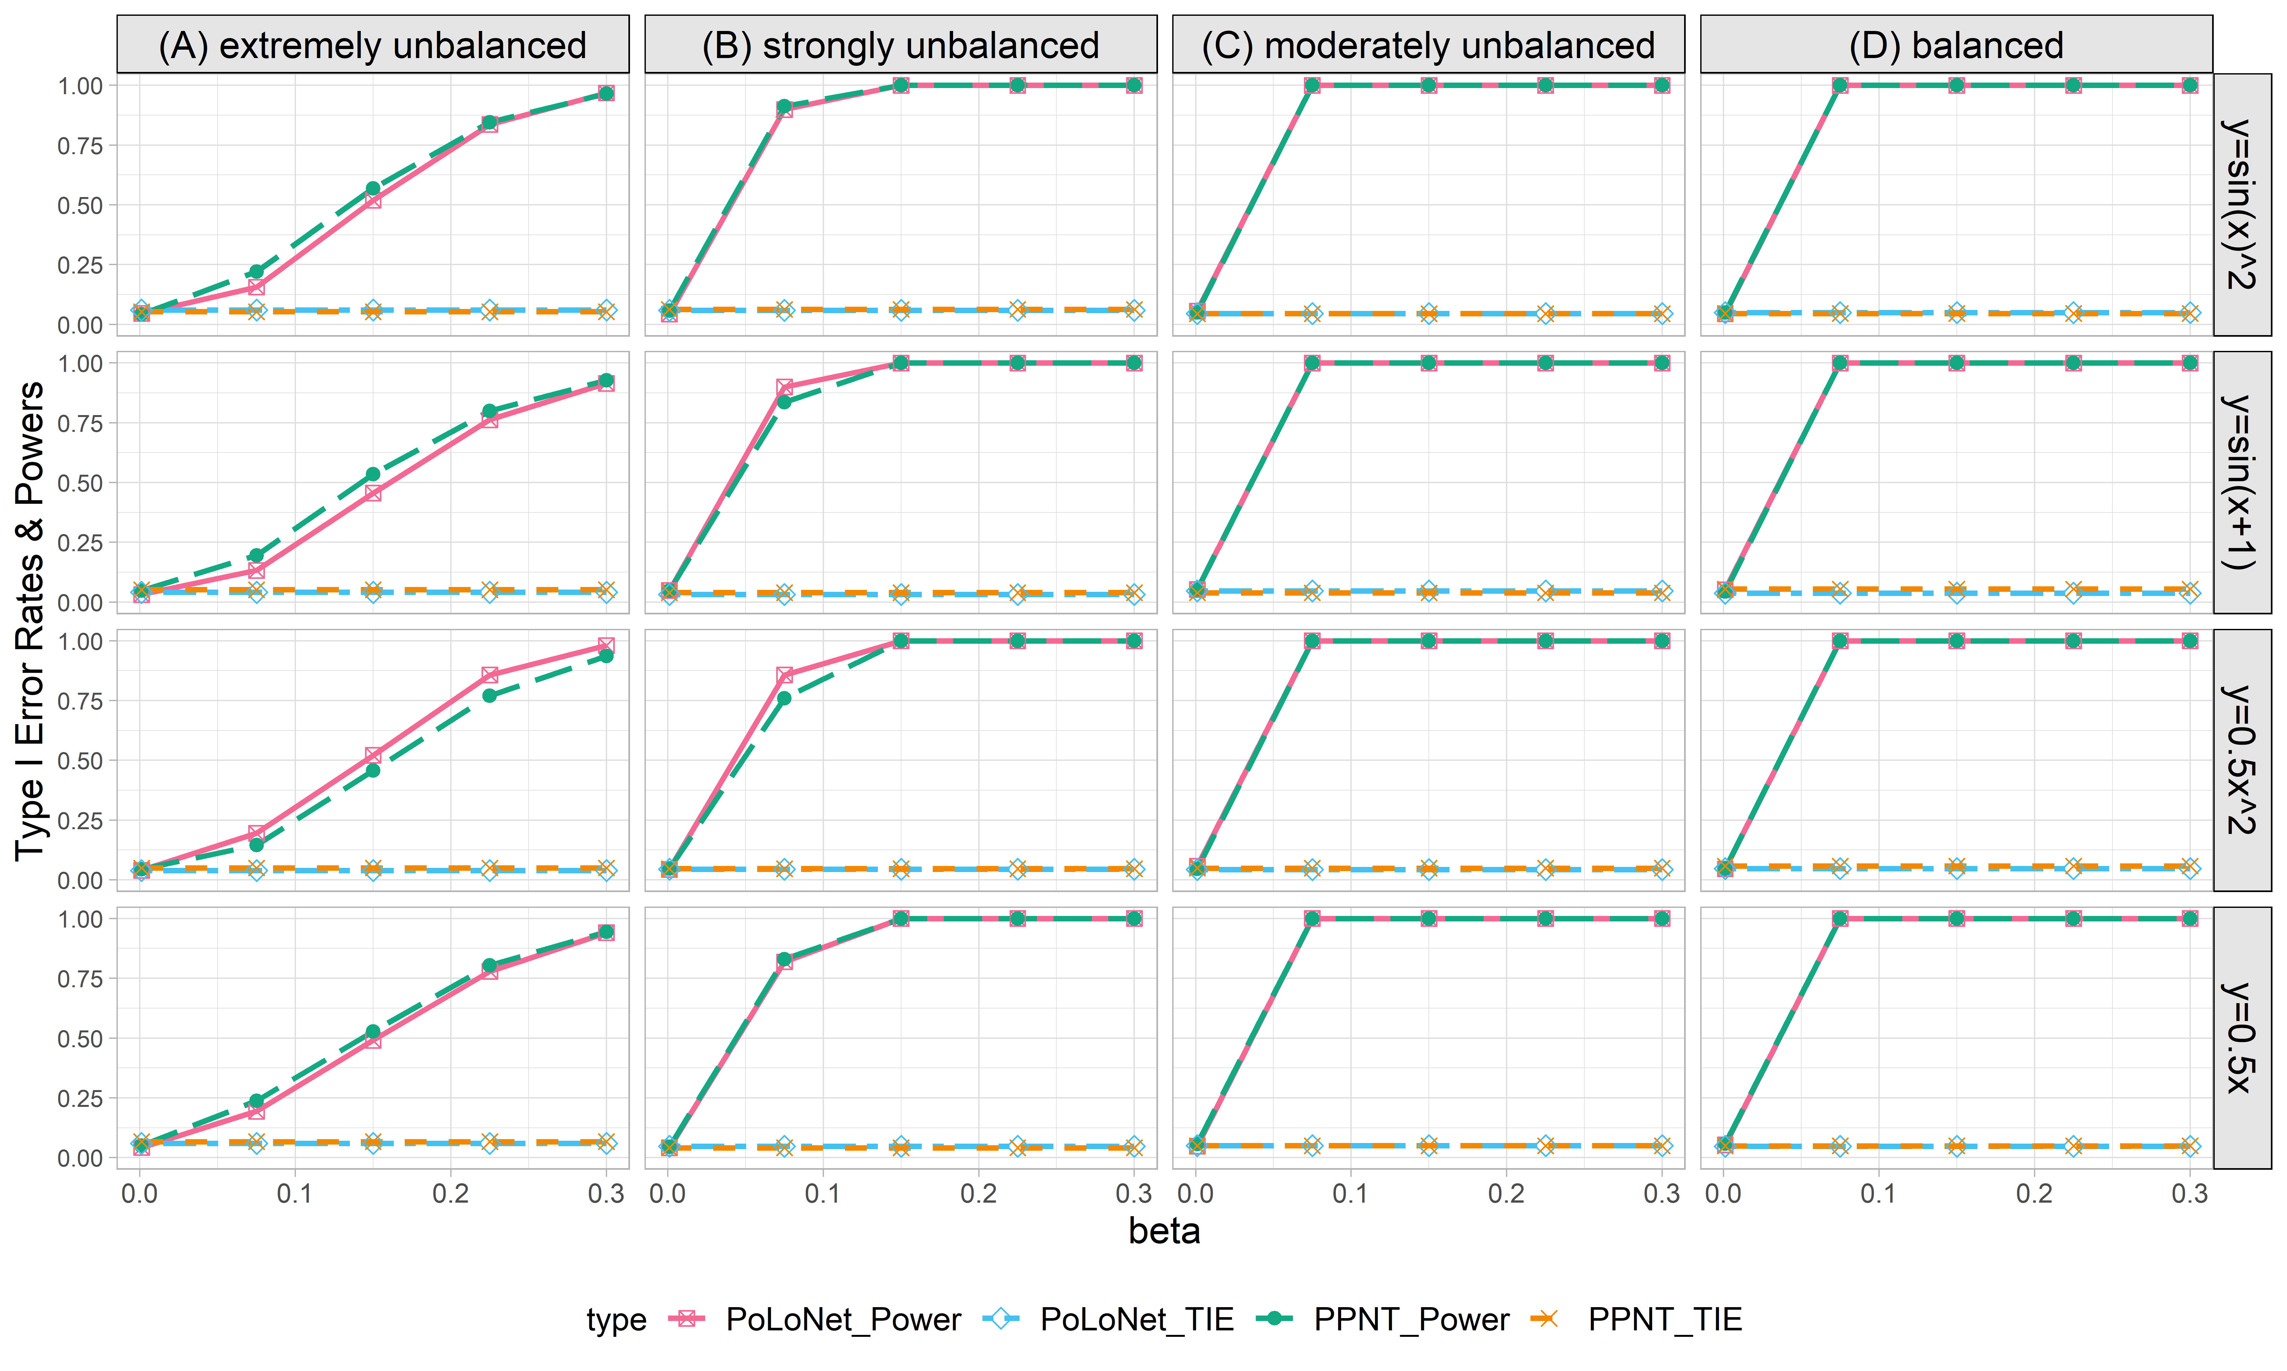

**Figure S33. Empirical type I error rates and powers for detecting the effect of the node for the binary trait under the setting that both node and edge have effects, with the node not hanging on the edge (n=10000), with BSLMM as gene expression prediction model in TWAS.** The significance level is α=0.05. Simulations are conducted with 4 different between-node correlation patterns (the recombination of quadratic and sine, sine, quadratic, linear) and 5 different effect sizes (0.001, 0.075, 0.15, 0.225, 0.3). (A) extremely unbalanced (1:999) ; (B) strongly unbalanced (99:1); (C)moderately unbalanced (1:9); (D) balanced (1:1)).

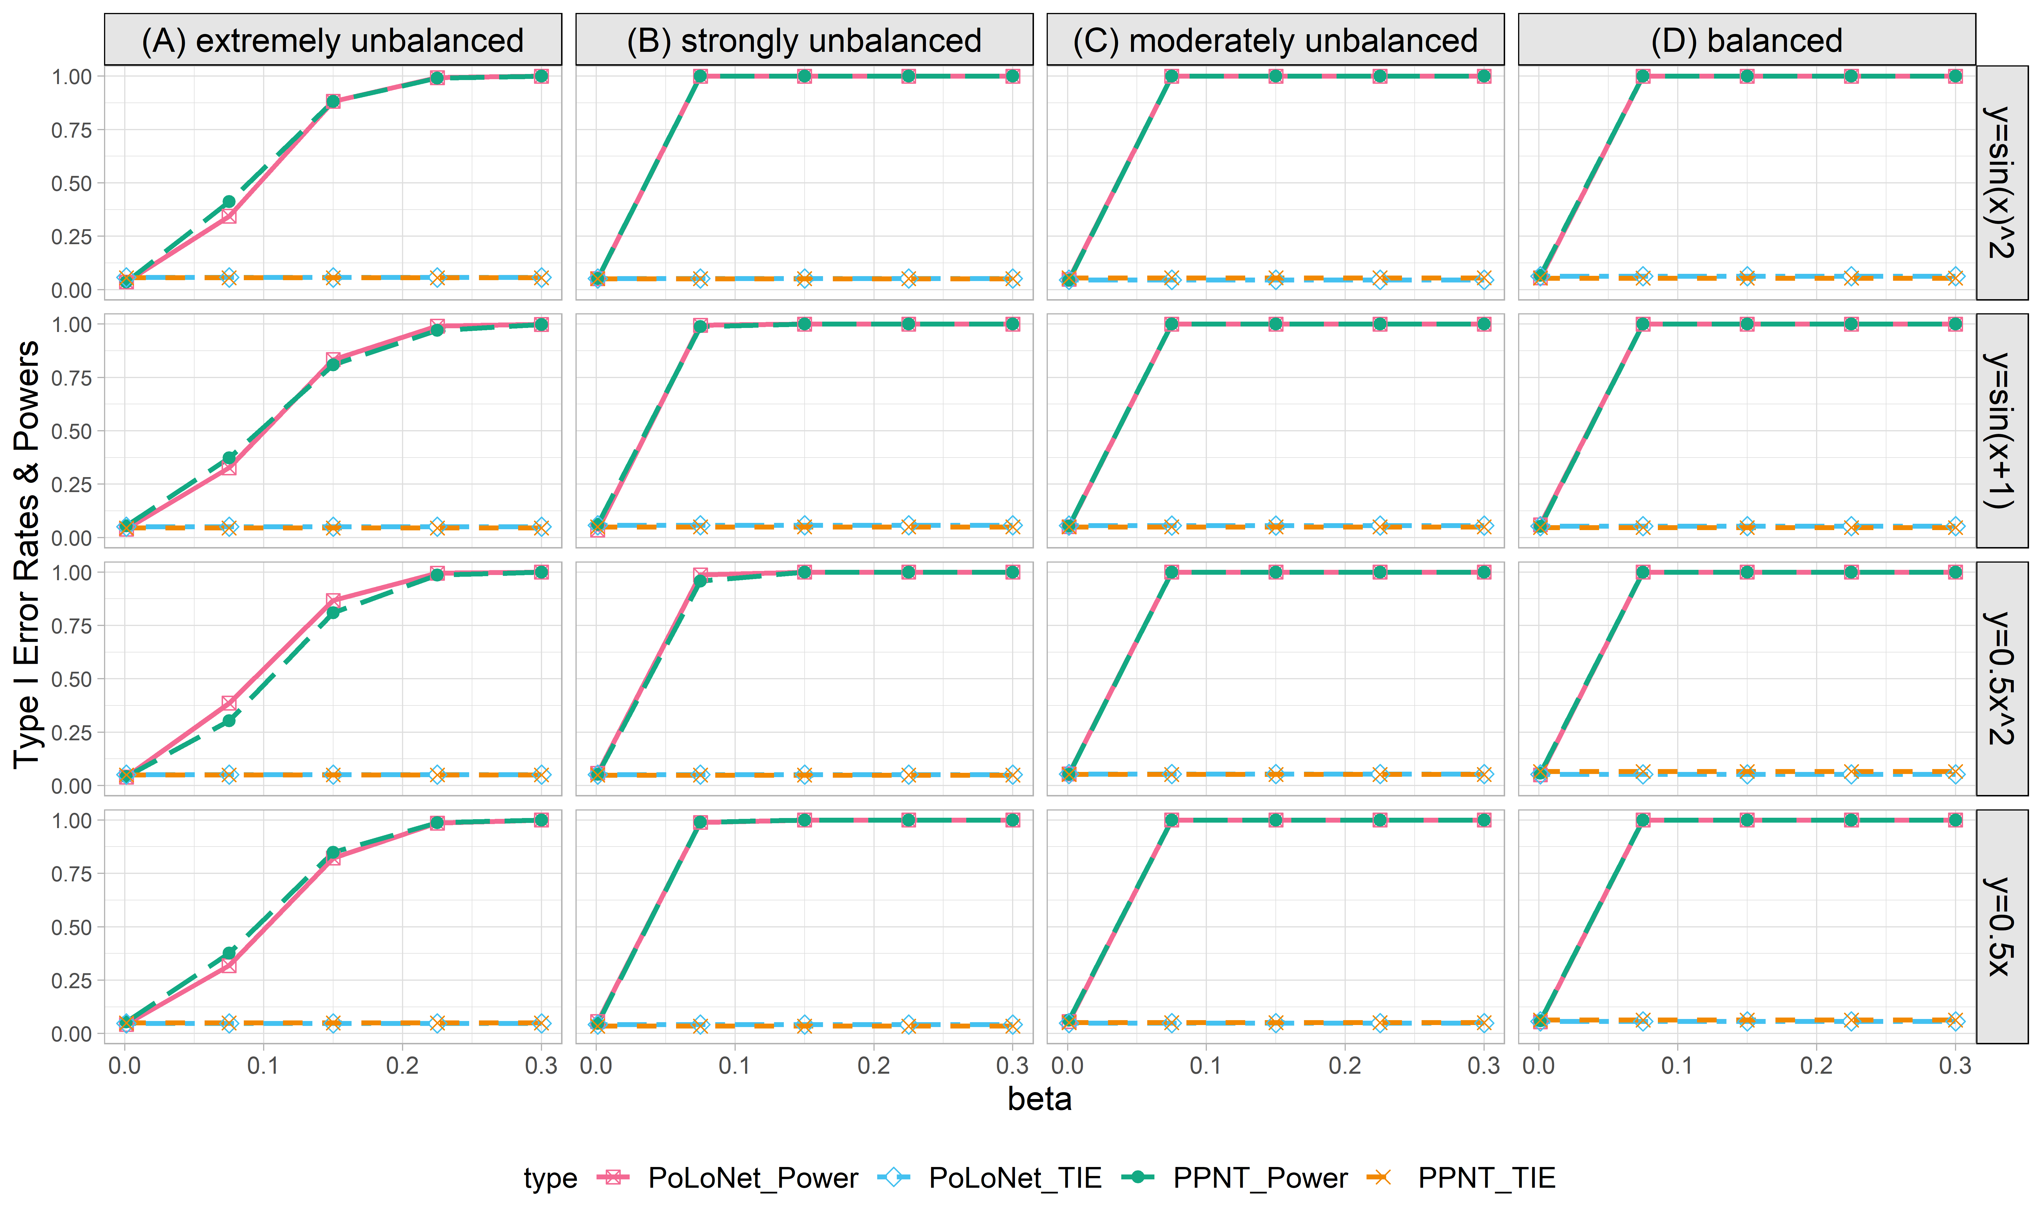

**Figure S34. Empirical type I error rates and powers for detecting the effect of the node for the binary trait under the setting that both node and edge have effects, with the node not hanging on the edge (n=20000), with BSLMM as gene expression prediction model in TWAS.** The significance level is α=0.05. Simulations are conducted with 4 different between-node correlation patterns (the recombination of quadratic and sine, sine, quadratic, linear) and 5 different effect sizes (0.001, 0.075, 0.15, 0.225, 0.3). (A) extremely unbalanced (1:999) ; (B) strongly unbalanced (99:1); (C)moderately unbalanced (1:9); (D) balanced (1:1)).

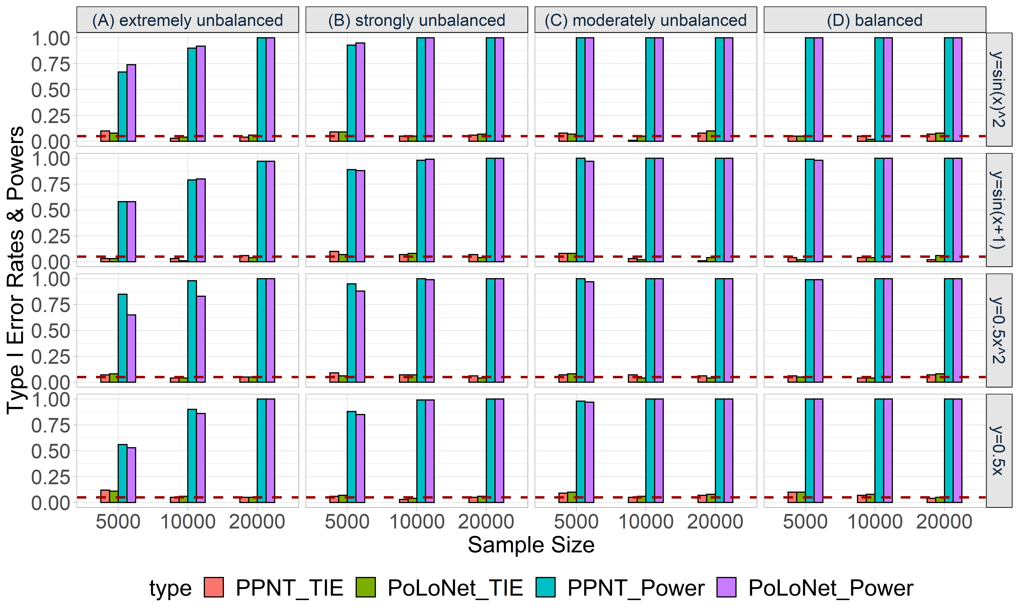

**Figure S35. Empirical type I error rates and powers for detecting the effect of the node for an ordinal trait with 4 categories under the setting that both node and edge have effects, with the node hanging on the edge.** The effect size is set to be 0.05 and DPR is used as the gene expression prediction model in TWAS.The red dotted line represents the significance level (α=0.05). Simulations are conducted with different sample sizes (5000, 10000, 20000) and 4 different between-node correlation patterns (the recombination of quadratic and sine, sine, quadratic, linear). (A) extremely unbalanced (100:1:1:1); (B) strongly unbalanced (30:1:1:1); (C) moderately unbalanced (10:1:1:1); (D) balanced (1:1:1:1).

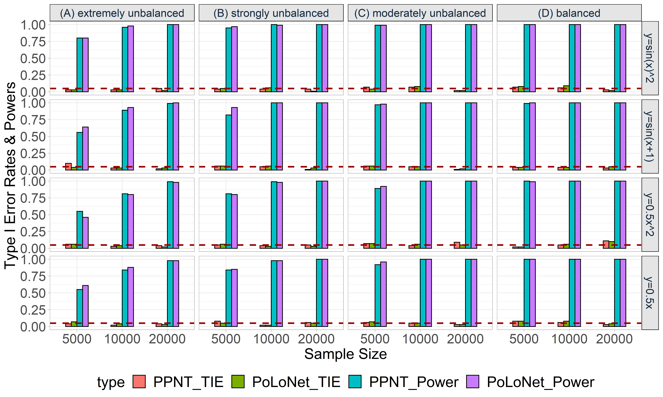

**Figure S36. Empirical type I error rates and powers for detecting the effect of the node for an ordinal trait with 4 categories under the setting that both node and edge have effects, with the node not hanging on the edge.** The effect size is set to be 0.05 and DPR is used as the gene expression prediction model in TWAS. The red dotted line represents the significance level (α=0.05). Simulations are conducted with different sample sizes (5000, 10000, 20000) and 4 different between-node correlation patterns (the recombination of quadratic and sine, sine, quadratic, linear). (A) extremely unbalanced (100:1:1:1); (B) strongly unbalanced (30:1:1:1); (C) moderately unbalanced (10:1:1:1); (D) balanced (1:1:1:1).

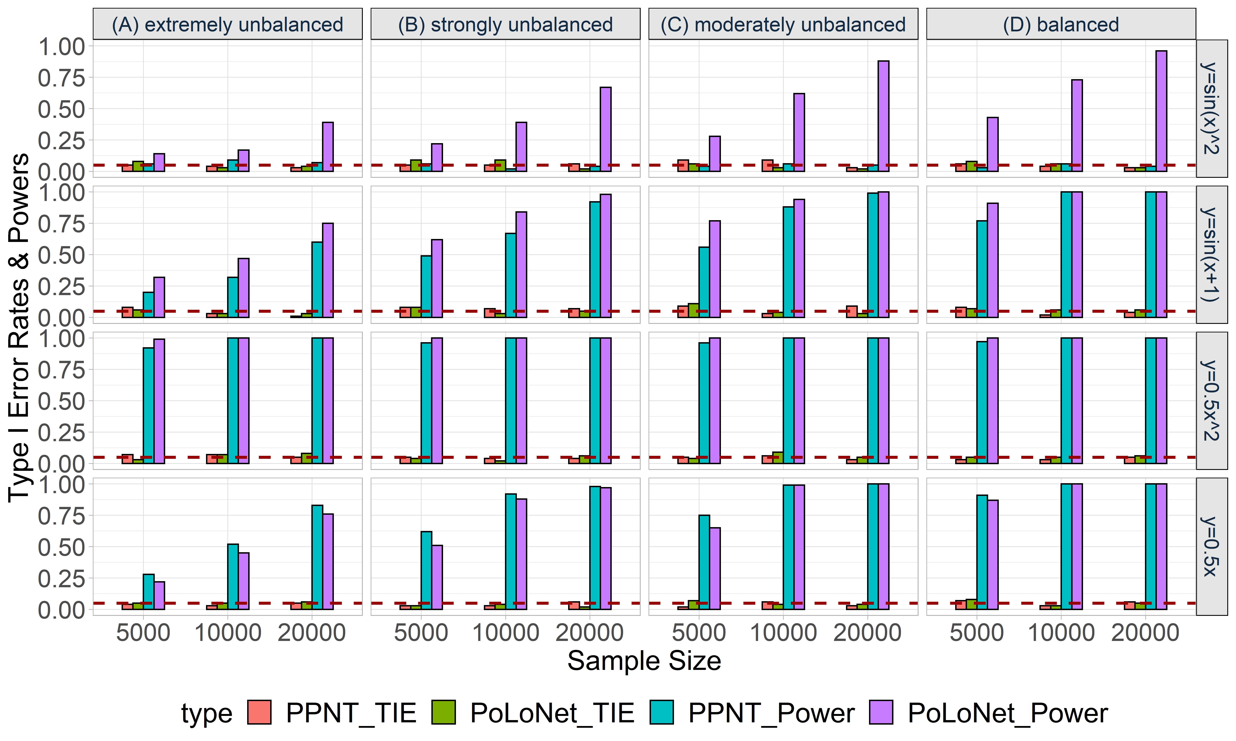

**Figure S37. Empirical type I error rates and powers for detecting the effect of the edge for an ordinal trait with 4 categories under the setting that both node and edge have effects, with the node hanging on the edge.** The effect size is set to be 0.05 and DPR is used as the gene expression prediction model in TWAS. The red dotted line represents the significance level (α=0.05). Simulations are conducted with different sample sizes (5000, 10000, 20000) and 4 different between-node correlation patterns (the recombination of quadratic and sine, sine, quadratic, linear). (A) extremely unbalanced (100:1:1:1); (B) strongly unbalanced (30:1:1:1); (C) moderately unbalanced (10:1:1:1); (D) balanced (1:1:1:1).

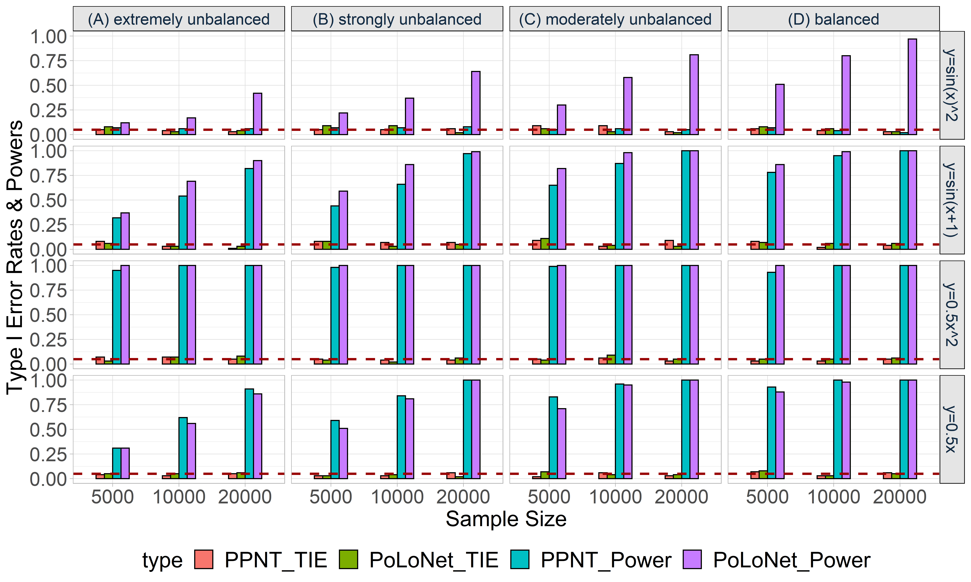

**Figure S38. Empirical type I error rates and powers for detecting the effect of the edge for an ordinal trait with 4 categories under the setting that both node and edge have effects, with the node not hanging on the edge.** The effect size is set to be 0.05 and DPR is used as the gene expression prediction model in TWAS. The red dotted line represents the significance level (α=0.05). Simulations are conducted with different sample sizes (5000, 10000, 20000) and 4 different between-node correlation patterns (the recombination of quadratic and sine, sine, quadratic, linear). (A) extremely unbalanced (100:1:1:1); (B) strongly unbalanced (30:1:1:1); (C) moderately unbalanced (10:1:1:1); (D) balanced (1:1:1:1).

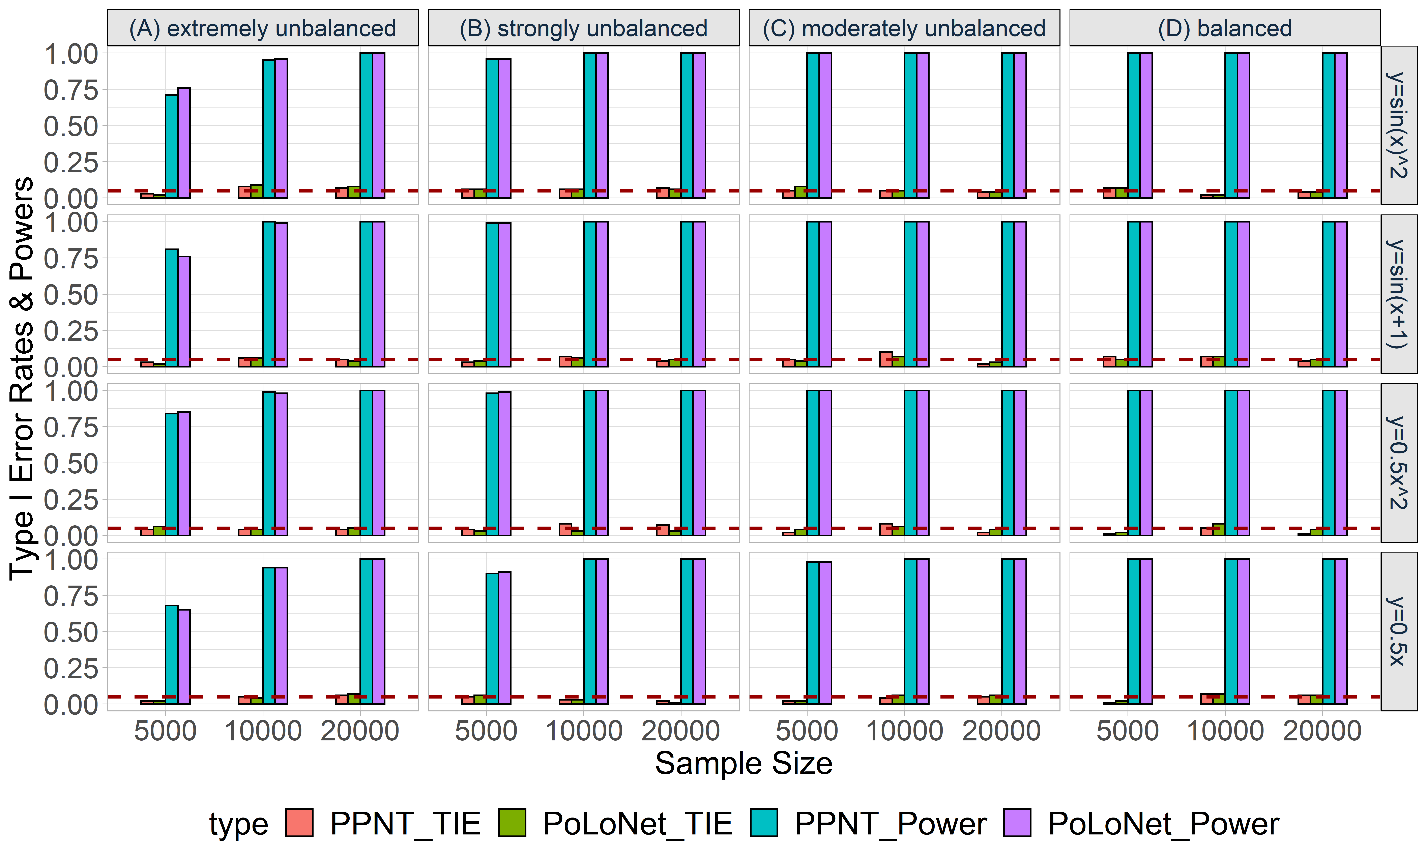

**Figure S39. Empirical type I error rates and powers for detecting the effect of the node for an ordinal trait with 4 categories under the setting that only the node has an effect. The effect size is set to be 0.05 and BSLMM is used as the gene expression prediction model in TWAS.** The red dotted line represents the significance level (α=0.05). Simulations are conducted with different sample sizes (5000, 10000, 20000) and 4 different between-node correlation patterns (the recombination of quadratic and sine, sine, quadratic, linear). (A) extremely unbalanced (100:1:1:1); (B) strongly unbalanced (30:1:1:1); (C) moderately unbalanced (10:1:1:1); (D) balanced (1:1:1:1).

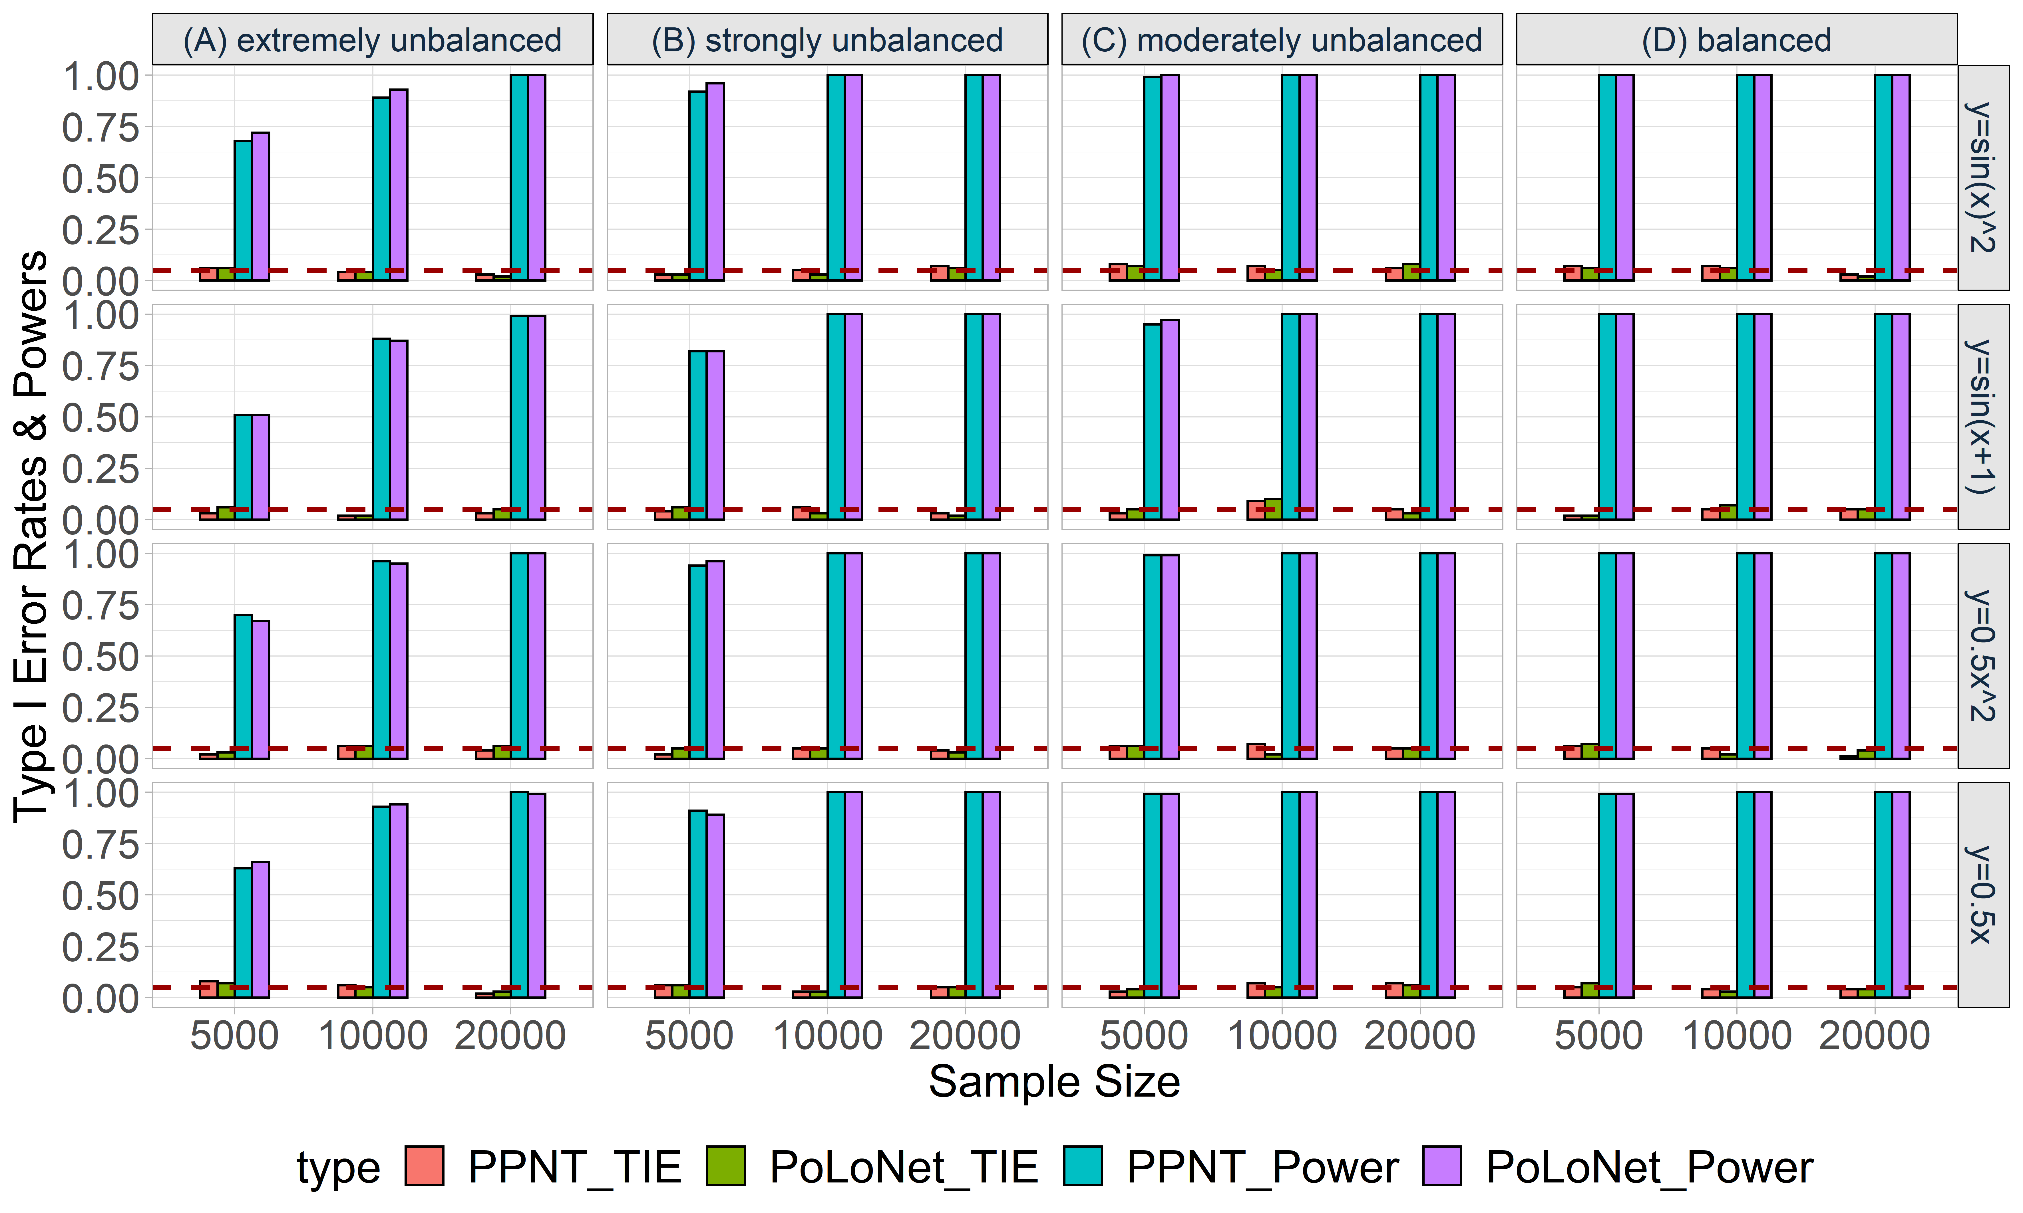

**Figure S40. Empirical type I error rates and powers for detecting the effect of the node for an ordinal trait with 4 categories under the setting that both node and edge have effects, with the node hanging on the edge.** The effect size is set to be 0.05 and BSLMM is used as the gene expression prediction model in TWAS. The red dotted line represents the significance level (α=0.05). Simulations are conducted with different sample sizes (5000, 10000, 20000) and 4 different between-node correlation patterns (the recombination of quadratic and sine, sine, quadratic, linear). (A) extremely unbalanced (100:1:1:1); (B) strongly unbalanced (30:1:1:1); (C) moderately unbalanced (10:1:1:1); (D) balanced (1:1:1:1).

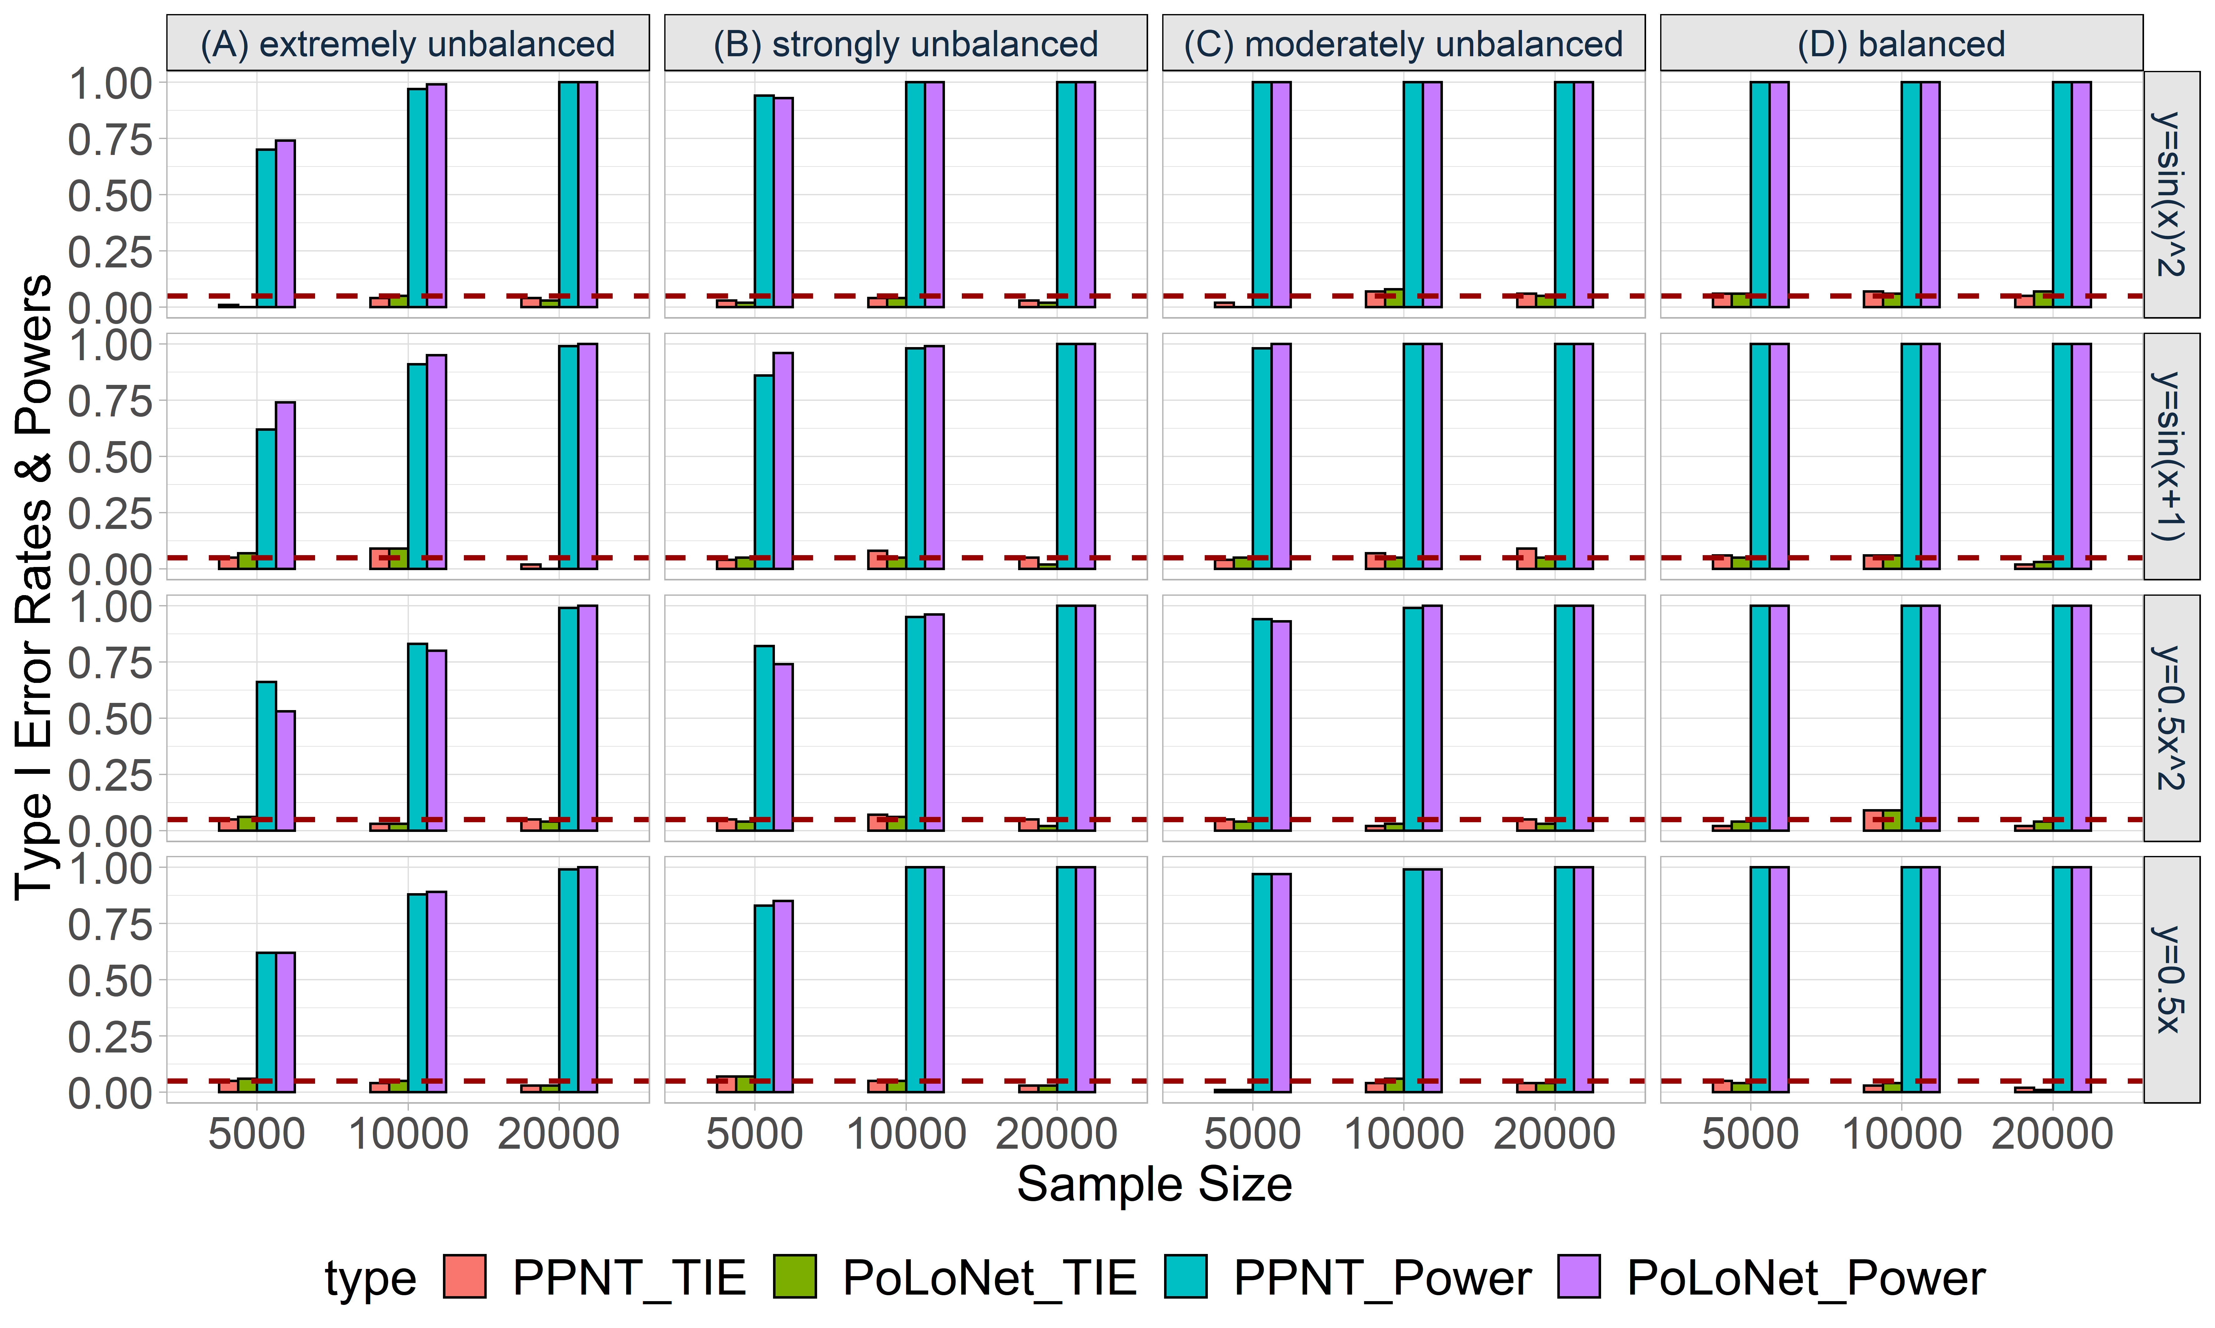

**Figure S41. Empirical type I error rates and powers for detecting the effect of the node for an ordinal trait with 4 categories under the setting that both node and edge have effects, with the node not hanging on the edge.** The effect size is set to be 0.05 and BSLMM is used as the gene expression prediction model in TWAS. The red dotted line represents the significance level (α=0.05). Simulations are conducted with different sample sizes (5000, 10000, 20000) and 4 different between-node correlation patterns (the recombination of quadratic and sine, sine, quadratic, linear). (A) extremely unbalanced (100:1:1:1); (B) strongly unbalanced (30:1:1:1); (C) moderately unbalanced (10:1:1:1); (D) balanced (1:1:1:1).

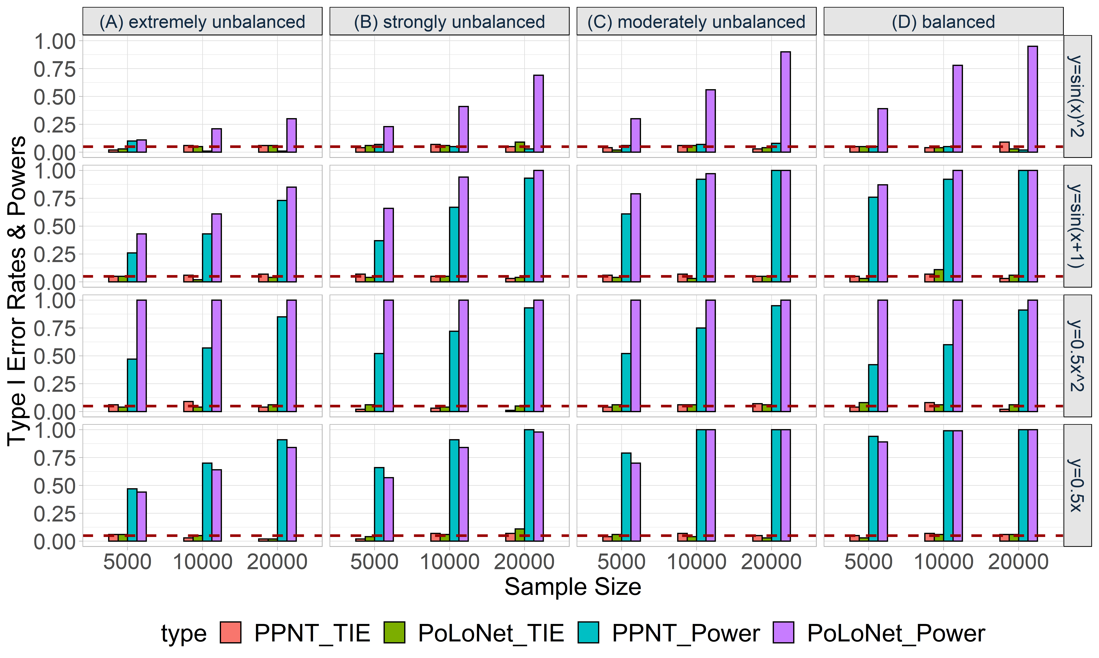

**Figure S42. Empirical type I error rates and powers for detecting the effect of the edge for an ordinal trait with 4 categories under the setting that only the edge has an effect.** The effect size is set to be 0.05 and BSLMM is used as the gene expression prediction model in TWAS. The red dotted line represents the significance level (α=0.05). Simulations are conducted with different sample sizes (5000, 10000, 20000) and 4 different between-node correlation patterns (the recombination of quadratic and sine, sine, quadratic, linear). (A) extremely unbalanced (100:1:1:1); (B) strongly unbalanced (30:1:1:1); (C) moderately unbalanced (10:1:1:1); (D) balanced (1:1:1:1).

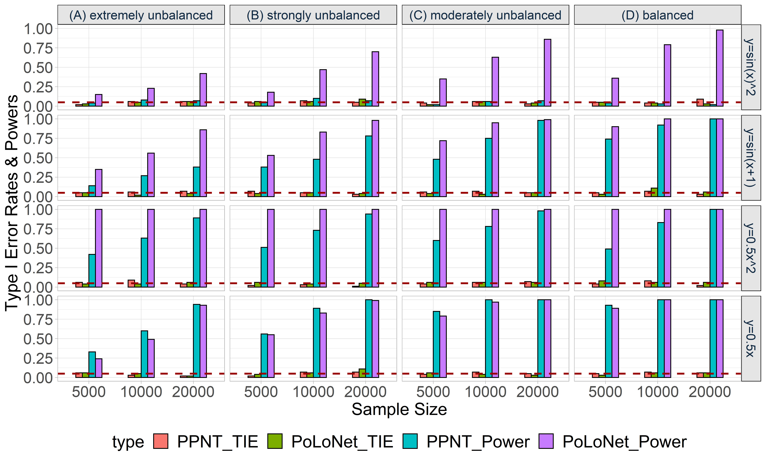

**Figure S43. Empirical type I error rates and powers for detecting the effect of the edge for an ordinal trait with 4 categories under the setting that** **both node and edge have effects, with the node hanging on the edge.** The effect size is set to be 0.05 and BSLMM is used as the gene expression prediction model in TWAS. The red dotted line represents the significance level (α=0.05). Simulations are conducted with different sample sizes (5000, 10000, 20000) and 4 different between-node correlation patterns (the recombination of quadratic and sine, sine, quadratic, linear). (A) extremely unbalanced (100:1:1:1); (B) strongly unbalanced (30:1:1:1); (C) moderately unbalanced (10:1:1:1); (D) balanced (1:1:1:1).

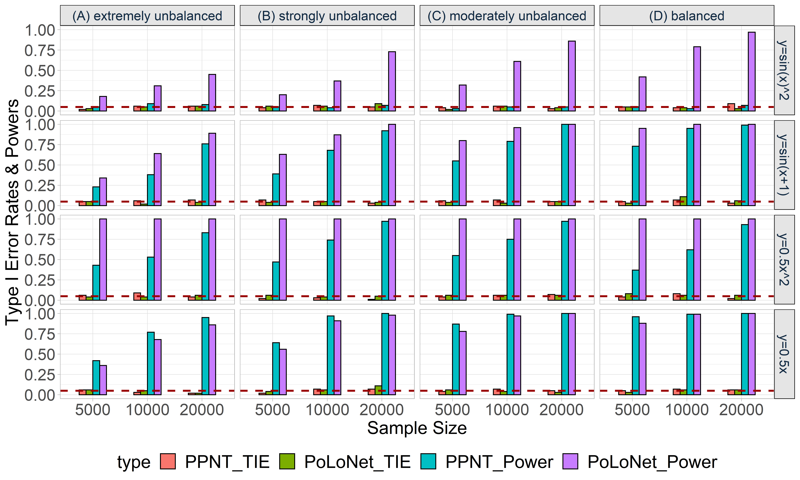

**Figure S44. Empirical type I error rates and powers for detecting the effect of the edge for an ordinal trait with 4 categories under the setting that** **both node and edge have effects, with the node not hanging on the edge.** The effect size is set to be 0.05 and BSLMM is used as the gene expression prediction model in TWAS. The red dotted line represents the significance level (α=0.05). Simulations are conducted with different sample sizes (5000, 10000, 20000) and 4 different between-node correlation patterns (the recombination of quadratic and sine, sine, quadratic, linear). (A) extremely unbalanced (100:1:1:1); (B) strongly unbalanced (30:1:1:1); (C) moderately unbalanced (10:1:1:1); (D) balanced (1:1:1:1).

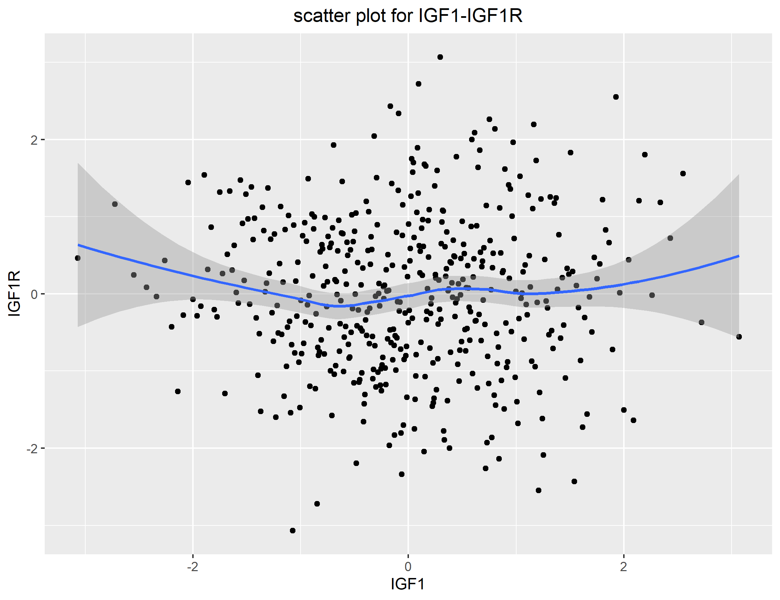

**Figure S45. Scatter plot for IGF1-IGF1R in eQTL study in long-term depression network.**

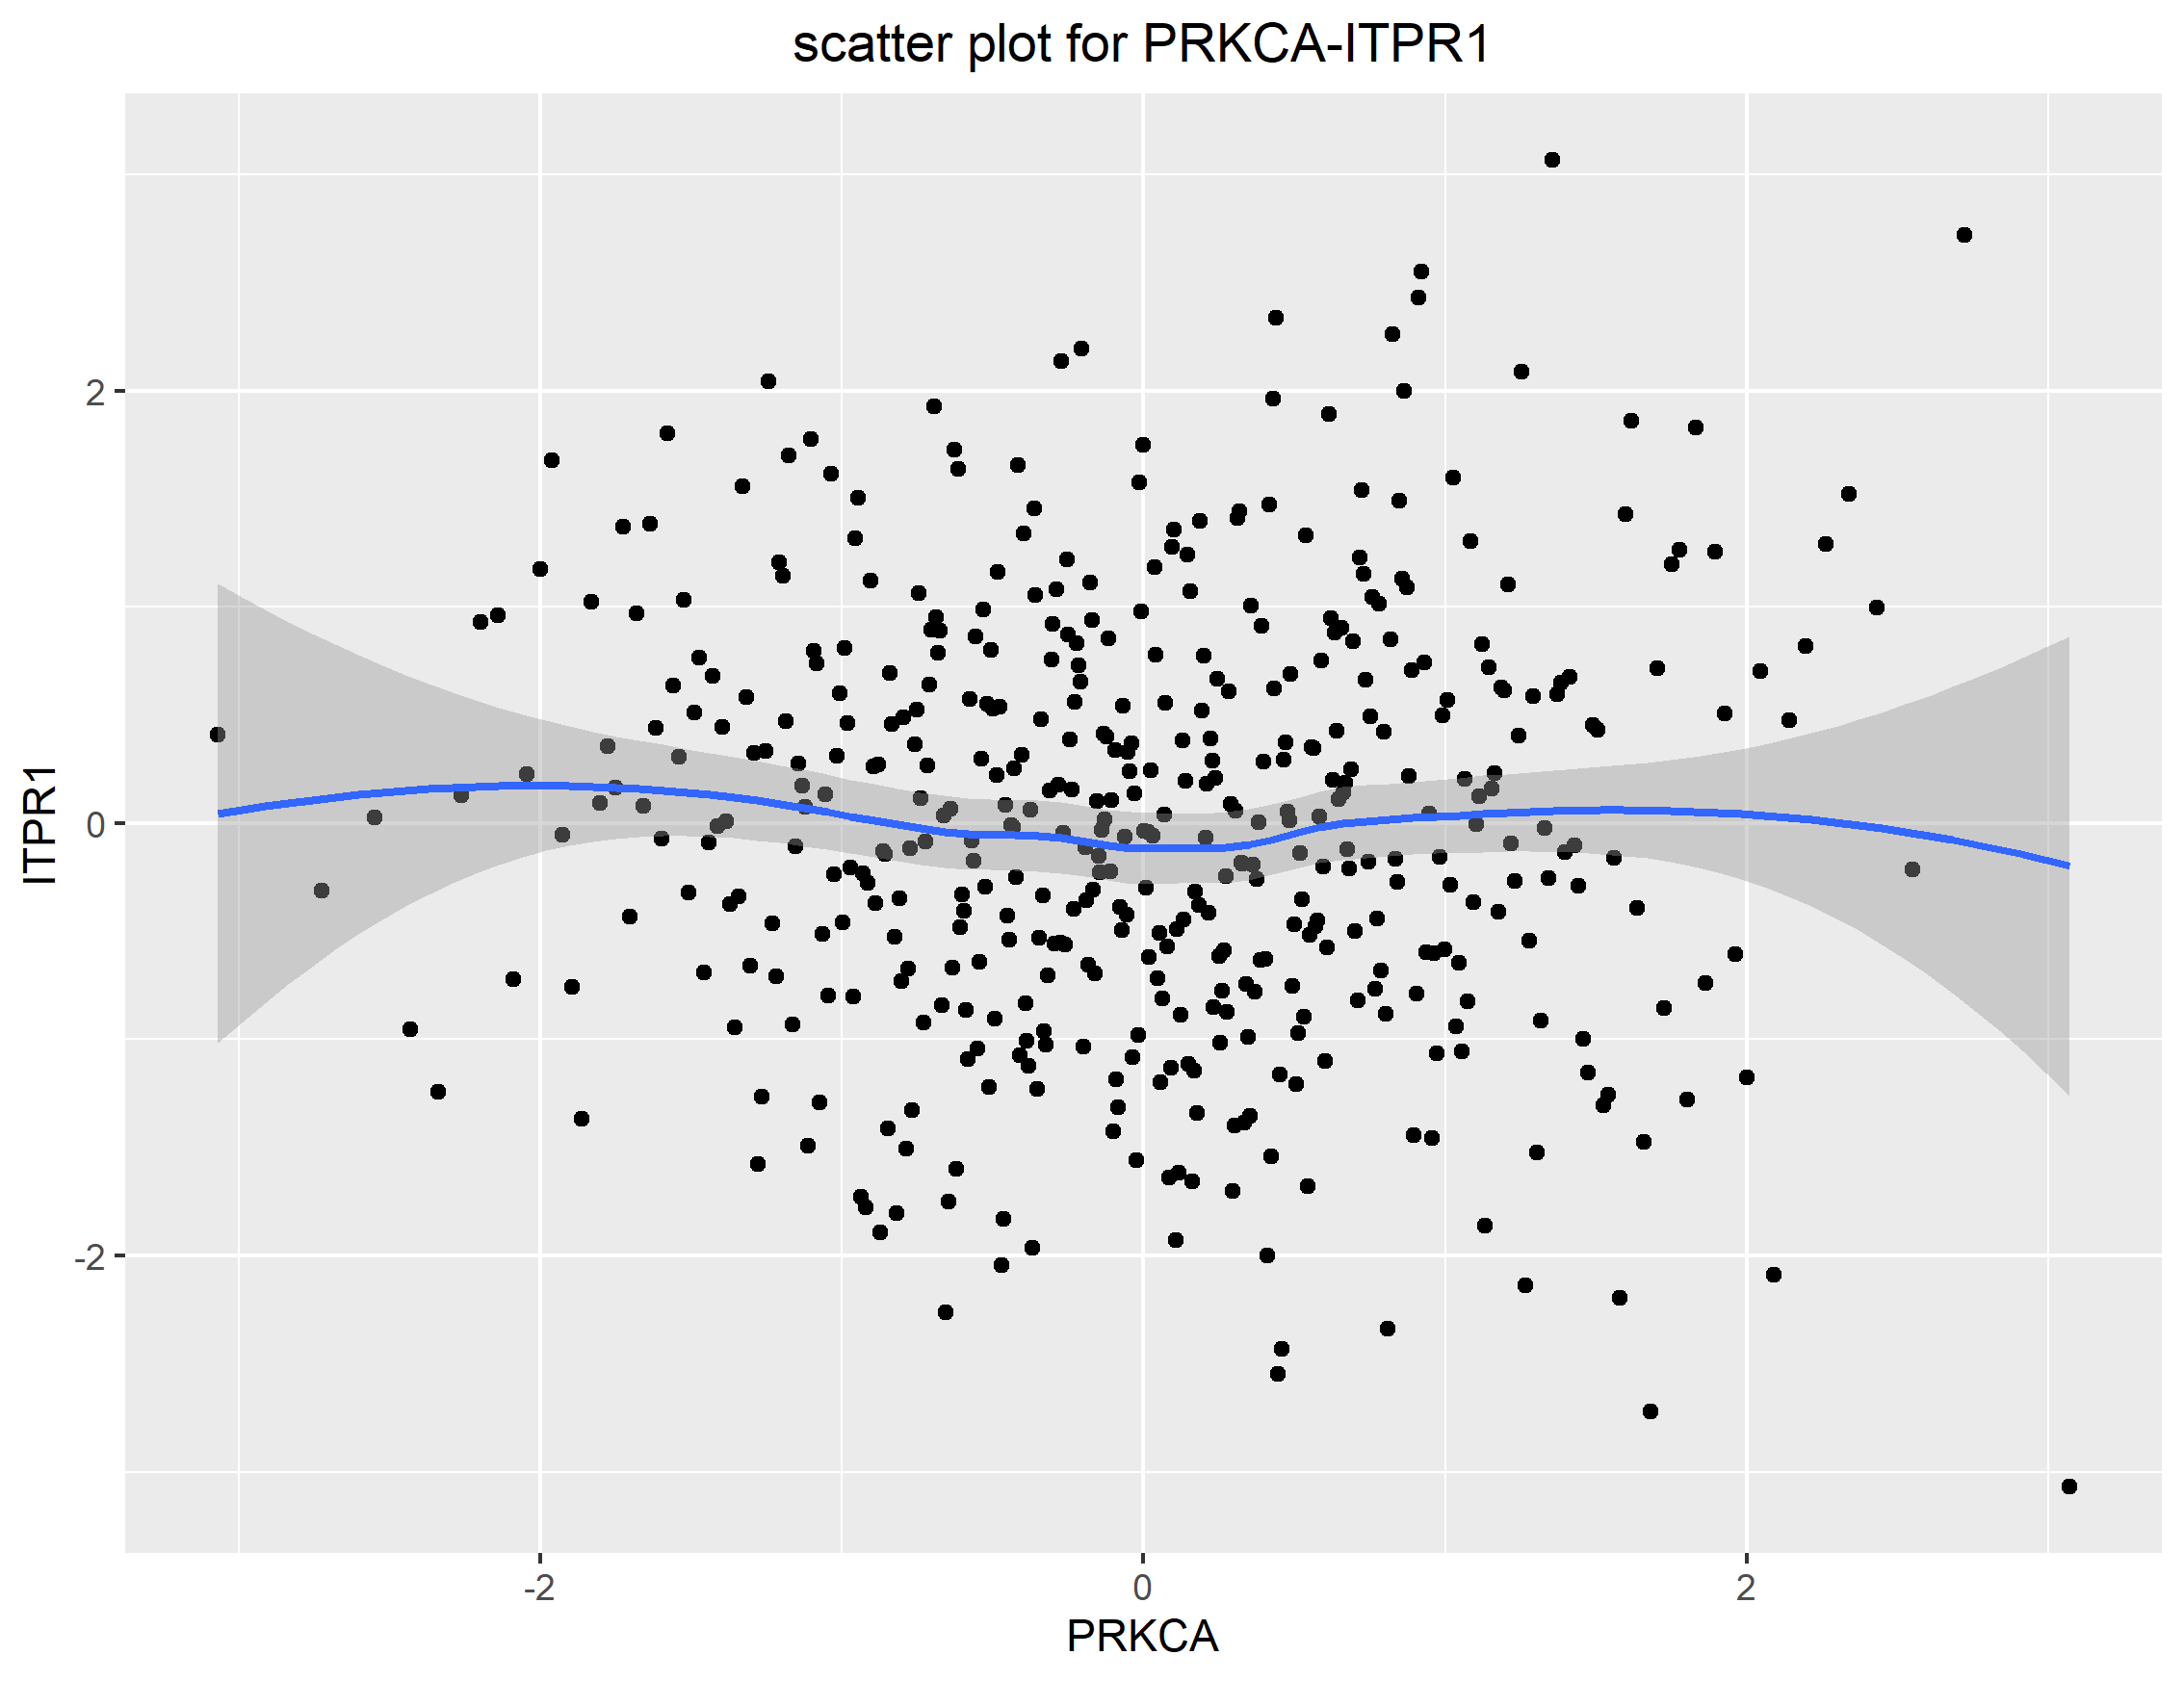

**Figure S46. Scatter plot for PRKCA-ITPR1 in eQTL study in long-term depression network.**

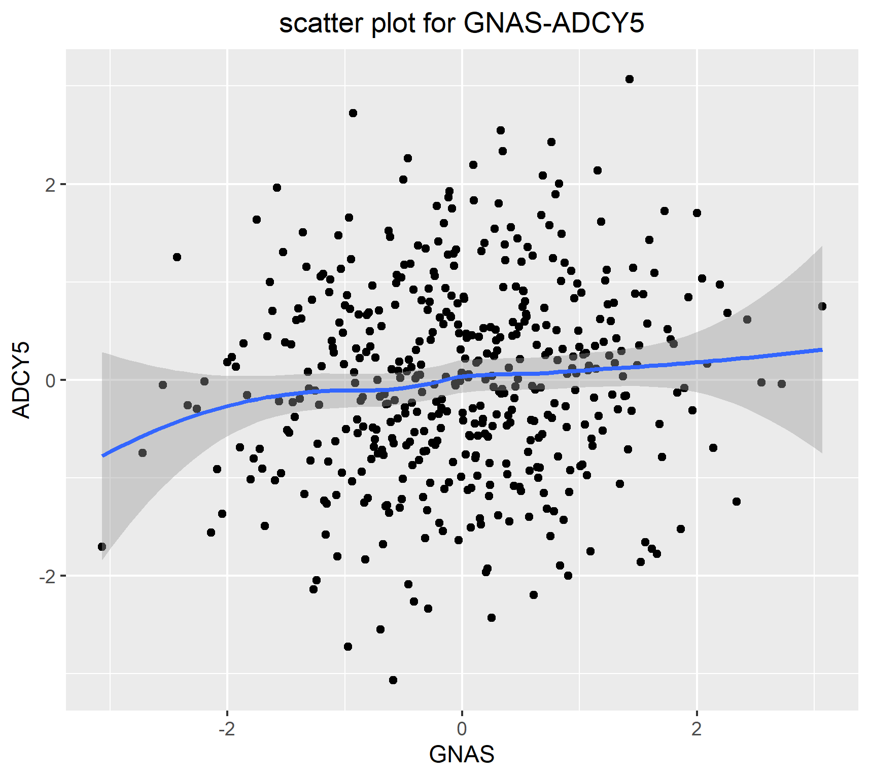

**Figure S47. Scatter plot for GNAS-ADCY5 in eQTL study in renin secretion network.**

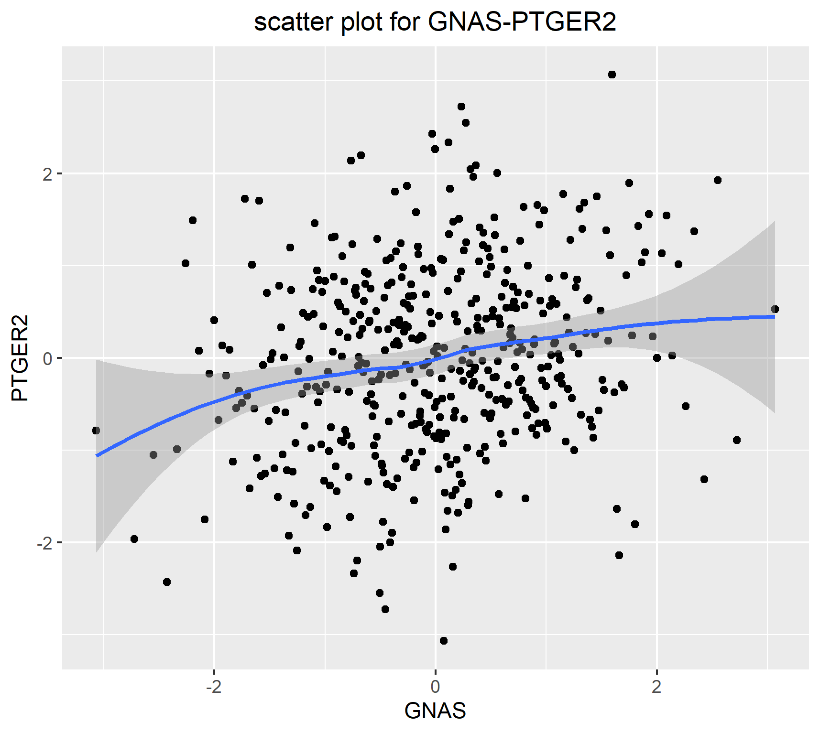

**Figure S48. Scatter plot for GNAS-PTGER2 in eQTL study in renin secretion network.**

**Supplementary Tables S1-S5:**

|  |  |  |  |
| --- | --- | --- | --- |
| **Table S1. Classification of office blood pressure and definitions of hypertension grade** | | | |
| **Category** | **Systolic (mmHg)** |  | **Diastolic (mmHg)** |
| Optimal | <120 | and | <80 |
| Normal | 120-129 | and/or | 80-84 |
| High normal | 130-139 | and/or | 85-89 |
| Grade 1 hypertension | 140-159 | and/or | 90-99 |
| Grade 2 hypertension | 160-179 | and/or | 100-199 |
| Grade 3 hypertension | $$≥180$$ | and/or |  |

|  |  |  |
| --- | --- | --- |
| **Table S2. Long-term depression network regression of binary phenotype with the gene expression prediction model being constructed from BSLMM model and p values in parenthesis.** | | |
|  | **PoLoNet** | **PPNT** |
| **node** | NOS(0.00876)  GRIA1(0.04466) | NOS(0.00762)  GRIA1(0.05019) |
| **edge** |  |  |

|  |  |  |
| --- | --- | --- |
| **Table S3. Long-term depression network regression of ordinal categorical phenotype with the gene expression prediction model being constructed from BSLMM model and p values in parenthesis.** | | |
|  | **PoLoNet** | **PPNT** |
| **node** | GRIA1(0.03078)  NOS(0.03114)  CRHR1(0.03888)  IGF1R(0.04238) | NOS(0.02752)  CRHR1(0.02962)  GRIA1(0.03436) |
| **edge** |  |  |

|  |  |  |
| --- | --- | --- |
| **Table S4. Renin secretion network regression of binary phenotype with the gene expression prediction model being constructed from BSLMM model and p values in parenthesis.** | | |
|  | **PoLoNet** | **PPNT** |
| **node** | KCNMA1(0.01068) | KCNMA1(0.01542) |
| **edge** |  |  |

|  |  |  |
| --- | --- | --- |
| **Table S5. Renin secretion network regression of ordinal categorical phenotype with the gene expression prediction model being constructed from BSLMM model and p values in parenthesis.** | | |
|  | **PoLoNet** | **PPNT** |
| **node** | KCNMA1(0.00335)  NPR1(0.02227) | KCNMA1(0.00601)  NPR1(0.02303) |
| **edge** | PRKACA-KCNMA1(0.00622) |  |